Final Project Report
for

Voice and Infrastructure Modernization
Version 1.10 approved
Prepared by:
Dawn Bissell
Michael Hristoviski
Tom Troup

Team 2, VoIP Solutions LLC.
Franklin University
July 16, 2017

Table of Contents

Table of Contents ii
Revision History iii
Group Members iv
1. Final Project Summary 1
1.1. Content Summary 1
1.1.1 Scope 1
1.1.2 Schedule 2
1.1.3 Cost 3
1.1.4 Risks 4
1.1.5 Communications Strategies 4
1.1.6 IT Technologies Employed 4
1.1.7 Significant Challenges 5
1.2. Lessons Learned 5
1.3. Learning Outcomes Summary 6
1.3.1 Communications 6
1.3.2 Critical Thinking 6
1.3.3 Network Design 7
1.3.4 Management Information Systems 8
1.3.5 Systems Administration and Scripting 9
1.3.6 Security 9
1.3.7 Employability 10
2. Future directions 10
2.1. Future Security Impacts 11
2.2. Upgrade to IoT Devices 11
3. Annotated Bibliography/References 12
3.1. Vision and Scope 12
3.2. White Paper: Remote Access of IoT Devices Via VoIP 13
3.3. White Paper: Security Challenges in VoIP Systems 14
3.4. White paper: Computer Telephony Integration and QOS Implementation 15
3.5. Final Report 15
4. Appendix A: Vision and Scope 17
5. Appendix B: Presentation Slides 37
6. Appendix C: Other Deliverables/Artifacts 42
6.1. White Paper: Remote Access of IoT Devices Via VoIP 42
6.2. White Paper: Security Challenges in VoIP Systems 53
6.3. White paper: Computer Telephony Integration and QOS Implementation 70
7. Response to Reviewers 79

Revision History

Name | Date | Reason For Changes | Version
Dawn Bissell | 7/12/17 | Formatted title page, added group members | 1.1
Michael Hristovski | 7/13/17 | Added content to section 1.3.3 | 1.2
Michael Hristovski | 7/15/17 | Added white paper artifact and section 2.0 content | 1.3
Dawn Bissell | 7/16/17 | Added white paper artifact, section 2.1, 1.2, sections 1-1.2, 1.3.4 | 1.4
Michael Hristovski | 7/16/17 | Added content to section 1.31, 1.32,1.37, and 2.0 | 1.5
Tom Troup | 7/16/17 | Added content to section 1.3.5-6, uploaded white paper | 1.6
Dawn Bissell | 7/16/17 | Format paper and fix table of contents. Inserted artifacts (3white papers, V/S) as an image to fix page number issue, added content to An. Bib, conducted Grammarly scan | 1.7
Dawn Bissell | 7/27/17 | Applied changes addressed by peer reviewers and proof read | 1.8
Michael Hristovski | 7/28/17 | Applied changes addressed by peer reviews, and added network diagram to section 1.3.3 | 1.9
Dawn Bissell | 7/30/17 | Applied changes from peer reviews, added presentation slides(version 2, pre-revision) and response to reviewers. Edit Content | 1.10

Group Members

Name | Role | Responsibilities | Skills | Attributes
Dawn Bissell | Project Manager | Facilitate team communication. Perform quality control of deliverables. Provide documentation and help where needed on deliverables. | Quality Control, Virtual Machines, Windows System Administration | Detailed oriented, Introverted, Opened minded, Myers-Briggs: INTP-T
Michael Hristovski | Team Member | Provide networking and help where needed on deliverables. | Networking, Virtual Machines, Cabling | Detailed, critical thinker, organized
Tom Troup | Team Member | The main contact for VoIP related technology, help develop deliverables and help where needed. | Traditional and IP Telecommunications, Networking, and Interior Wiring | Quiet and reserved, big picture thinker

Final Project Summary
The scope of this project includes the modernization of Charlie's Manufacturing voice and network systems. It also includes the replacement of existing network cabling within office areas. Charlie’s manufacturing was experiencing repeated failures with the existing PBX system, which required frequent support calls and system downtime. By upgrading to a VoIP solution, Charlie’s Manufacturing will reduce the support costs. With the use of the FreePBX solution, the company can begin with basic features, expanding capabilities as needed. Due to the frequent outages and lack of voice communications, a rapid paced schedule was implemented to complete all project requirements between 4 Jun and 5 Aug 2017.

The max budget for this project is $85k. The cost estimate from VoIP Solutions LLC states the cost was $80,211 for this project. The main risk for this project involved employees struggling with the software or showing resistance.

VoIP Solutions LLC primarily utilized email and business skype for this project. The IT technology that was employed was FreePBX for the VoIP solution. The team faced the challenge of having a short staff and workload balance.

Content Summary

Scope
By choosing VoIP Solutions LLC, Charlie's Manufacturing received a refresh of the existing voice and network infrastructure. In the execution of this effort, VoIP Solutions LLC evaluated the existing architecture, identified areas requiring additional resources and improvements, and replaced components that have reached End of Life. This included infrastructure cabling systems within the administration facilities.

The modernization of the internal components provided a unified communications platform. It was integrated into the existing Windows Server environment and offered more robust capabilities into the voice network. The project effort was accomplished in accordance with industry standard practices for installation and security.

See Appendix A, section 3 for specifics for the scope of the initial release and the scope of subsequent releases.

Schedule
*Referenced (Allen, et. al., 2015).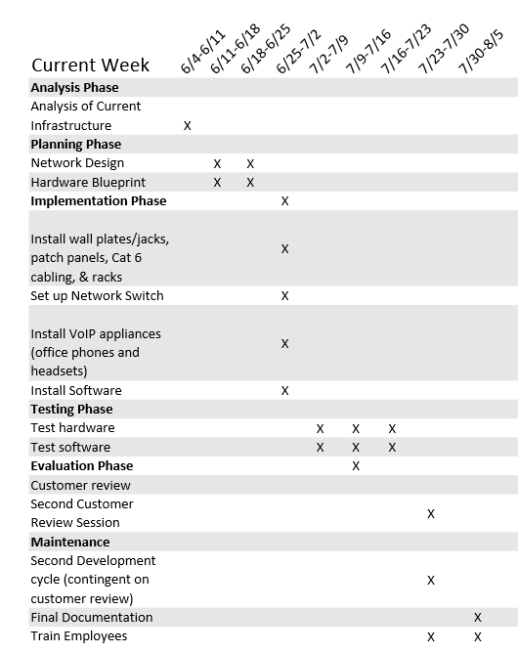

Cost
VoIP Solutions, Inc. Cost Estimate
*template obtained from (Schwalbe, 2014). Referenced (Business Literacy Institute, 2017).
 | # Units/Hrs. | Cost/Unit/Hr. | Subtotals | WBS Level 2 totals | Capitalized or Expense
- Project Management |  |  |  | $50,000 | Expense
1.1 Project Management | 80 | $100 | $8,000
1.2 Project team members | 560 | $75 | $42,000
- Hardware |  |  |  | $11,030 | Capitalized
2.1 VoIP Appliances |  |  | $2,400
2.2 VoIP Office Phones |  |  | $1,200
2.3 Headsets |  |  | $1,500
2.4 Network Switches |  |  | $4,500
2.5 Cat 6 Cabling |  |  | $600
2.6 Wall Plates/Jacks |  |  | $200
2.7 Racks |  |  | $200
2.8 Patch Panels |  |  | $130
2.9 Cable Management |  |  | $300
- Software |  |  |  | $1,100 | Expense
3.1 FreePBX Support |  |  | $800/year
3.2 Software Development |  |  | $300
- Testing (10% of total hardware and software costs) |  |  |  | $1,213 | Expense
- Training and Support |  |  |  | $3,500 | Expense
Training cost | 20 | $100 | $2,000
Travel cost |  |  | $0
Project Team Members | 20 | $75 | $1,500
- Reserves (20% of total estimate) |  |  |  | $13,368
Total Project cost estimate |  |  |  | $80,211

Risks

Risk | Severity Level | Mitigation
Employees may have difficulty learning the new system | Medium | The organization will offer training on the new system, along with printed documentation on how to use all the features. Navigation guides of the interface will be provided.
The organization may have resistance to the new system from employees | Medium | We will offer additional training that will show the ease of the new system along with the benefits of the new features
Customers view the new VoIP system as a security issue | Medium | We must ensure them that the new system will not be a security risk by thoroughly testing the system before deployment
The existing infrastructure may not be able to support the new VoIP system | Low | The budget accounts for upgrading the infrastructure if needed
The downtime associated with implementing the new VoIP system | Low | We will deploy with parallel adoption. This will allow the analog system to provide service until the new system is running and tested.
See Appendix A, section 1.5 for a full description of risks.

Communications Strategies
The team primarily communicated with email and business Skype. Weekly meetings, were held via Skype, to review progress and go over assignments for the following week. For emails, a 24-48-hour response time was expected. Deliverables had the added communication of comments. This was accomplished with Microsoft OneDrive to share documents with the team. Utilizing OneDrive allowed the team to collaborate together and see changes in real time. Deadlines were set and managed through Microsoft’s calendar with reminders being generated and sent out via email to each team member.

IT Technologies Employed
The main technology that VoIP Solutions LLC employed was FreePBX. This hardware/software combo was the foundation for the VoIP upgrade. To showcase FreePBX, the OS was installed on a virtual machine to demonstrate configurations that allowed for the desired features (see Appendix A, section 2.2).
Other technologies that were employed was the research of new wiring that met ANSI/NECA/BICSI 568-2006, Standard for Installation of Commercial Building Telecommunications Cabling (2002).

Link to installation demo: https://youtu.be/gF1l12BWMZI

Significant Challenges
There were two significant challenges for this project. The first being the unexpected loss of a team member; as a result, the team had to divide the workload amongst the group. The second challenge was workload balance which compounds with the previous challenge; it increased the required work for each member. Each team member had to face the difficulties of managing this project with school, full-time work, and families. The main strategy to remedy this was communication (discussed in detail in section 1.2)

Lessons Learned
- Why was this particular information technology problem chosen?

VoIP Solution LLC chose this particular IT problem because one of the team members has experience in VoIP outside of Franklin University. This gave the team a strong foundation to build on with the skills of the other two members. This also gave the team an opportunity to gain experience in a widely utilized technology.

- What decisions were made when developing the project proposal and draft?

The main decision that was made when developing the project proposal was the implementation of VoIP to upgrade the analog phone system of Charlie’s Manufacturing. VoIP Solutions LLC also had to decide on the hardware required for this implementation.

- What were the major challenges faced during the project and how were they resolved?

The major challenges faced by VoIP Solutions LLC were workload balance and a staff shortage. Workload balance was an ever-present issue with the demands of outside work, schooling, and family demands. The staff shortage was caused by a team member that left VoIP Solutions LLC without notice.
To resolve these issues, VoIP Solutions LLC implemented strong communication techniques. Each of the team members had to divide the labor that would have been covered by the missing team member. By communicating with each other, the team was able to adapt when one member had a family issue or was running behind; thus, deliverables were kept on schedule by helping each other when needed.

- What revisions were made (if any) in response to the business practitioner and/or professor? If advice was ignored, explain the rationale for those decisions.

Revisions were made in response to a peer review cycle amongst the members of the class. The review cycle was conducted on the following documents: Vision and Scope document, individual team member’s White Paper, and the Final Report document. Most advice was accepted except feedback that did not pertain to the action items of deliverables. For example, the White Paper document was an academic paper, not a business deliverable. Feedback was received to change the paper to a business style document. Since business style was not required as an action item, this feedback ignored (see Appendix C: Other Deliverables/Artifacts, section 14.2, Response to Reviewers).

- What further improvements should be made to your project if more time were available? In other words, what lessons were learned through the course of the project?

The biggest lessons learned through the course of this project was the ability to adapt. The team used communication strategies to be able to adjust the workload as needed to meet deliverables. If more time were available, schedules could be adjusted for a more balanced workload.
Further improvements that could be made would also be the upgrade of Charlie’s Manufacturing’s equipment to IoT devices. This would require a full modernization of the operating environment. Also, IoT devices could be implemented with the VoIP infrastructure VoIP Solutions LLC. Provided production. (see Appendix C: Other Deliverables/Artifacts).

Learning Outcomes Summary

Communications
Each team member learned the importance of communication. By having a short staff, this was vital for success. Each member had to provide progress updates to ensure forward mobility of the project. Furthermore, meeting minutes allowed for the team to stay aware of events even when attending a meeting was not possible. Lastly, synced calendars and OneDrive folders allowed the team to be aware of progress in real time.

Critical Thinking
Each team member involved in the project provided their unique input and experience towards meeting the required finish product. Whether the experience was in team leadership, networking, VoIP systems, or communication all aspects were useful in maintaining deadlines and completing the project successfully. By having such a diverse skill set, it allowed the team to utilize those individuals and take advantage of their knowledge and experience in those areas.

The choice to implement a VoIP solution was multifaceted, as an overlooked technology within the program courses. VoIP poses unique considerations when added to an existing network. By executing this project, it enabled the team to learn concepts of a new skill that are often not considered. Implementation of network Quality of Service, Virtual LAN segmentation, and the choice to use physical phones or software based clients were all considered in the planning phase based on the customers budget and timeline requirements. During the team’s initial planning for the new VoIP system, other options were considered such as a hosted PBX through Vonage or RingCentral that included monthly fees. However, after weighing the options, the team decided that Charlie’s Manufacturing would be better suited with an appliance on site that was managed by the IT department that would provide a better return on investment and allow for more future growth at minimal costs.

Network Design
The VoIP Solutions LLC team evaluated the current network infrastructure and made upgrades to hardware so that the VoIP system implementation was completed without any performance issues or security concerns. Our team implemented a network design that would be able to support normal data operations in addition to the 75 users that will be utilizing the new VoIP system.

Changes to the infrastructure included:

- Replaced wiring throughout the infrastructure to CAT-6 cabling and added fiber optic cabling between distribution points to support higher data transfer speeds

- Replaced existing network devices that weren’t supported by the manufacturer which posed security risks

- Installed two new network switches that enabled support for VLAN and QoS features needed for VoIP

- Implemented multiple VLANs to separate the data and voice networks.

- Added two FreePBX appliances to the network and configured them to run the newly acquired VoIP phones

The upgraded infrastructure is designed to allow for expansion and future projects. Included are detailed screenshots of the FreePBX software being installed on the new appliance within the infrastructure (see artifacts, install folder, figures 1 through 6). Included on the following page is an updated network diagram containing the project changes that reflect the new VLAN with the voice portion of the network.

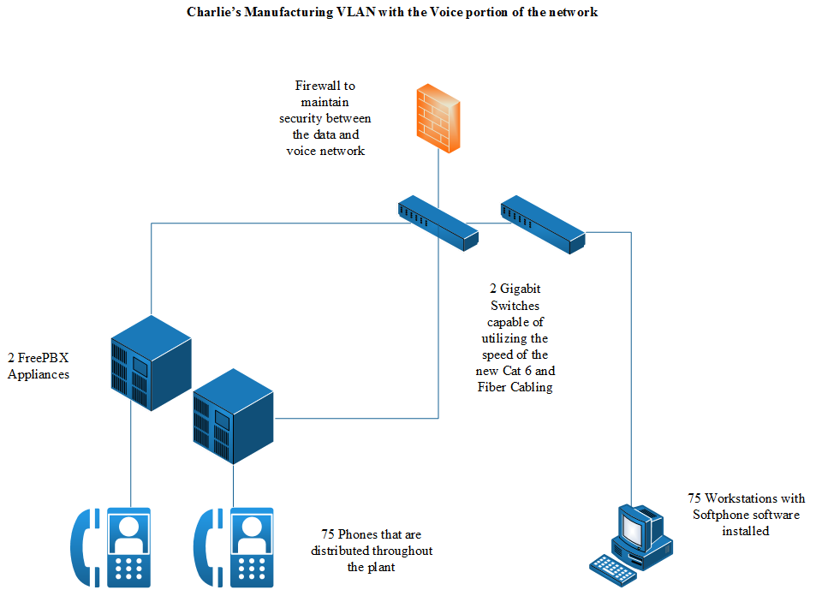

Management Information Systems

Management Information Systems outcomes (MIS) were primarily achieved with the use of technical communication strategies. Meeting minutes were conducted for VoIP Solutions LLC along with specification of what deliverables were required from each member (see artifacts, MIS folder). On the business side of MIS, an instructional brochure was produced to provide a basic over of the new system for employees. The IT department was given an overview of the new system and was directed to the FreePBX wiki. This will be the primary source of information for the day to day task of the system. As mention in the Vision and Scope document, a customer/employee satisfaction survey was also conducted. (see artifacts, MIS folder).

Communication with the stakeholders was vital for this project. To start, stakeholders were identified and a stakeholder register (see artifacts, MIS folder) was created. VoIP Solutions held weekly update meetings with key stakeholders. To beginning the project process, a kick-off meeting was conducted with stakeholders (see artifacts, MIS folder). A kick-off meeting allows for stakeholder to get to know each other and to discuss the goals of the project. This meeting was where VoIP Solution began the requirements and goals process with the stakeholders. (Schwalbe, 2014 ).

Systems Administration and Scripting
Through the course of implementing this project, VoIP Solutions LLC. has completed the design and upgrade of the data network, including the installation of a VoIP solution utilizing FreePBX.

This required our team to install switches, routers, and servers along with the application supporting the voice requirements of Charlie’s Manufacturing LLC. These configuration phases have required manual configuration through web-consoles, command line scripts. (see artifacts folder)

To ensure business continuity, the system was configured to automatically perform a daily configuration backup to off-site cloud storage service. The use of this allowed for a seamless recovery upon replacement of any failed or damaged hardware.

Security
Traditional phone systems are not typically monitored as an information asset. As the phone systems move to an IP network, risk becomes more evident. To meet the security objectives of Charlie’s Manufacturing, VoIP Solutions LLC. has implemented standard configuration practices to include media encryption, TLS session Authentication, and VLAN segmentation in the network design. (see artifacts folder)

Feature | Benefit
Media Encryption | Using the SRTP protocol, the voice media stream is encrypted end-to-end, using negotiated security protocol. Use of media encryption prevents eavesdropping of conversations, thus preventing loss of proprietary and client information.
TLS Session Authentication | TLS Authentication, assists in the prevention of fraudulent calls from external parties, by requiring a site authorized SSL certificate to register with the server. Registration is required, before allowing any call origination or termination. As an added benefit, the signaling data between parties is encrypted, preventing the release of customer contact information.
VLAN Segmentation | By separating Voice and Data networks using VLAN and appropriate ACL configuration Network Administrators can limit the exposure of security threats in each network enclave. Features include DoS Protection and can limit the spread of malware.

By implementing these security procedures Charlie’s Manufacturing can secure the voice network against risks such as follows:

- Denial of Service attacks
- Eavesdropping
- Alteration of the Voice Stream
- Toll Fraud
- Redirection of Calls
- Accounting Data Manipulation
- Caller ID Impersonation
- Unwanted Calls or Messages

(see Appendix C: Other Deliverables/Artifacts, Section 6.2)

Additional features of FreePBX include email alerts for security related events, including patch availability, intrusion detection, and suspected fraudulent activity. The system was configured to send alerts automatically to Charlie’s Manufacturing IT Staff.

Future updates:
Keeping the software updated is key to providing a secure VoIP solution. “The FreePBX Distro provides update scripts for every major release track.” (Lewis, 2016) After the project’s completion, the Charlie’s Manufacturing’s IT department will be responsible for updating the Distro. Complete instructions on how to do this is found on the FreePBX wiki. As mentioned above, a simple update script needs to be run which is obtained from the wiki.

Employability
VoIP Solutions LLC provided a solution that allowed Charlie’s Manufacturing to update their switched based phone system to a more modern VoIP system. This system allowed for added features and an excellent return on investment. By upgrading the infrastructure for this VoIP solution, the organization is now in a position to meet future expansions and upgrades to add even more functionality to the system and generate even more productivity by integrating many aspects of the business into one environment.

Future directions
With the upgrade of the infrastructure and implementation of the VoIP system Charlie’s Manufacturing will be able to maintain future expansions and updates that will continue to enhance the capabilities of the new VoIP system (see Appendix A: Vision and Scope, section 4.9). Charlie’s Manufacturing is poised to take advantage of new technologies and implement more of their machinery and devices into the infrastructure. Keeping the organization’s data safe and secured is also a priority. Therefore the system must stay current with updates, patches, and new technologies to protect against the ever-growing threat (see Appendix A: Vision and Scope, section 4.10).

Future Security Impacts

It is important to allocate funding going forward into security to maintain adequate protection of company data assets. The safety of the VoIP system and network overall will rely heavily on staying current with critical updates, patches, and new hardware technologies as they become available to help protect the infrastructure. Researching new security threats and remaining vigilant with penetration testing will give added reassurance against threats as they evolve. Maintaining layers of security throughout different entry points on the network will give added protection and allow for notice if a threat is detected (see Appendix C: Other Deliverables/Artifacts, section 6.2 - Figure 1). Making sure employees have the training to protect against phishing and other types of social engineering attacks are vital since they are usually targeted first to gather information or find a vulnerable spot for attackers to exploit.

Upgrade to IoT Devices
The next step for Charlie’s Manufacturing would be an upgrade of machinery to devices that are IoT compatible. By utilizing the upgraded VoIP system, remote access and control of these devices would become available. Upgrading to IoT devices would allow Charlie’s Manufacturing to explore automation within the plant; this will increase productivity. Remote access to devices would allow for programmable settings and sync of equipment to calendars. (see, section 6.1)

Annotated Bibliography/References

Vision and Scope
Allen, M., McLees, J., Richardson, C., Waterford, D. (2015. April). Project planning and best practices. Journal of IT and Economic Development, 6(1), 1-15.

Phases of a project: initiation, planning and design, execution, monitoring and controlling, and closing. Project management often has re-planning. The scope is defined and more precise as the plan is executed. A key element of a project plan is scheduling. Without a proper schedule, you are planning to fail. Utilize software tools to help with the planning and scheduling process.

BICSI. (2002). ANSI/NECA/BICSI 568 Standard for Installing Commercial Building Telecommunications Cabling. BICSI.

BICSI is a National Standards organization for Telecommunications and Data Wiring; Defined practices show how to properly install Communications Cables.

Business Literacy Institute. (2017). Expensing vs capitalizing. Retrieved on June 4, 2017 from http://www.business-literacy.com/financial-concepts/expensing-capitalizing/

“Expensing vs Capitalizing
Definition:
Expensing vs. capitalizing refers to how a cost is treated on the financial statements. Expensing a cost indicates it is included on the income statement and subtracted from revenue to determine profit. Capitalizing indicates that the cost has been determined to be a capital expenditure and is accounted for on the balance sheet as an asset, with only the depreciation showing up on the income statement.”

Guest Contributor on TechRepublic. (2013, July 8). 10 VoIP features that can benefit your small business. Retrieved June 08, 2017, from http://www.techrepublic.com/blog/10-things/10-voip-features-that-can-benefit-your-small-business/

This resource was very valuable in understanding the common features associated with VoIP systems and their benefits.

Half of All Network Devices BICSI. (2002). ANSI/NECA/BICSI 568 Standard for Installing Commercial Building Telecommunications Cabling. BICSI.re Outdated – And Vulnerable. (2016, June 26). Retrieved from Infosecurity Magazine: https://www.infosecurity-magazine.com/news/half-of-all-network-devices-are/

With the upward trend of malware attacks, global network monitoring firm Dimension Data, publishes an annual report of network health based on device age, supportability, and vulnerabilities.

Mae, I. (2016, September 12). VoIP and the internet of Things: can they transform your business? Retrieved on June 20, 2016 from https://www.voipreview.org/blog/voip-and-internet-things-can-they-transform-your-business

Using VoIP technology as the core for IoT provides greater functionality, cost-savings, and increased productivity for a business. VoIP allows for a business to cut costs while adding additional features that provide flexibility and increased productivity, especially when connected to IoT applications.
Examples of what is possible when integrating VoIP with IoT include:
• Control of lighting and temperature of facility from a VoIP device
• Alerts of when machines needs repaired or require maintenance
Sync calendar with machines to prepare for meetings

National Fire Protection Association. (2014). National Electric Code. Quincy, Massachusetts: National Fire Protection Association.

Section 800.25 of the NEC requires the removal of abandoned communications and electrical wiring. In addition to installation practices for communications equipment rooms, and racks.

Schwalbe, K. (2014). Information technology project management, 7ed. Boston, MA: Course Technology, Cengage Learning.

Obtained the template for section 6.4 Budget.

White Paper: Remote Access of IoT Devices Via VoIP
Aljabari, G. (2015). Integrating VoIP systems with the Internet of things. Retrieved from Palestine Polytechnic University: http://staff.ppu.edu/galjabari/files/21
Callari, R. (2016, January 21). IoT and VoIP are talking to each other. Retrieved on June 24, 2016 from https://telzio.com/blog/iot-voip-are-talking-to-each-other/
Dell. (2017). Dell edge gateway 5000. Retrieved on June 25, 2015 from http://www.dell.com/en-us/work/shop/productdetails/dell-edge-gateway-5000/xctoi5000us
Foxhoven, P. (2016, November 8). Security risks from the internet of things. Retrieved on July 9, 2017 from http://internetofthingsagenda.techtarget.com/blog/IoT-Agenda/Security-risks-from-the-internet-of-things
Mae, I. (2016, September 12). VoIP and the internet of things: can they transform your business? Retrieved on June 20, 2016 from https://www.voipreview.org/blog/voip-and-internet-things-can-they-transform-your-business
Postscapes. (n.d.). IoT Gateways. Retrieved on July 9, 2017 from https://www.postscapes.com/iot-gateways/
Rouse, M. (n.d.). IoT gateway. Retrieved on June 24, 2017 from http://whatis.techtarget.com/definition/IoT-gateway
Treadway, J. (2016, April). Using an IoT gateway to connect the "things" to the cloud. Retrieved on June 22, 2017 from http://internetofthingsagenda.techtarget.com/feature/Using-an-IoT-gateway-to-connect-the-Things-to-the-cloud

White Paper: Security Challenges in VoIP Systems
Butcher, D., Li, X., & Guo, J. (2007). Security challenge and defense in VoIP infrastructures. IEEE Transactions on Systems, Man, and Cybernetics, Part C (Applications and Reviews), 37(6), 1152-1162.

Cisco SAFE Reference Guide - SAFE Overview [Design Zone for Security]. (2013, October 31). Retrieved July 09, 2017, from http://www.cisco.com/c/en/us/td/docs/solutions/Enterprise/Security/SAFE_RG/SAFE_rg/chap1.html

How to Protect Your Voice: Tips on IP Phone Security. (2016, December 20). Retrieved June 25, 2017, from http://www.cisco.com/c/en/us/solutions/small-business/resource-center/do-business-better/tips-ip-phone-security.html

Is Your Security Layered Like Your Bean Dip? (2015, September 09). Retrieved July 09, 2017, from http://blog.thinknettech.com/is-your-security-layered-like-your-bean-dip/

Rahangdale, T. G., Tijare, P. A., Sawalkar, S. N., Balhare, Z. J., & Gulhane, V. S. (2014). An overview on security analysis of Session Initiation Protocol in VoIP network. IJRAT, 2(4), 190-5.

The Difference Between VoIP and PSTN Systems. (2008, May 9). Retrieved June 24, 2017, from http://www.webopedia.com/DidYouKnow/Internet/VoIP_POTS_Difference_Between.asp

VoIP History. (n.d.). Retrieved June 24, 2017, from http://www.voipinsights.com/voip_history.html

White paper: Computer Telephony Integration and QOS Implementation
Avaya. (2017). Product Lifecycle Dates. April. Retrieved from https://downloads.avaya.com/css/P8/documents/100172510
Cisco. (2001, April 13). Quality of Service for Voice over IP. Retrieved from Cisco Support: http://www.cisco.com/c/en/us/td/docs/ios/solutions_docs/qos_solutions/QoSVoIP/QoSVoIP.html#wp1015327
IETF. (2015). Software-Defined Networking (SDN): Layers and Architecture Terminology (RFC 7426). IETF. Retrieved from https://www.rfc-editor.org/rfc/pdfrfc/rfc7426.txt.pdf
Sugarcrm. (2017, July 9). About Sugar CRM. Retrieved from SugarCRM: https://www.sugarcrm.com/product

Final Report
Lewis, T. (2016, March 18). Updating FreePBX official distro. Retrieved on July 27, 2017 from https://wiki.freepbx.org/display/FD/Updating+FreePBX+Official+Distro
Schwalbe, K. (2014). Information technology project management, 7ed. Boston, MA: Course Technology, Cengage Learning.

Referenced chapter 3 pertaining to MIS section. Referenced material for stakeholder interactions and kick-off meeting.

Appendix A: Vision and Scope
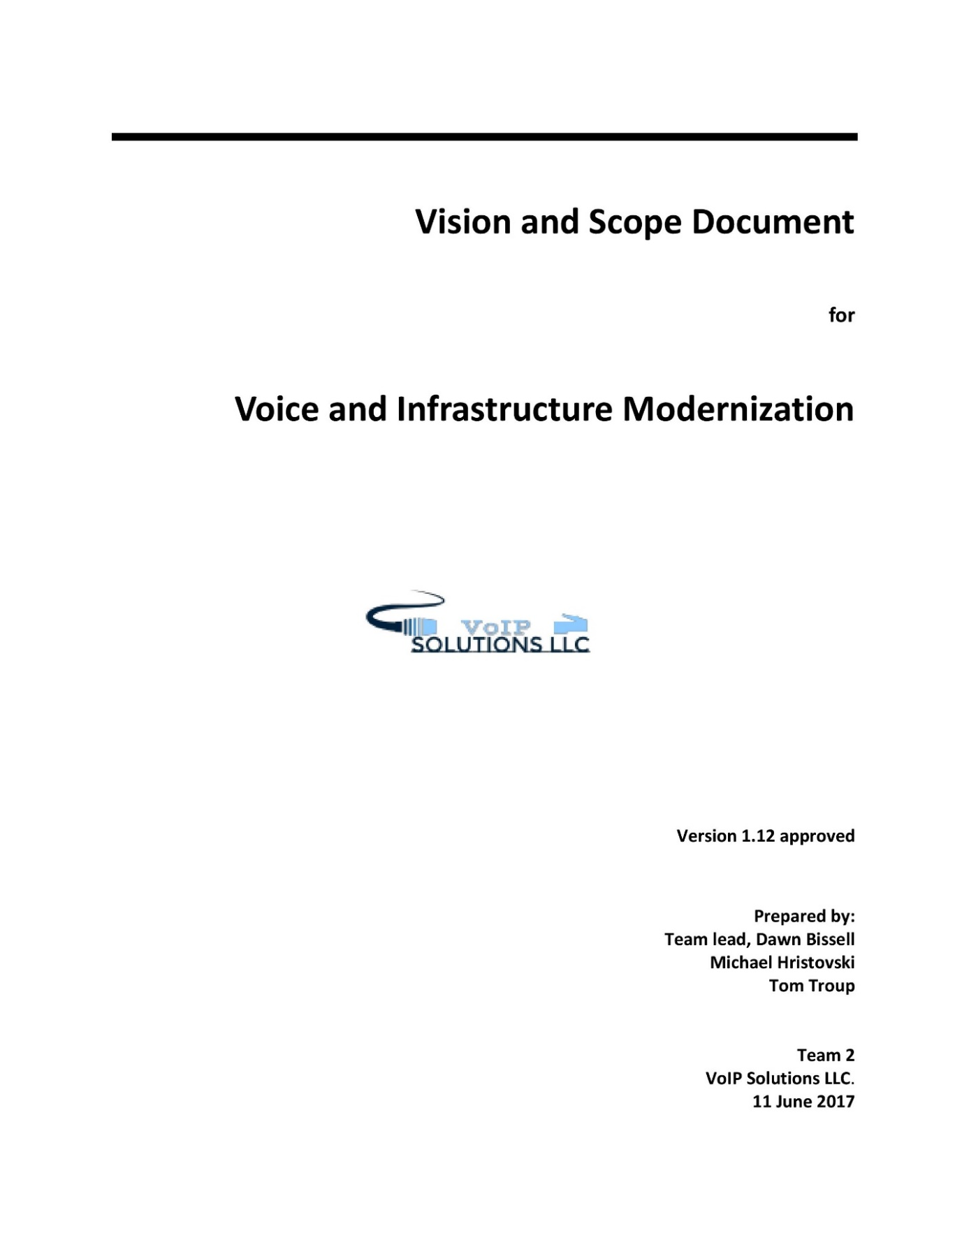

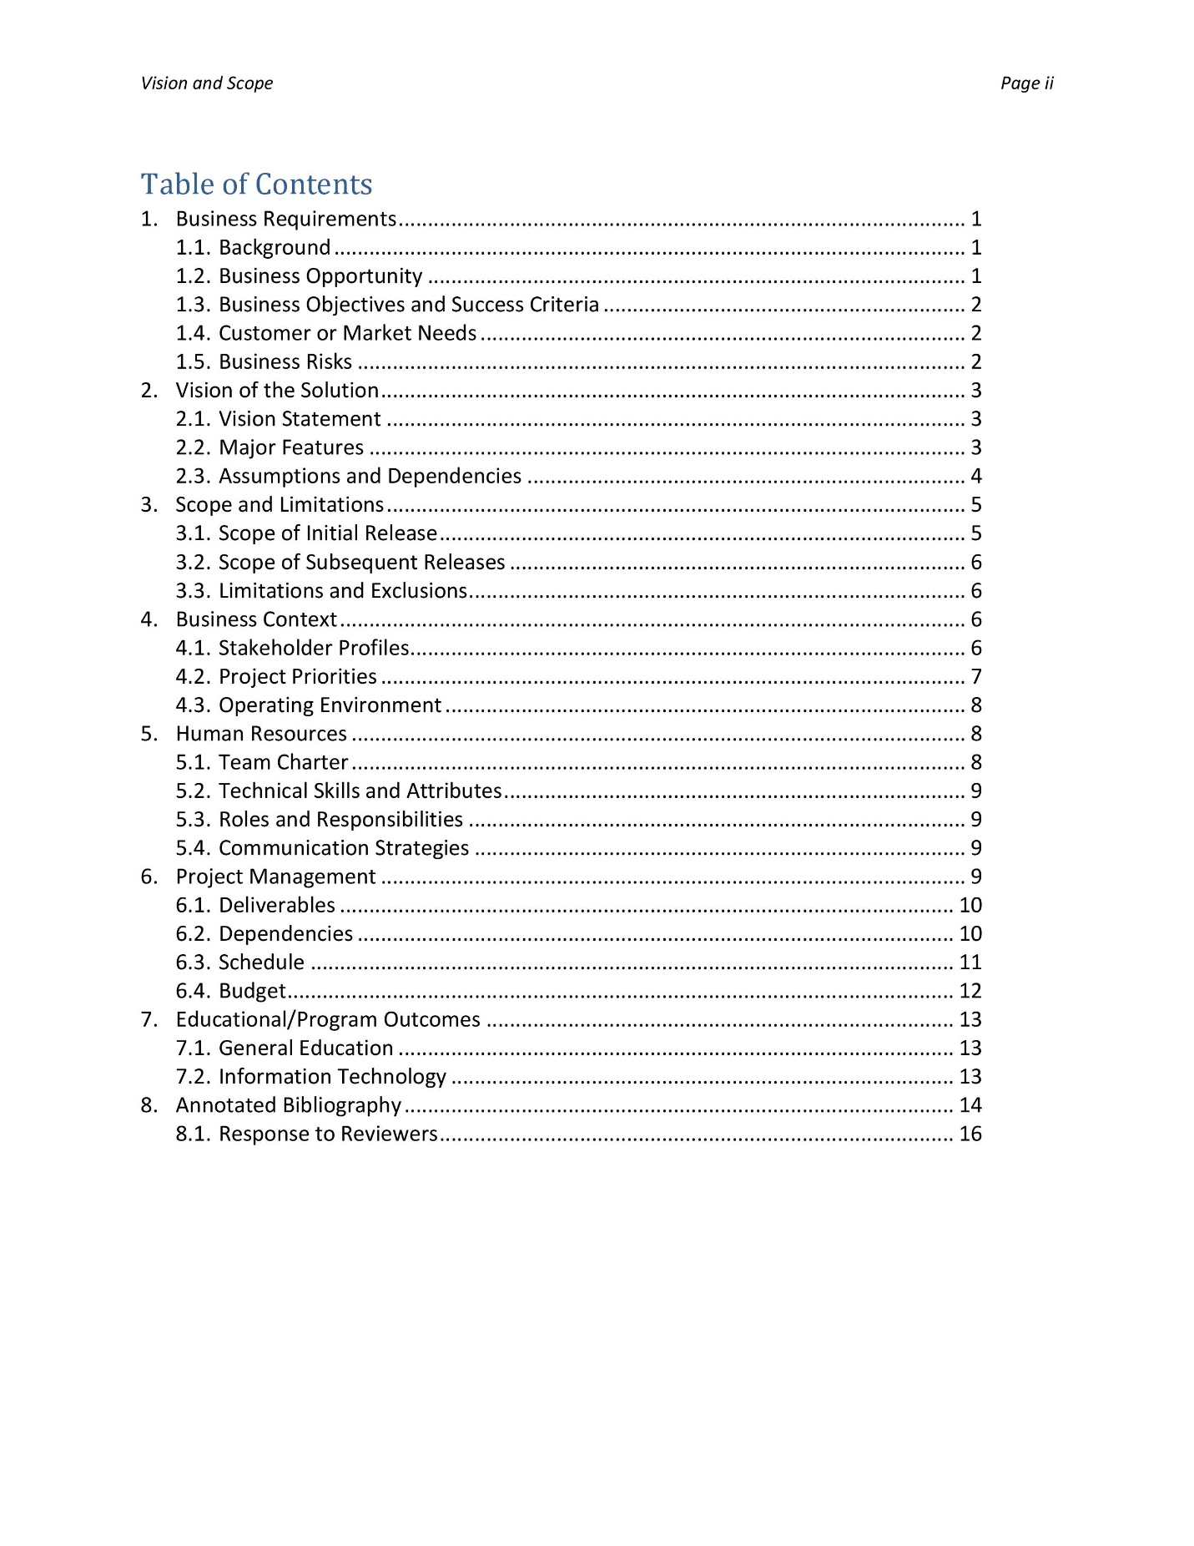

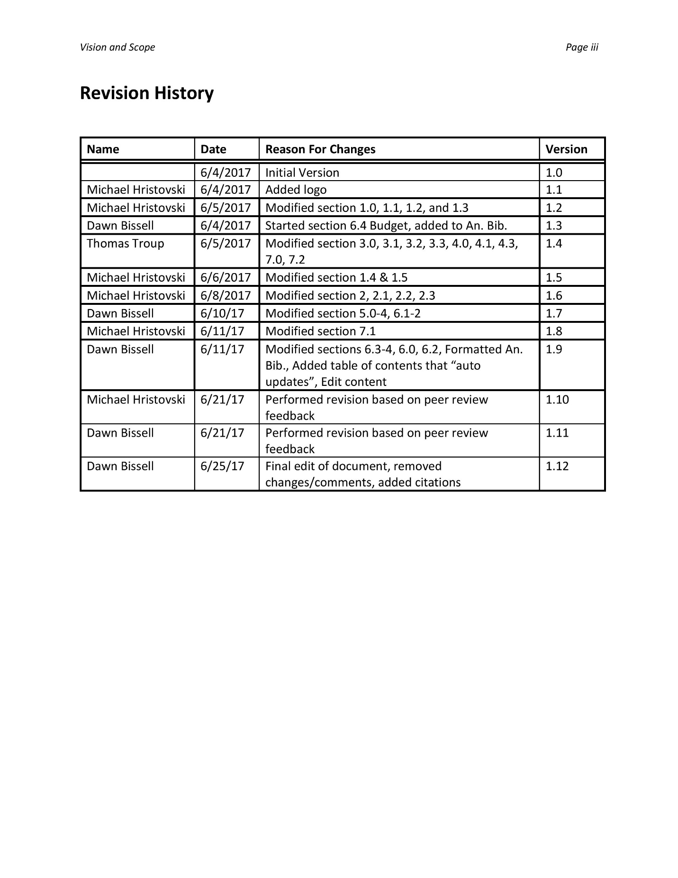

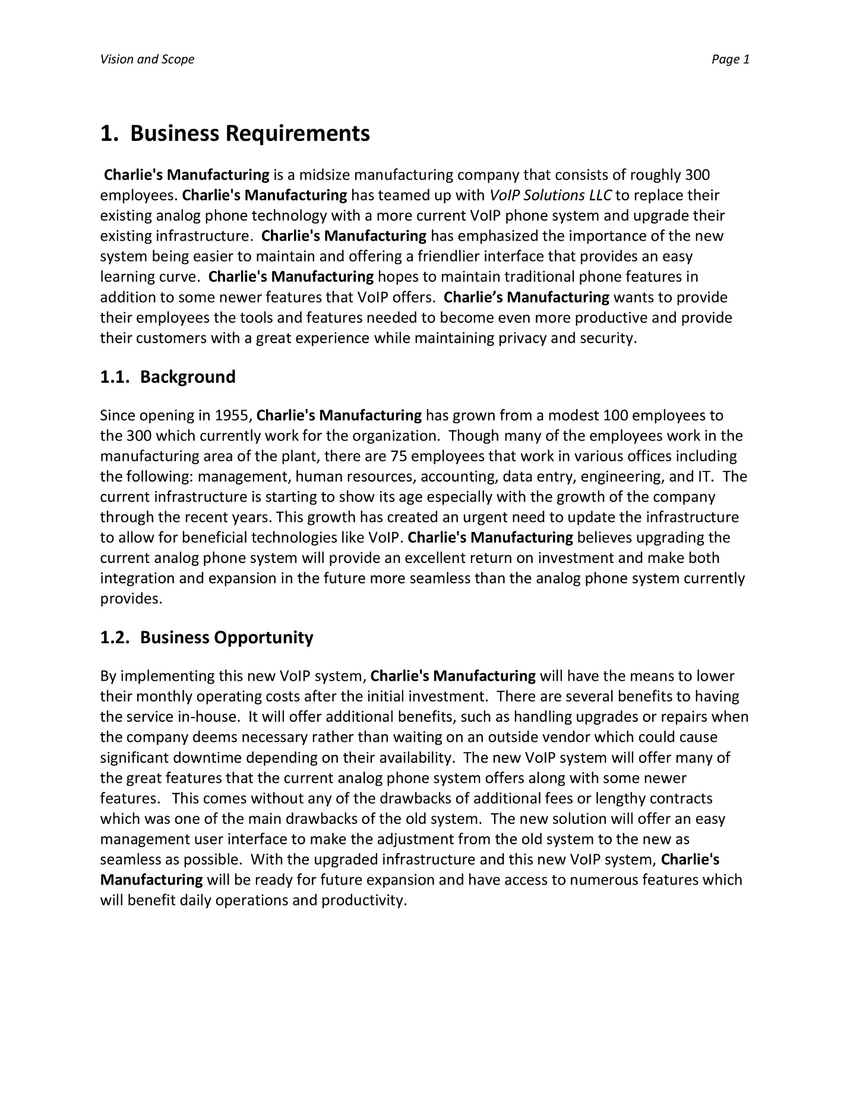

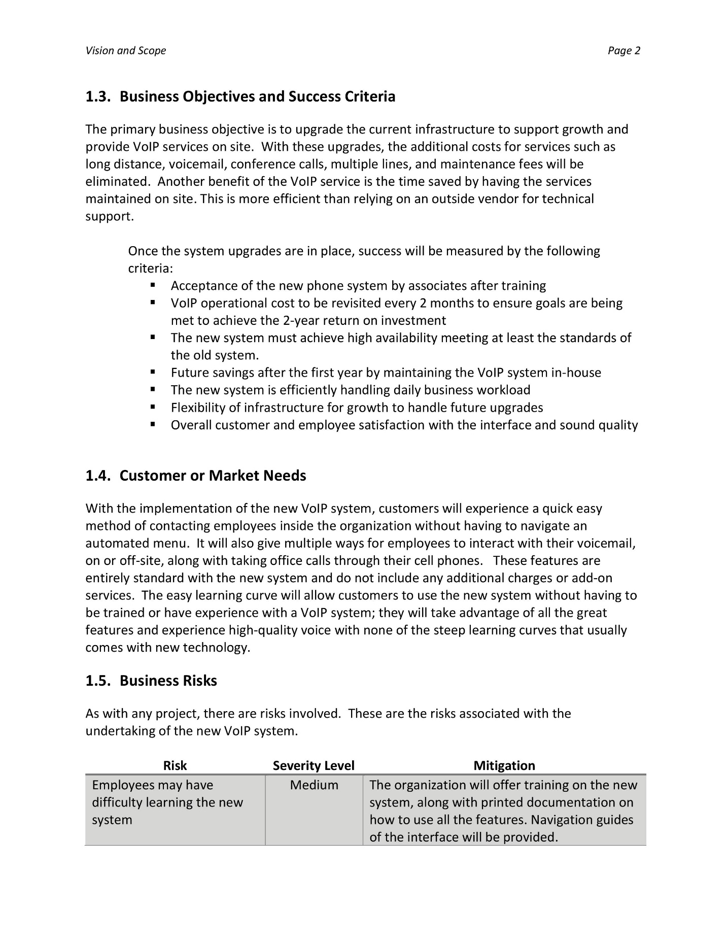

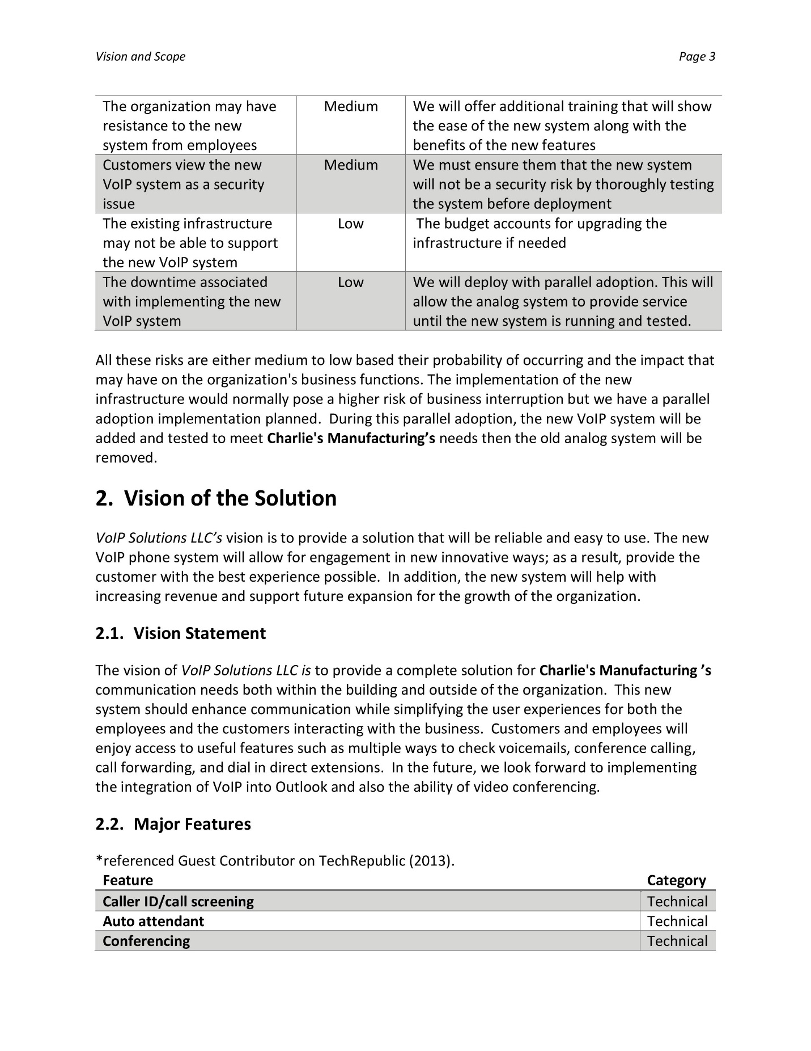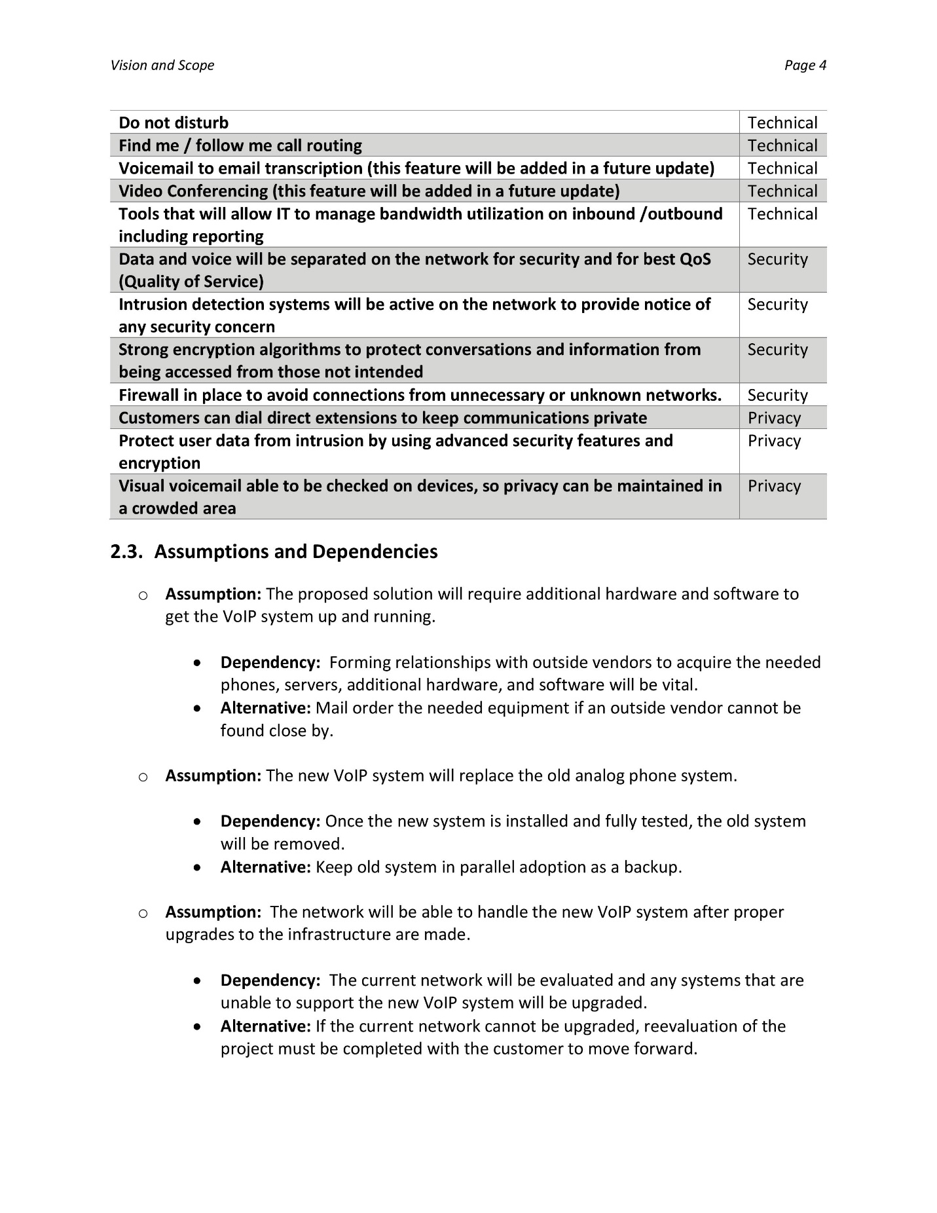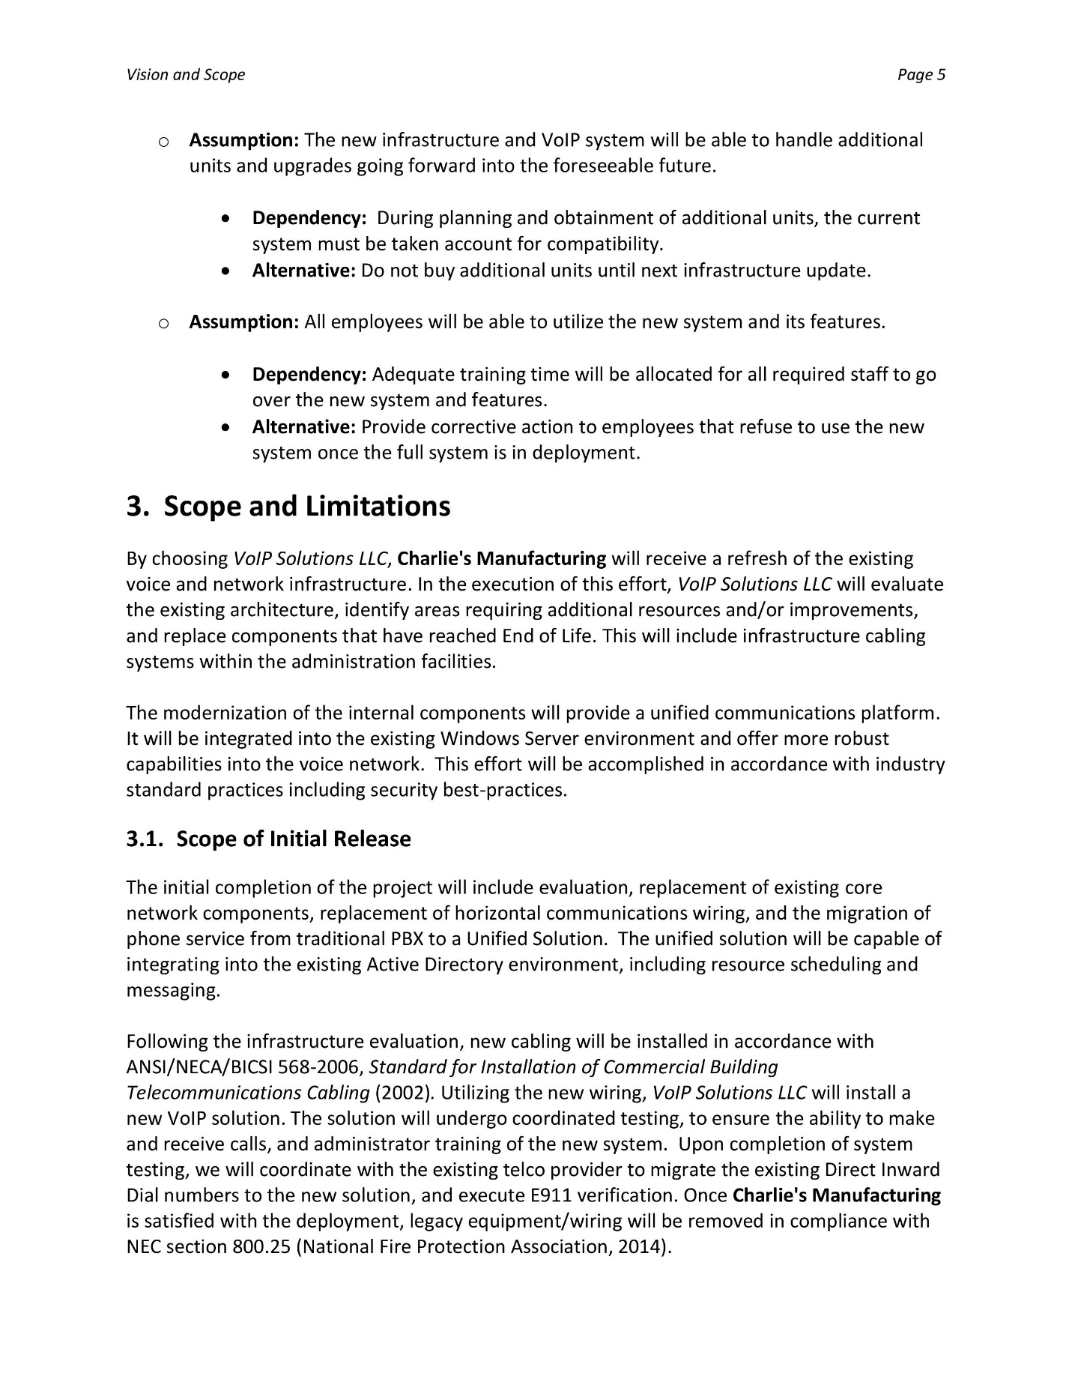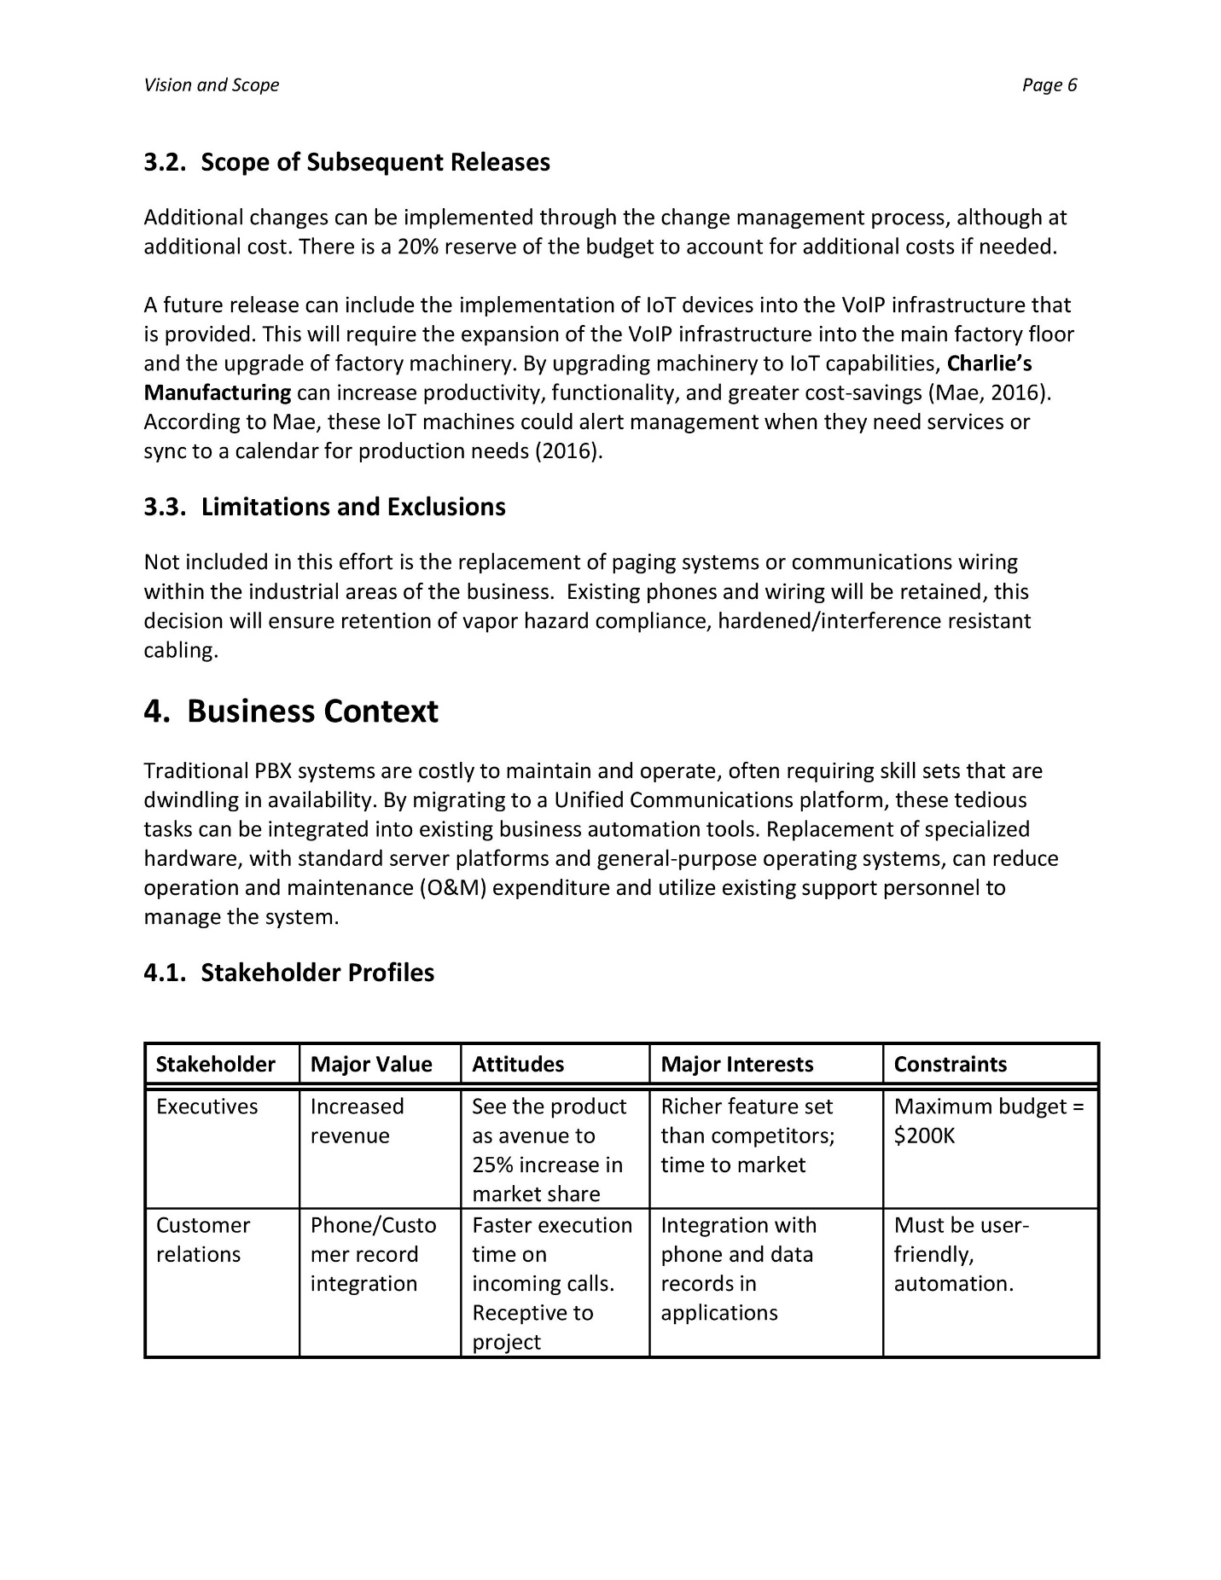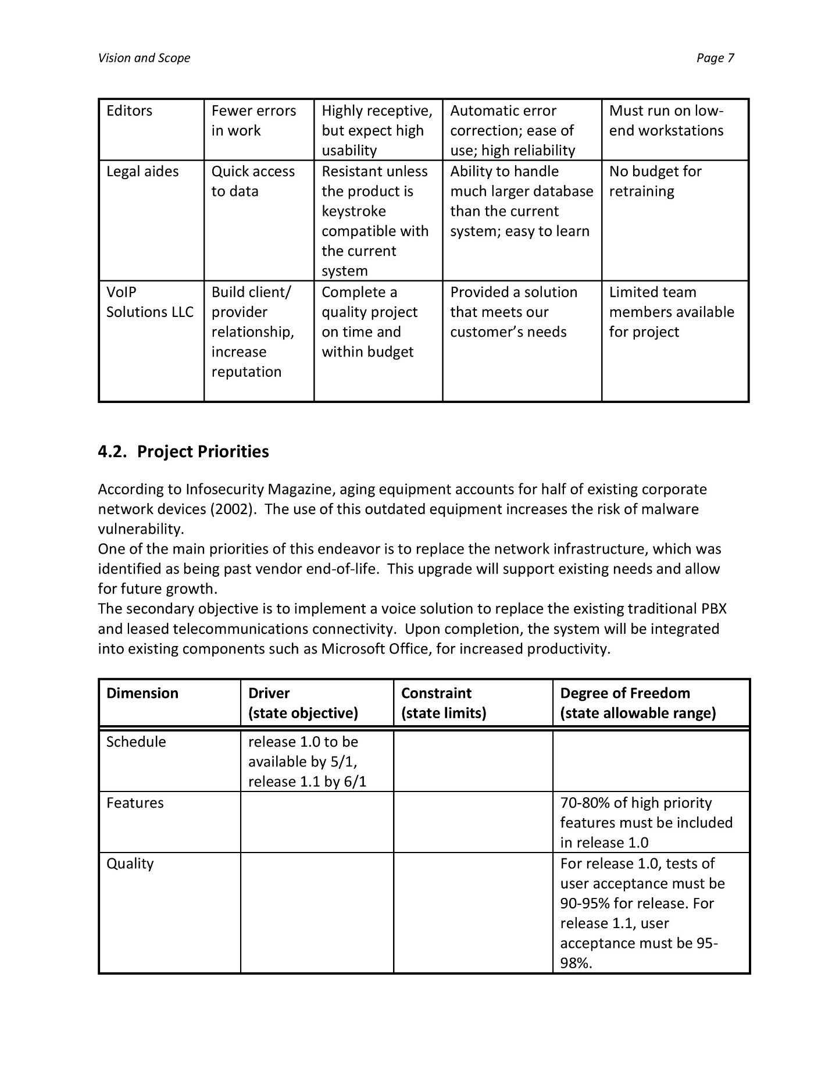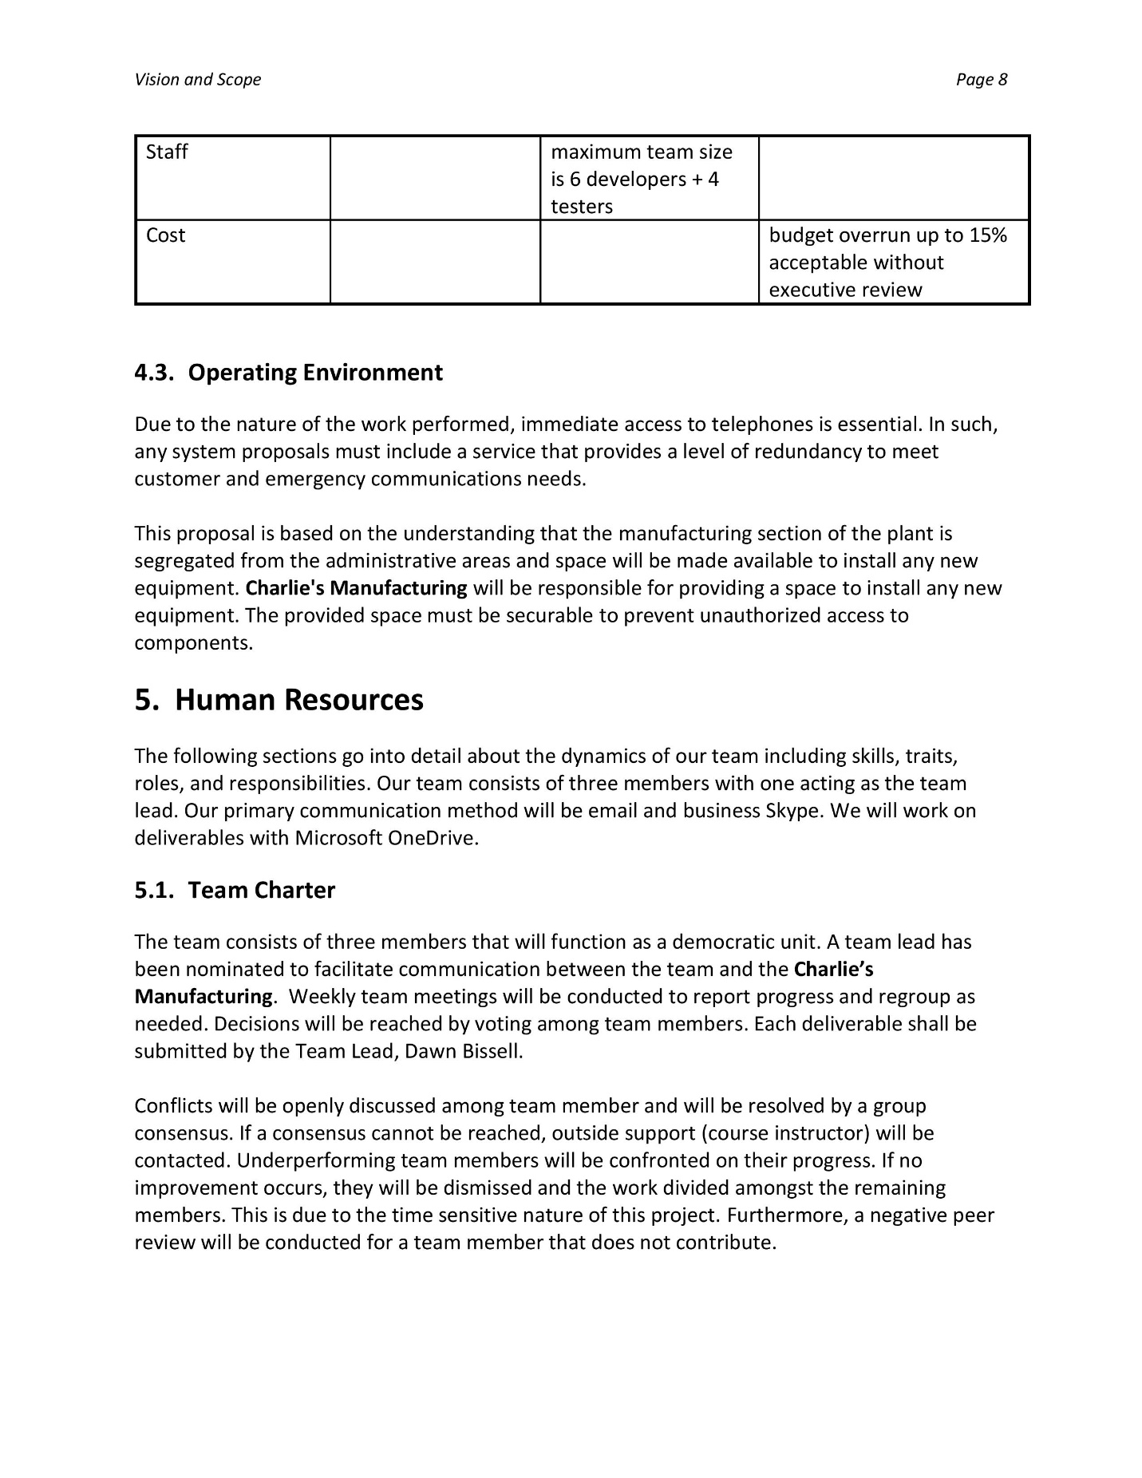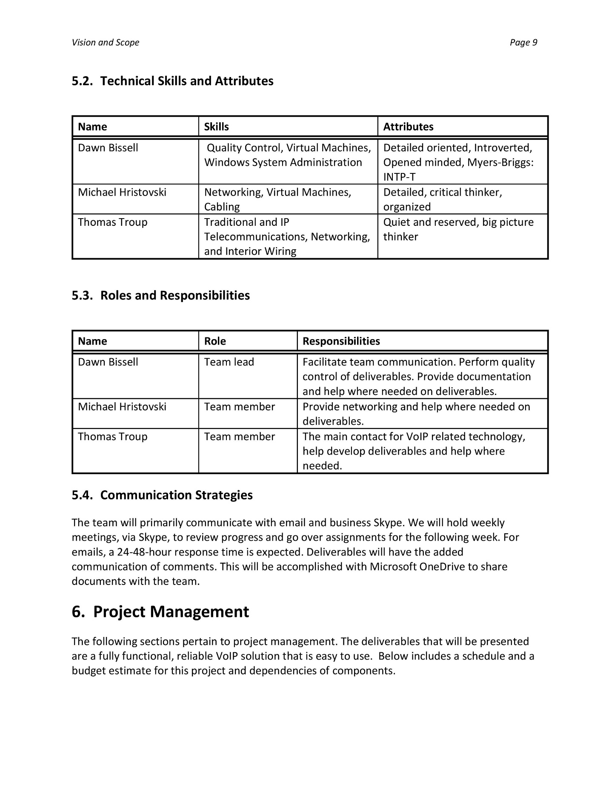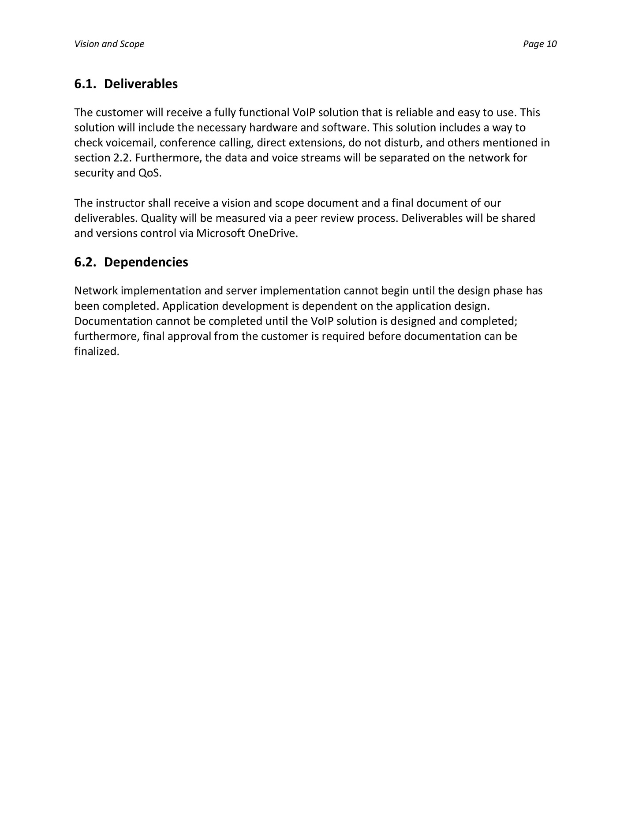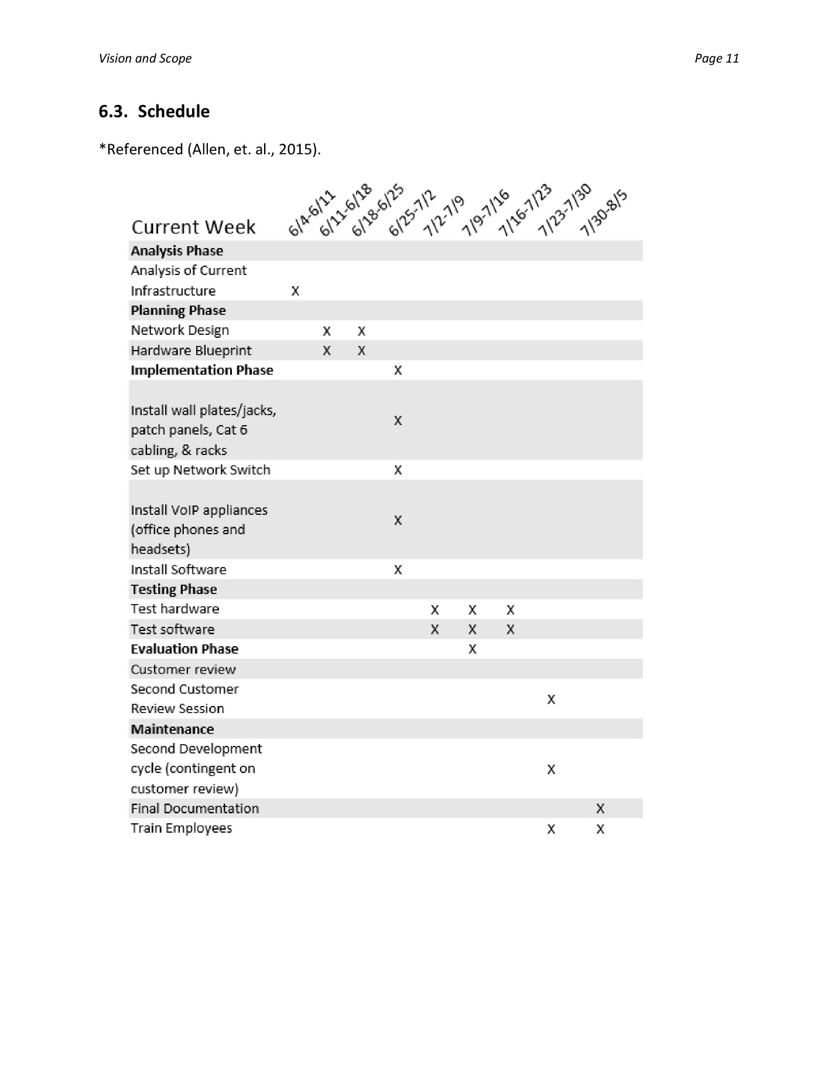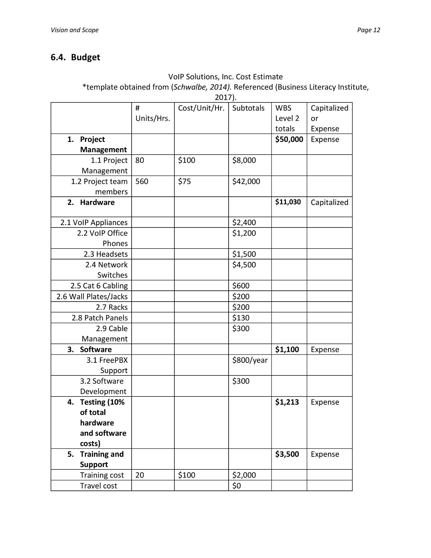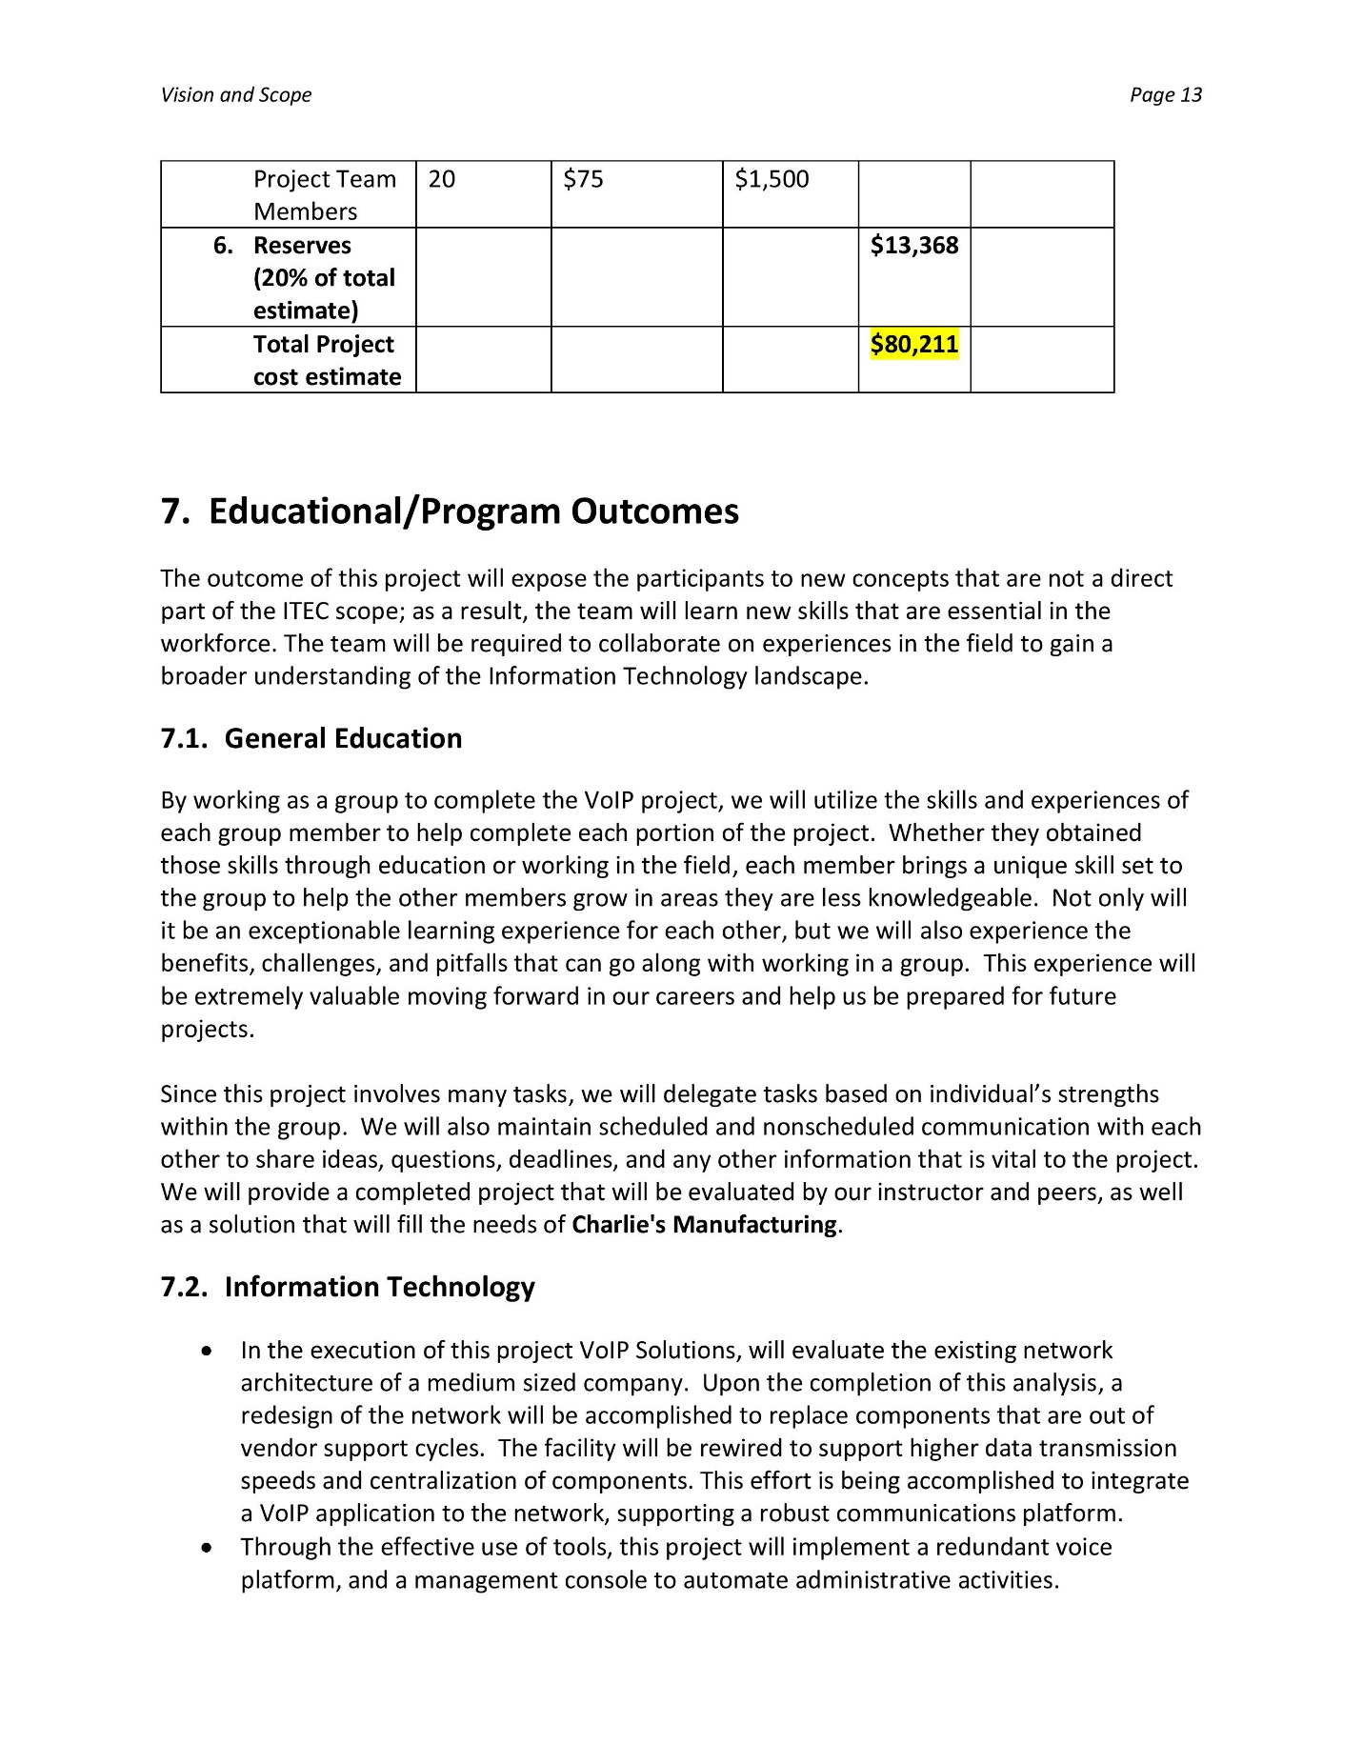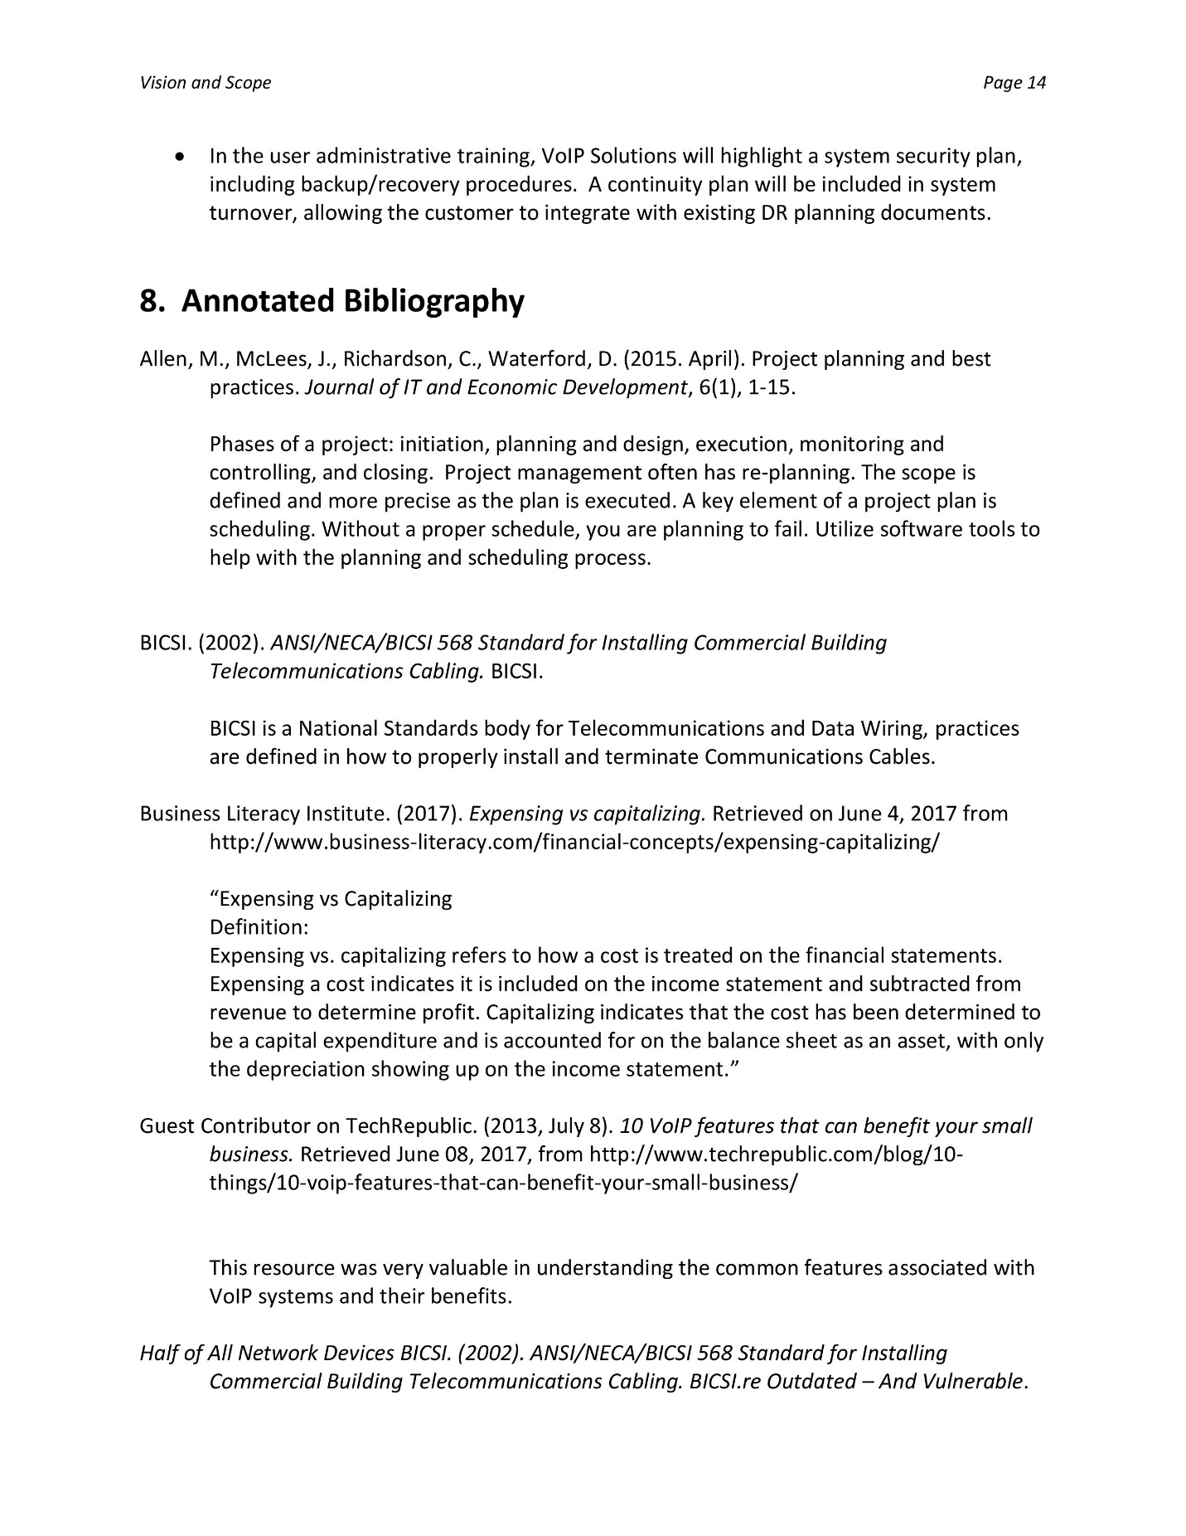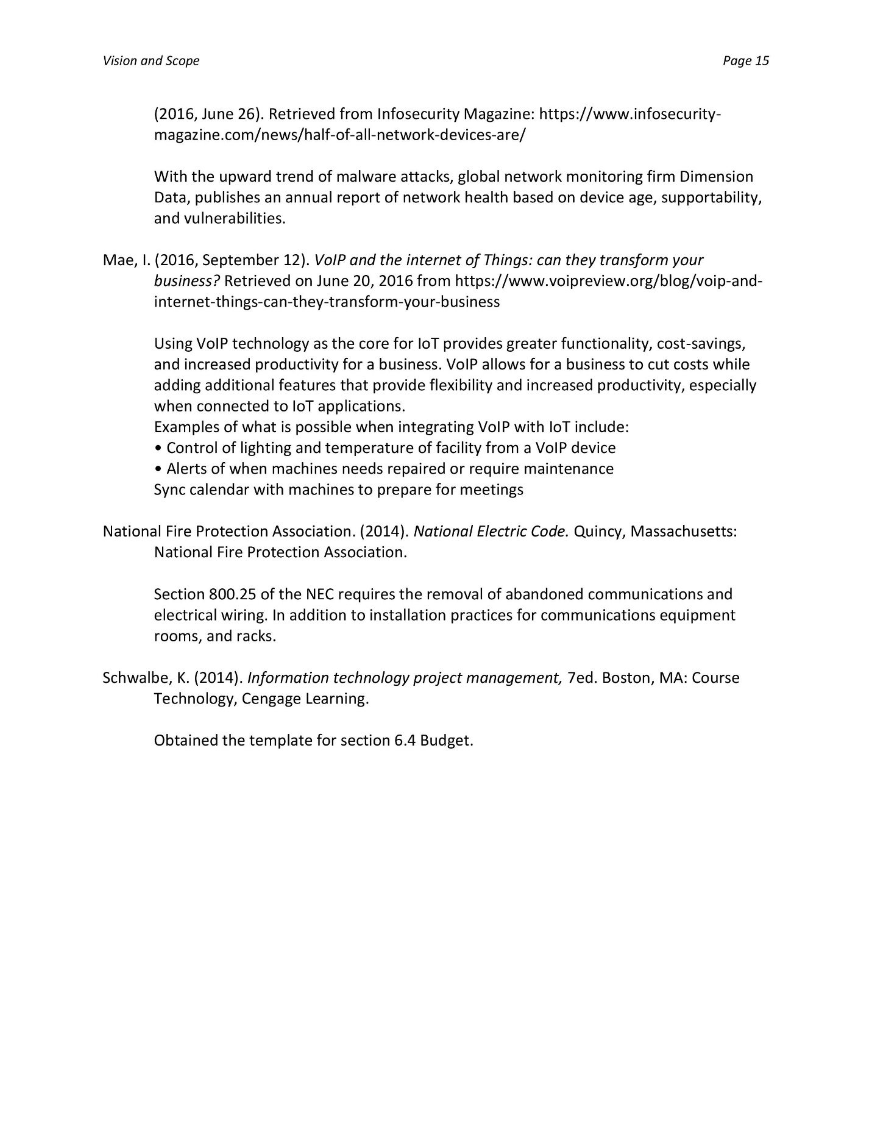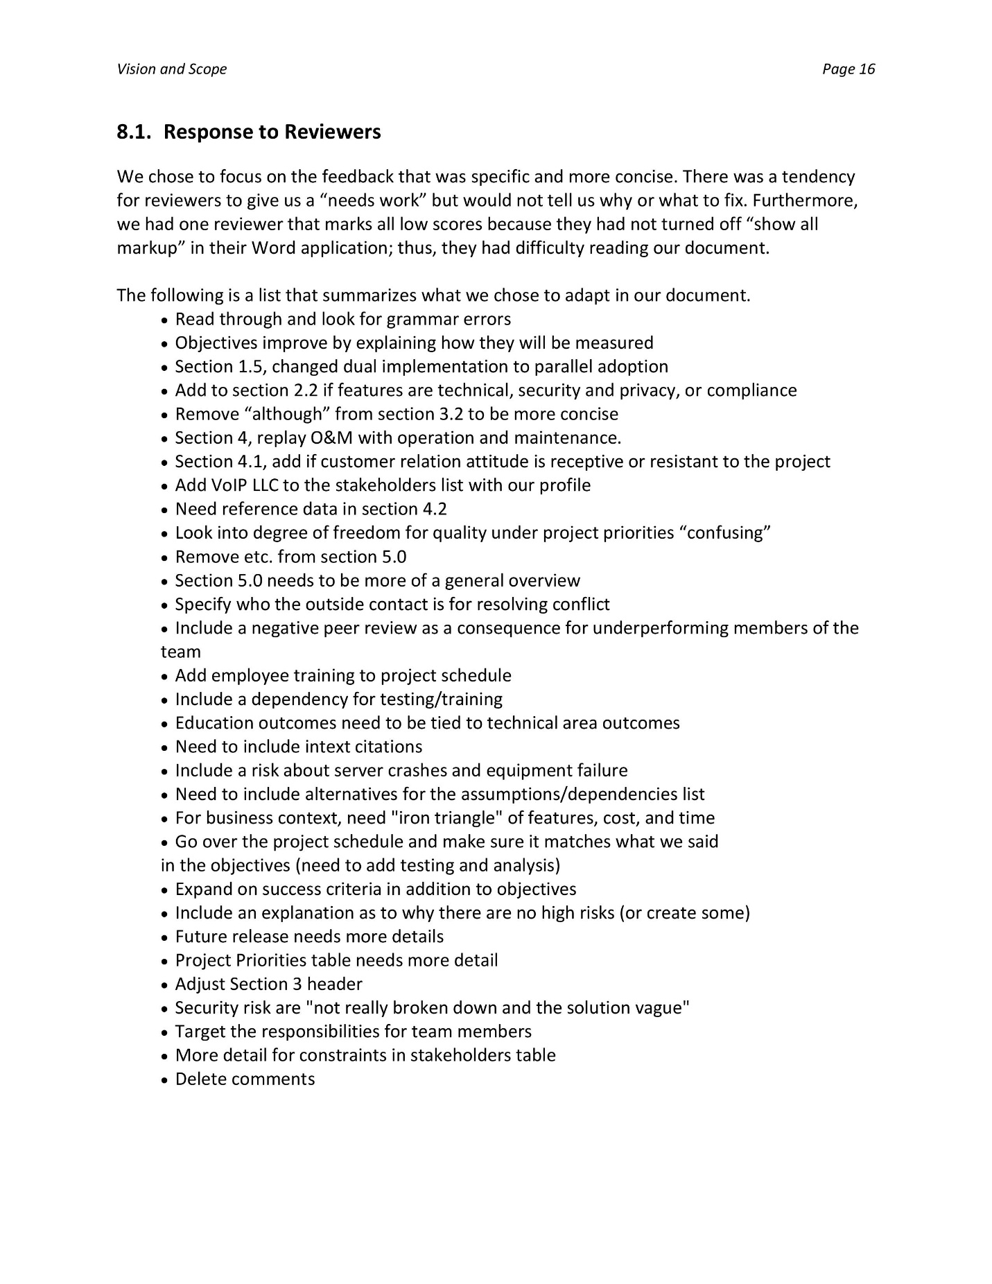

Appendix B: Presentation Slides

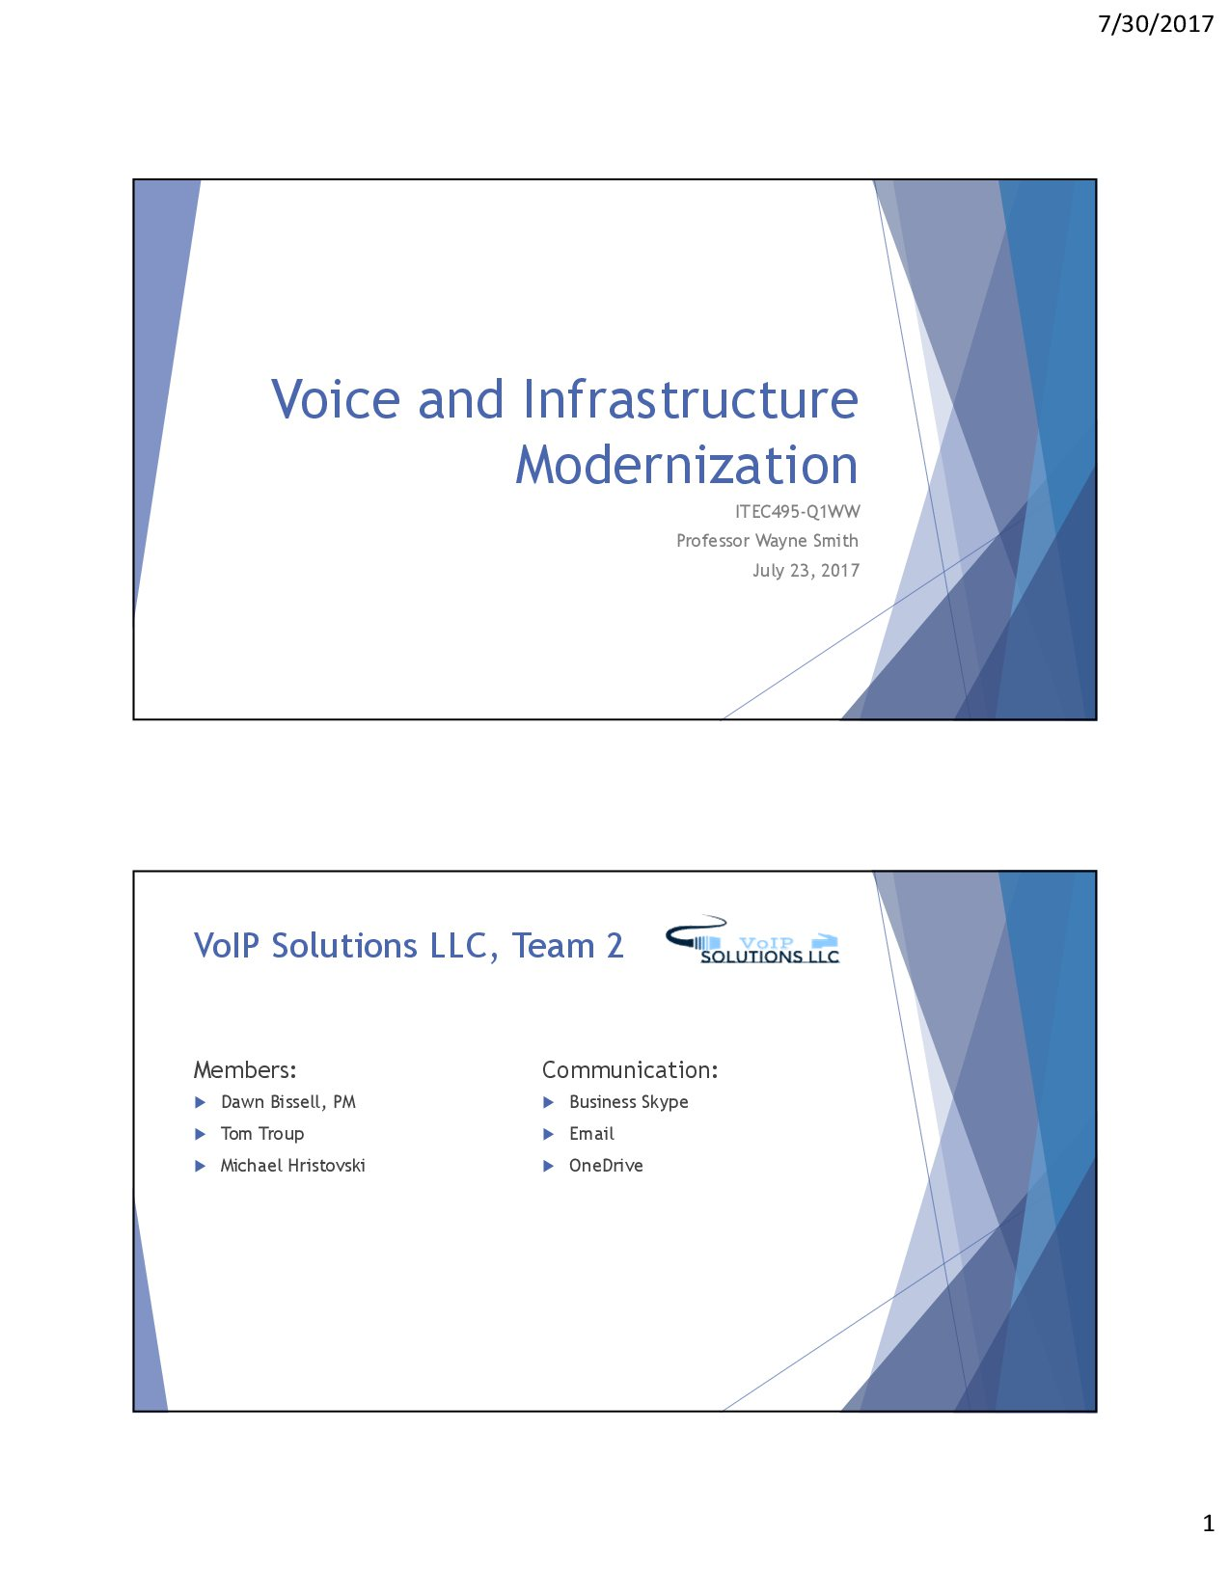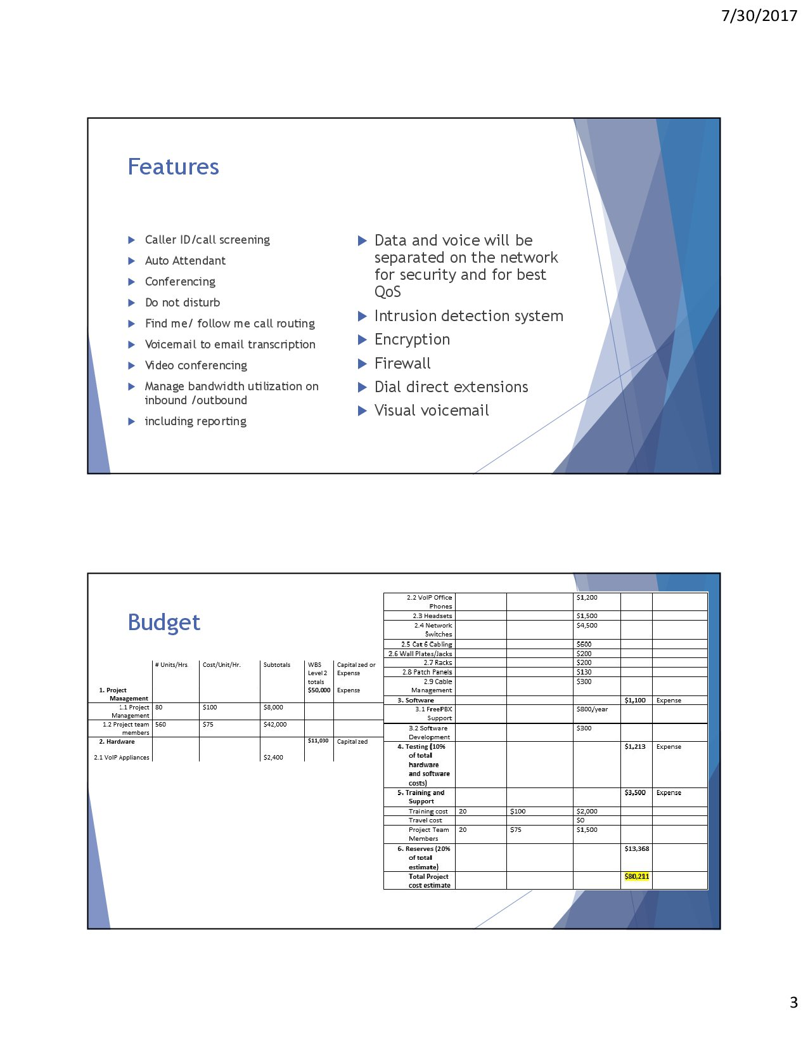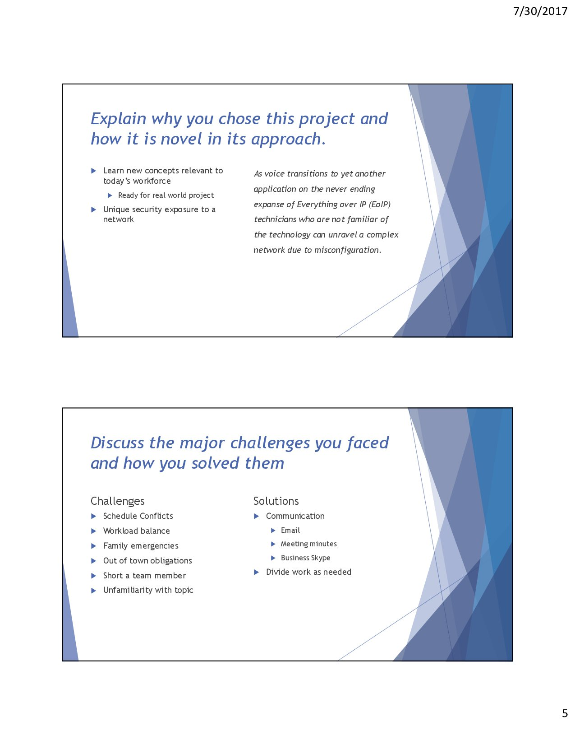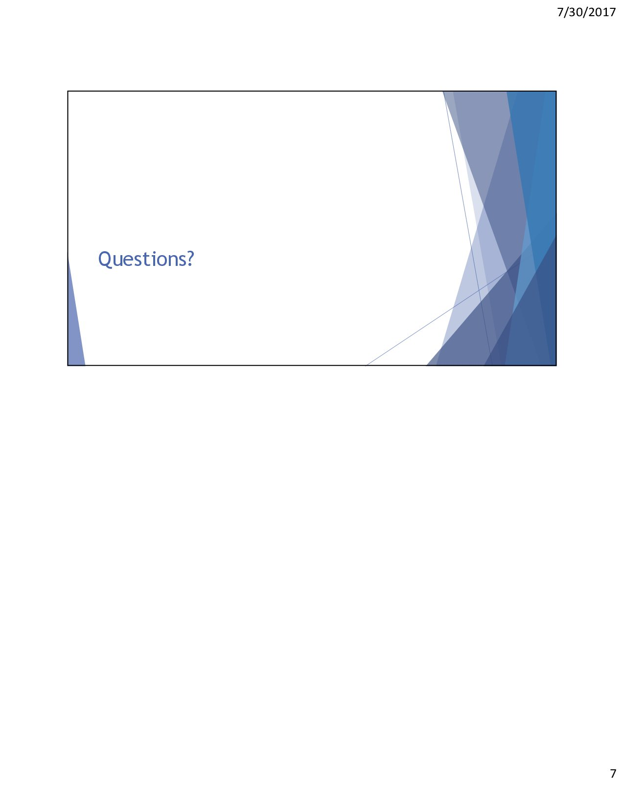

Appendix C: Other Deliverables/Artifacts

White Paper: Remote Access of IoT Devices Via VoIP
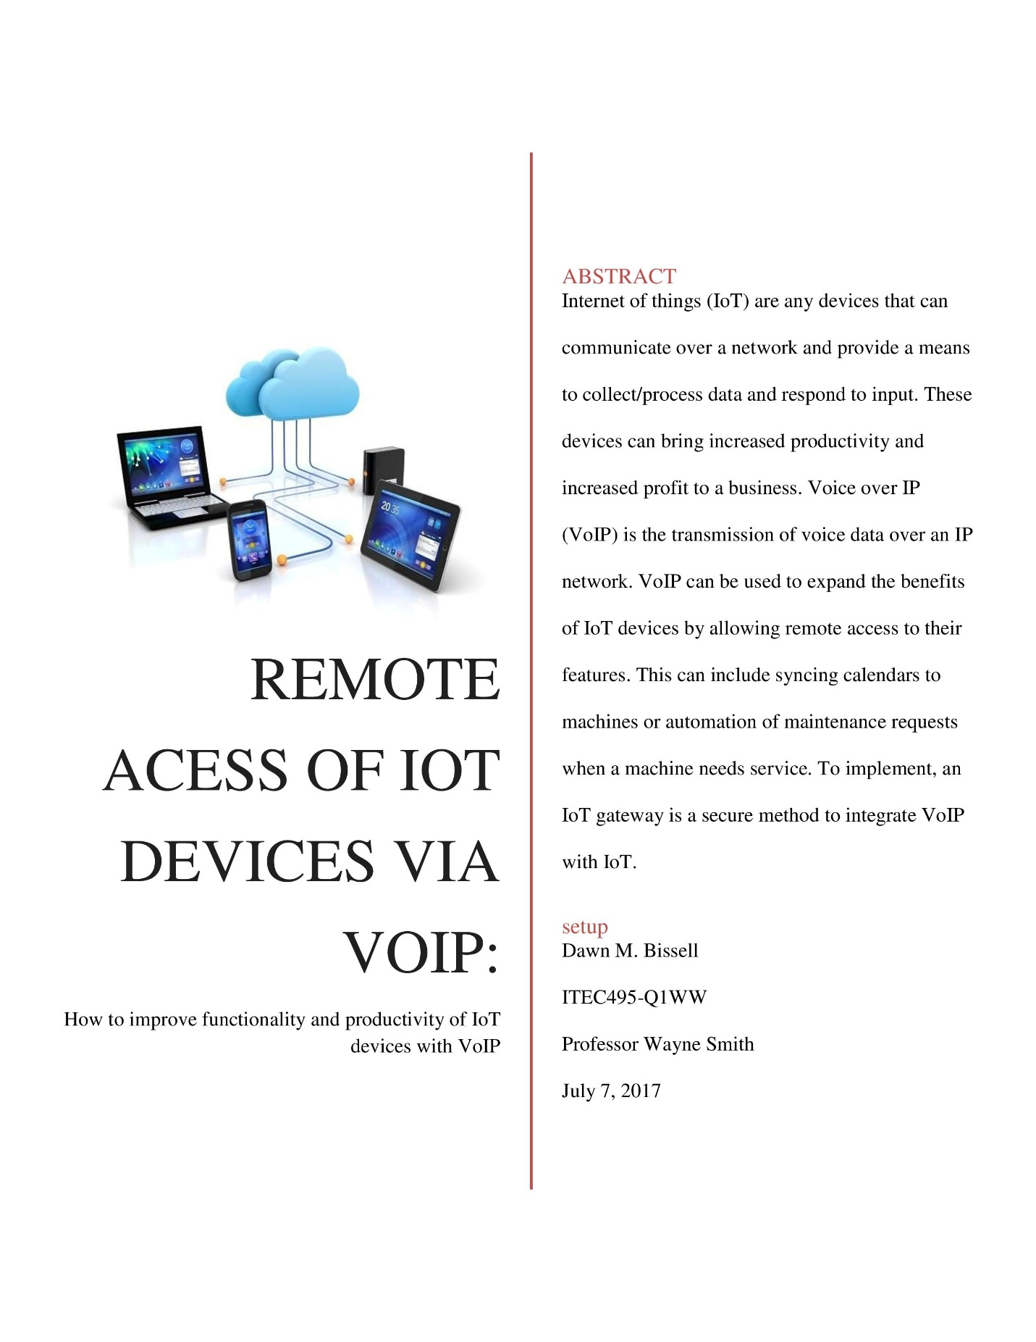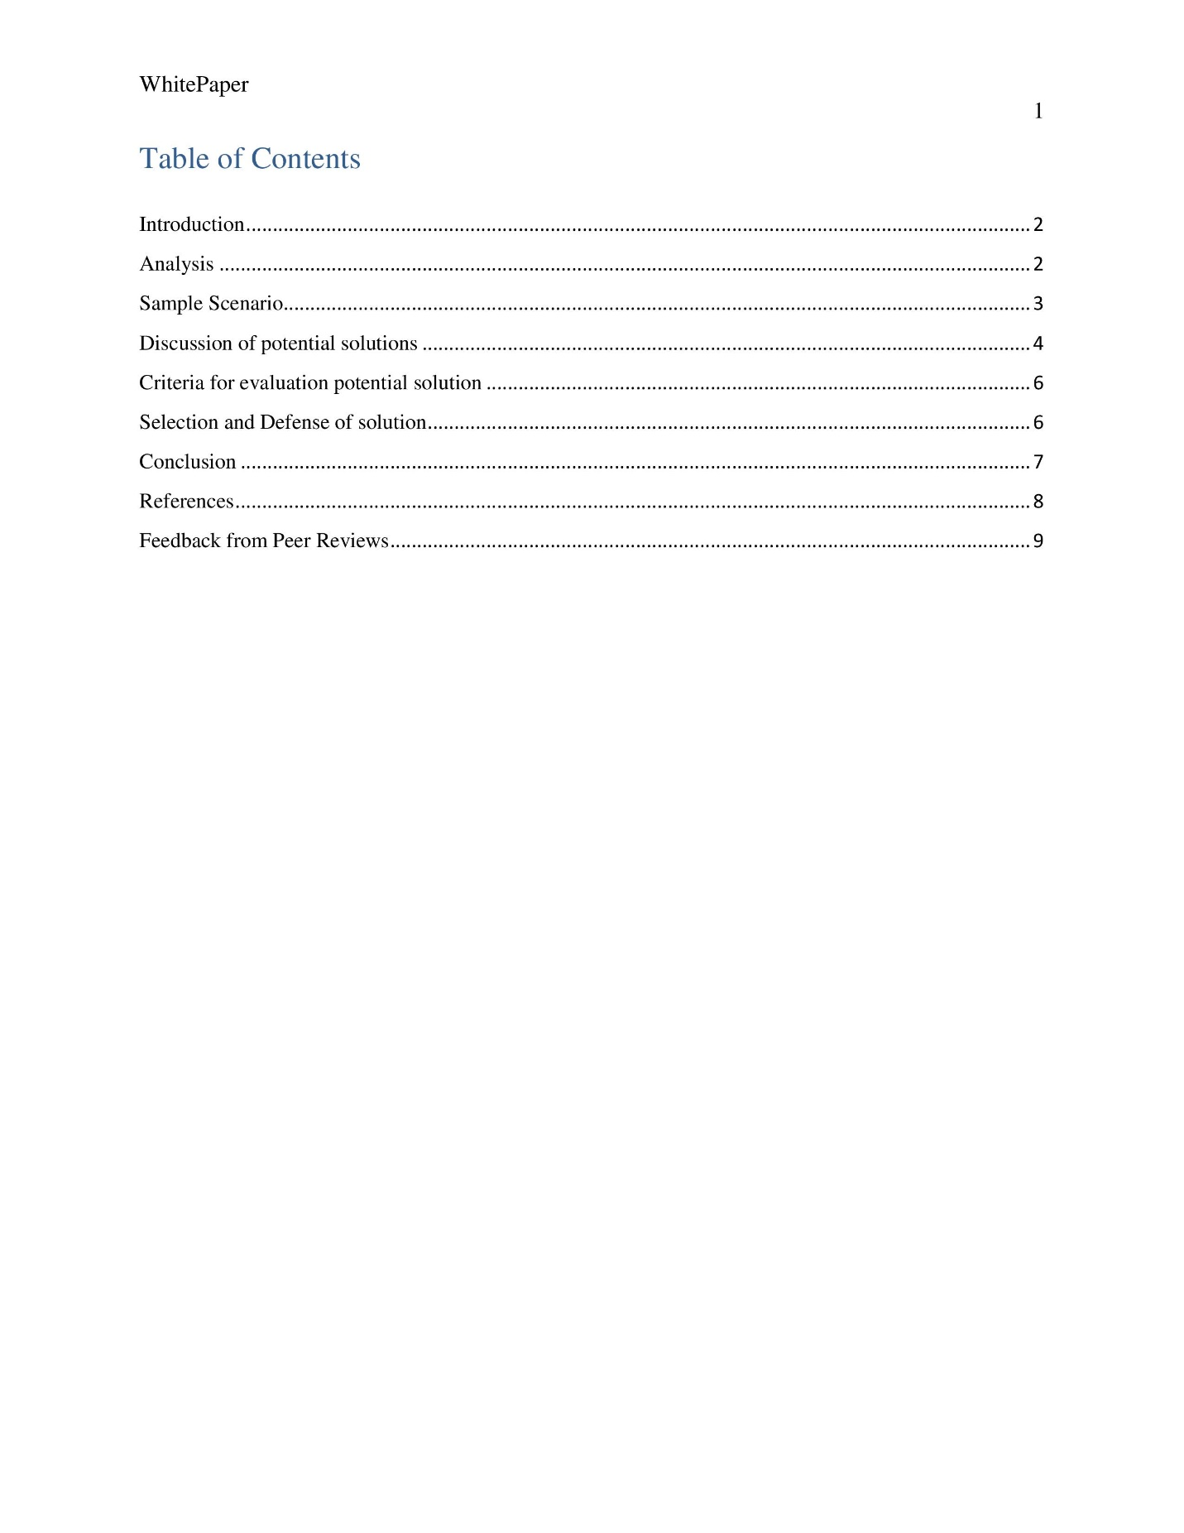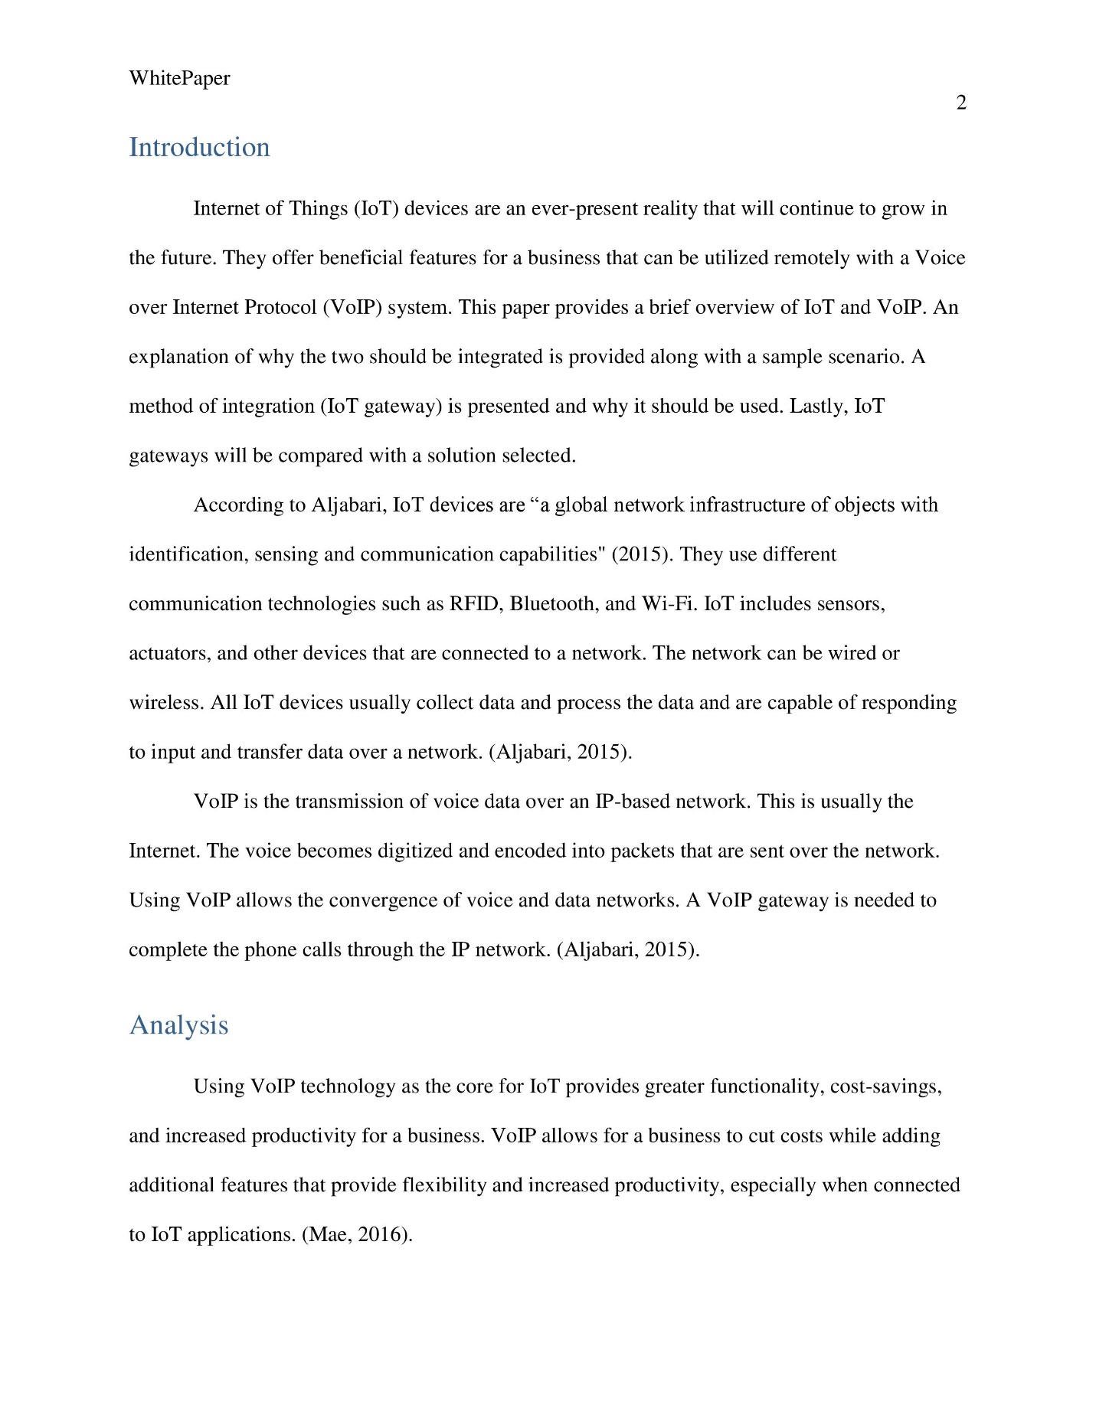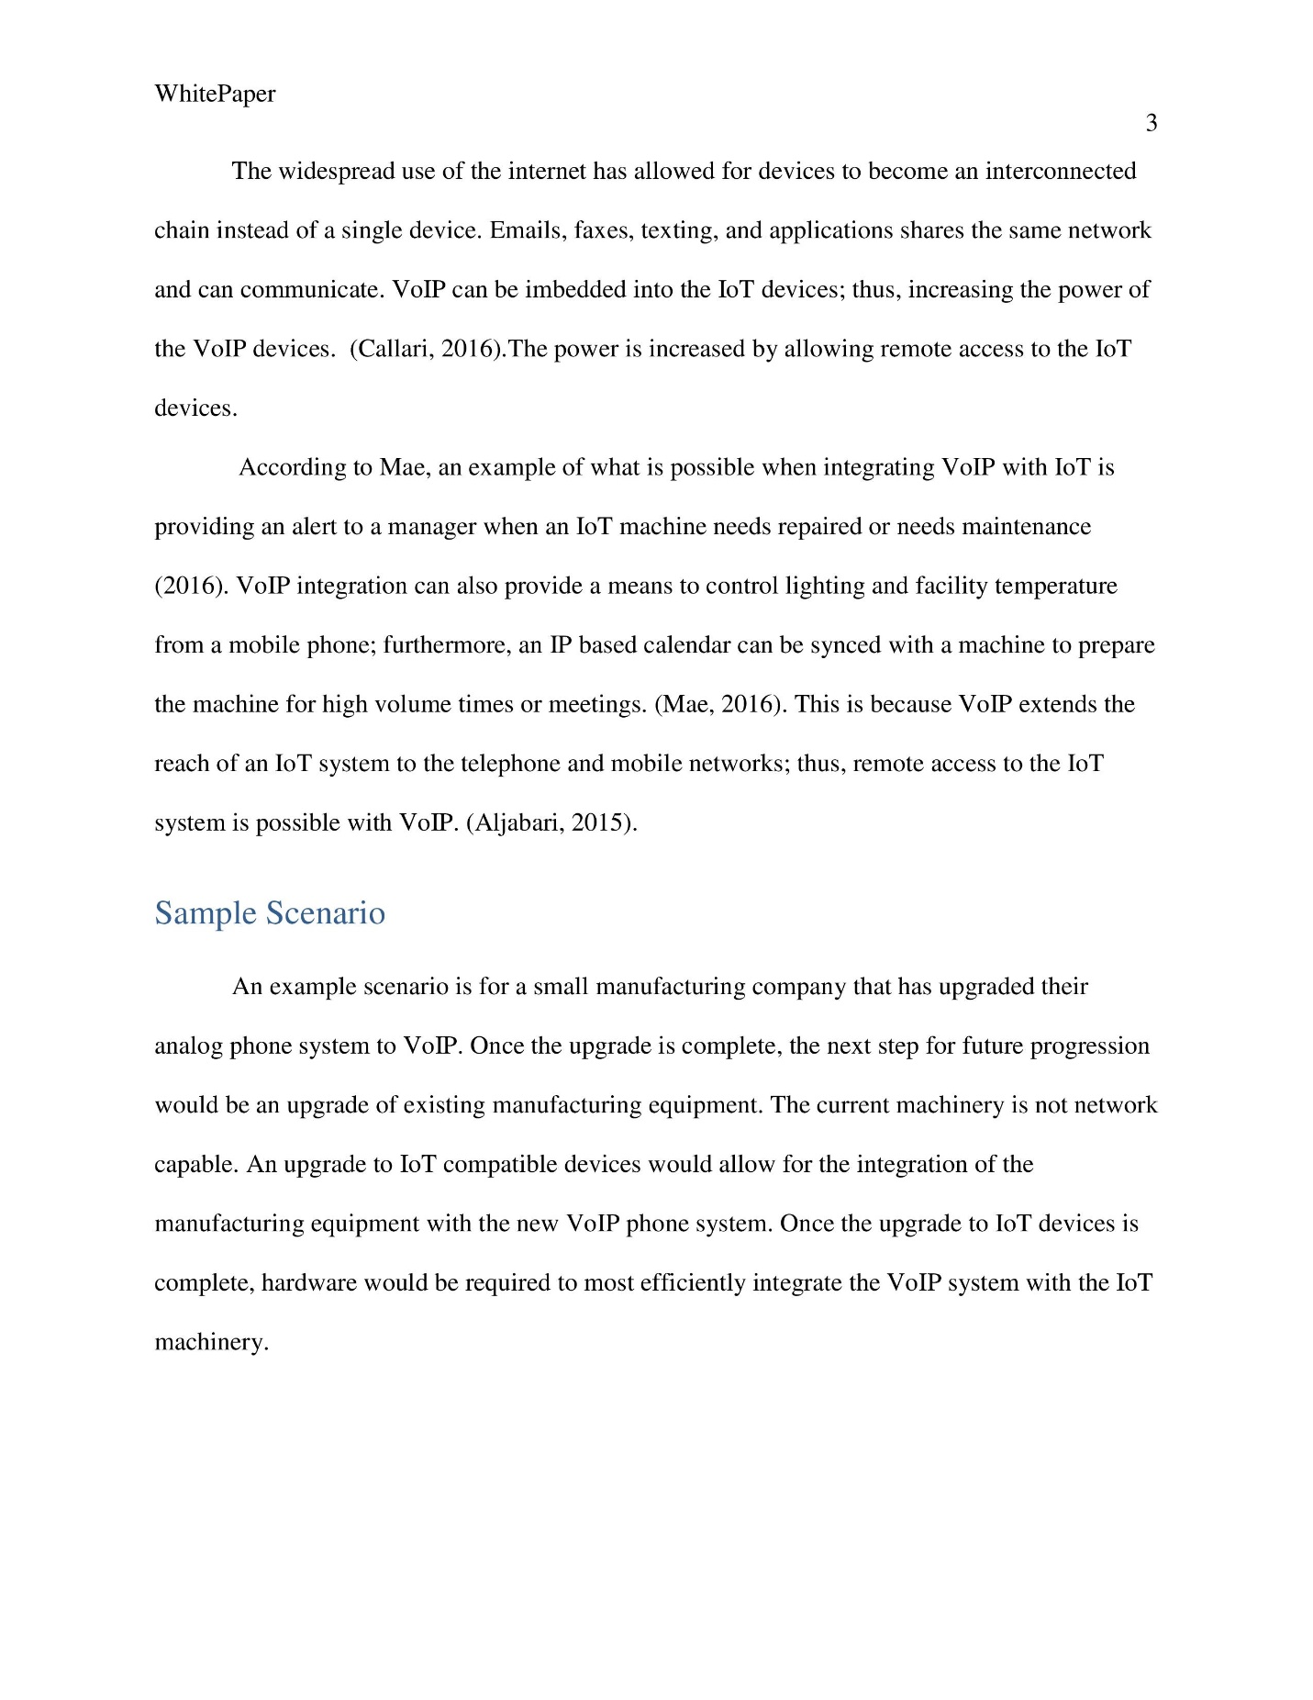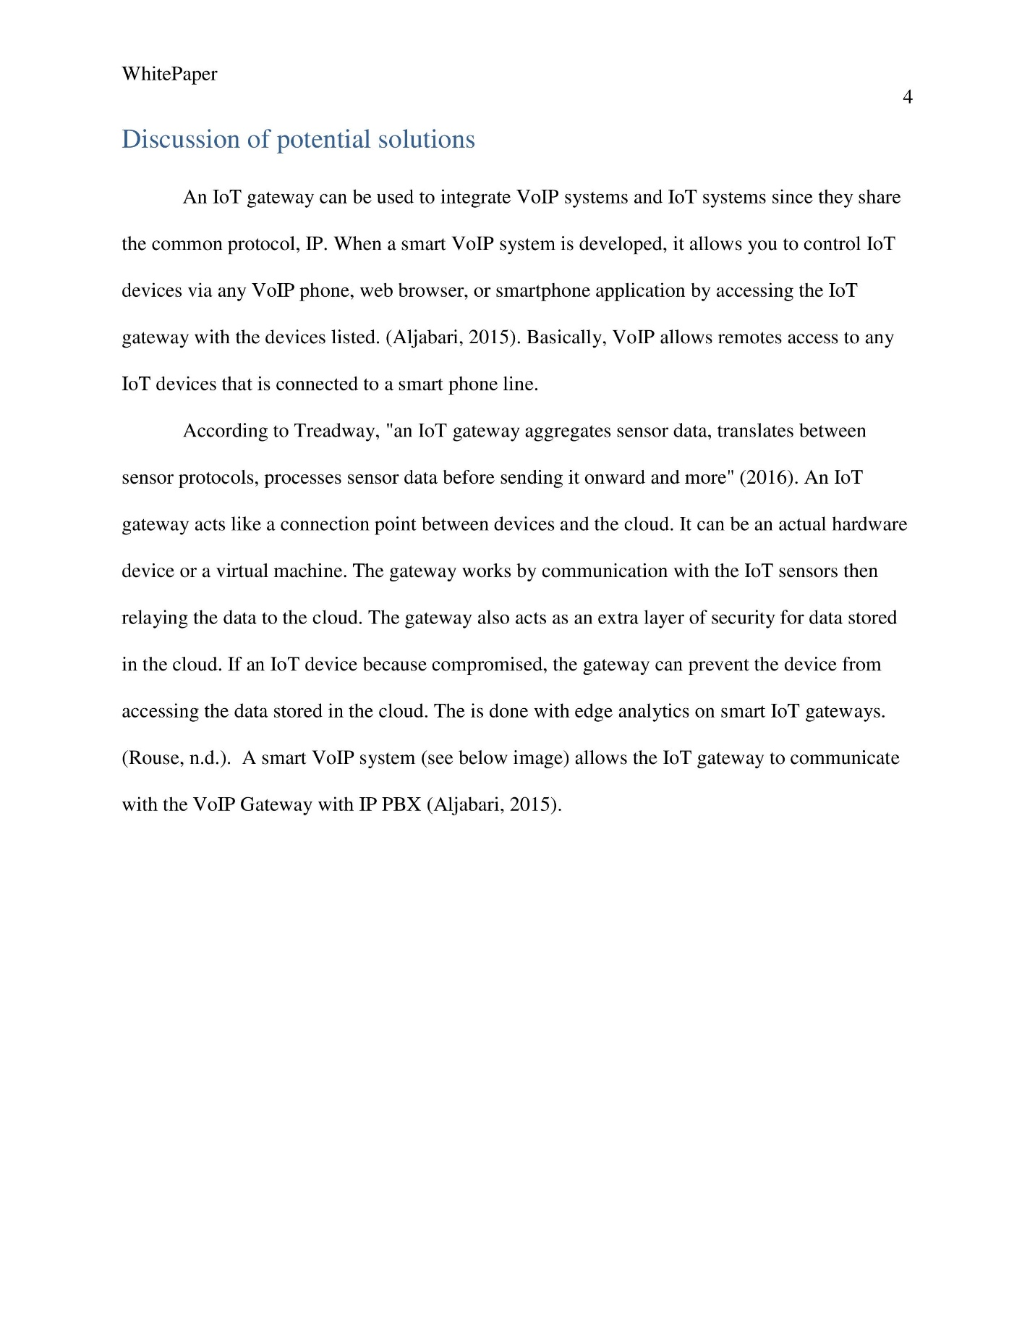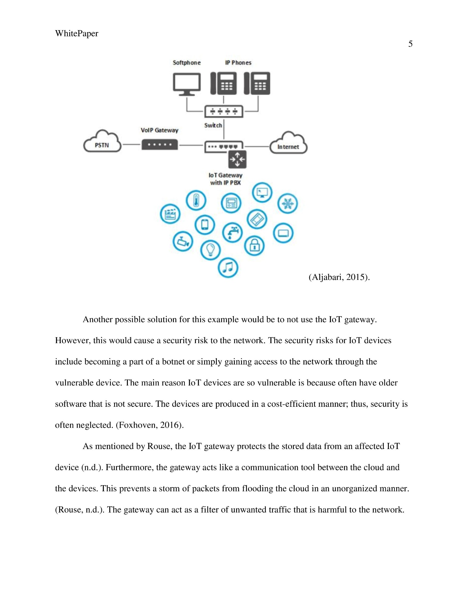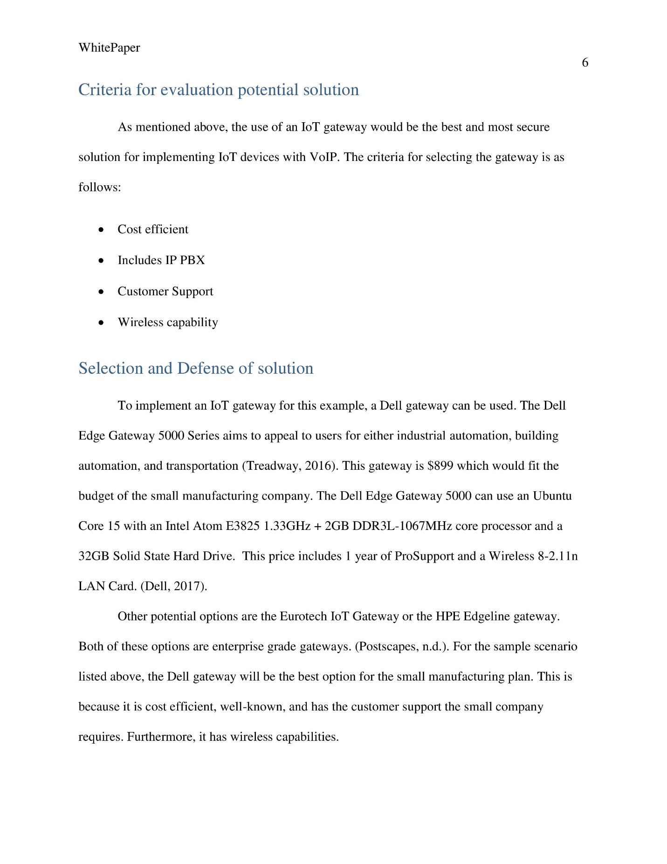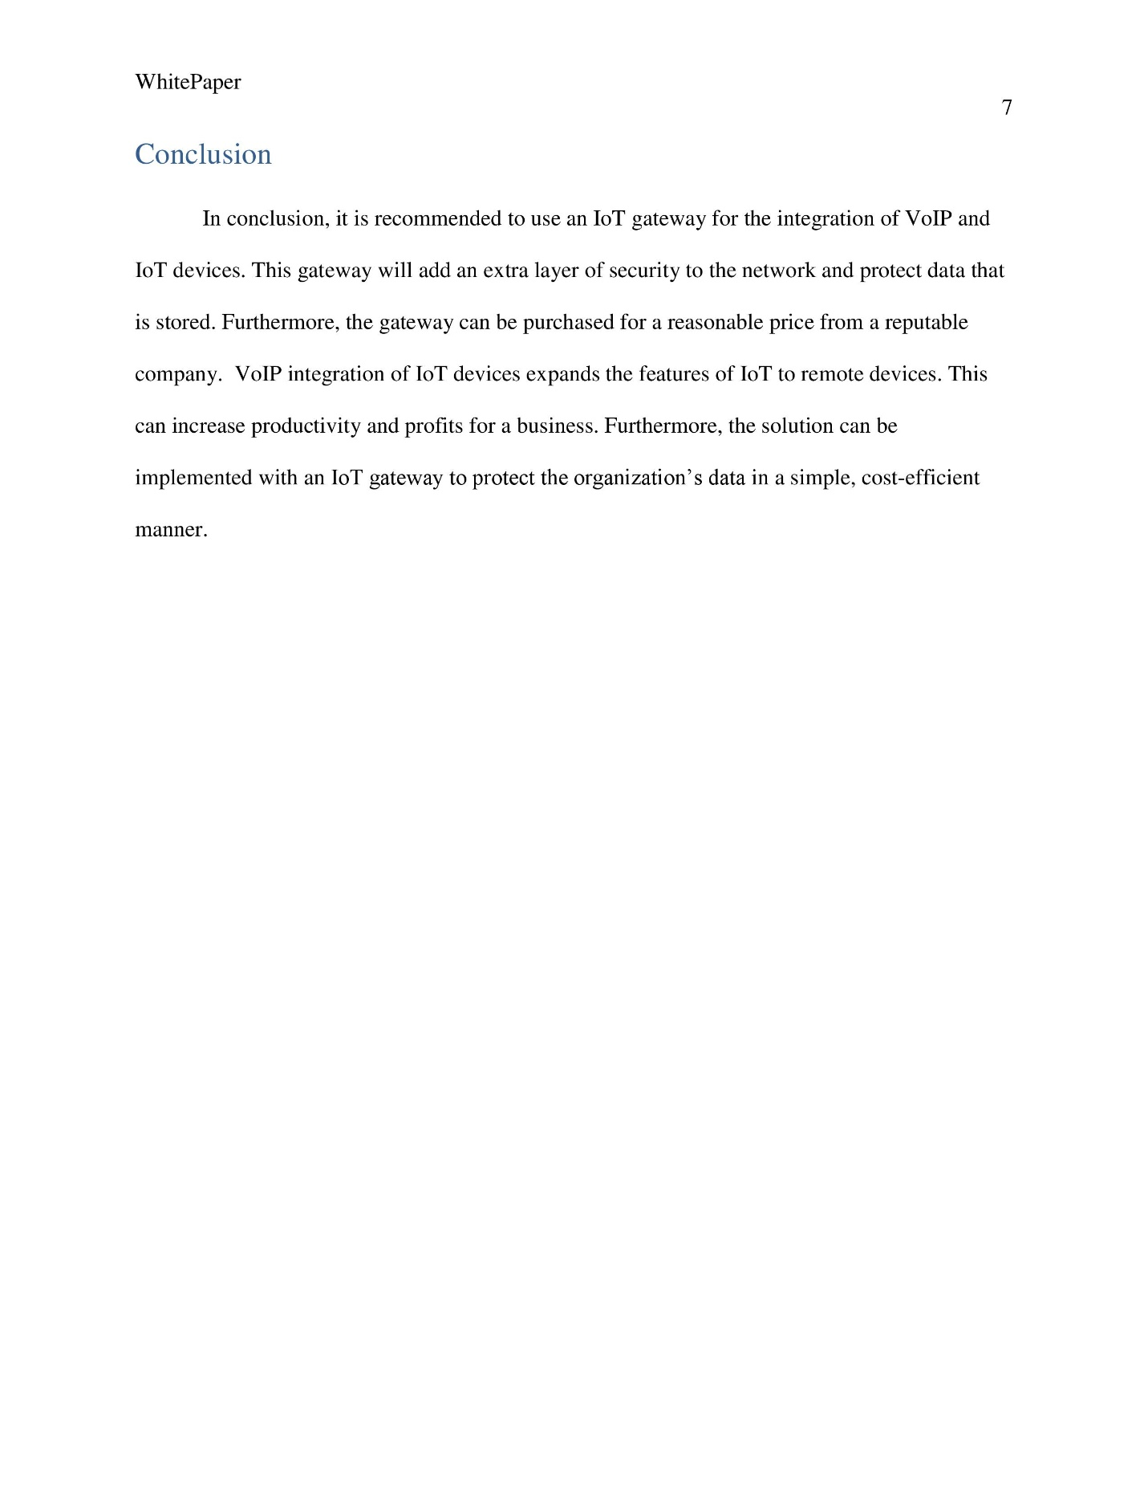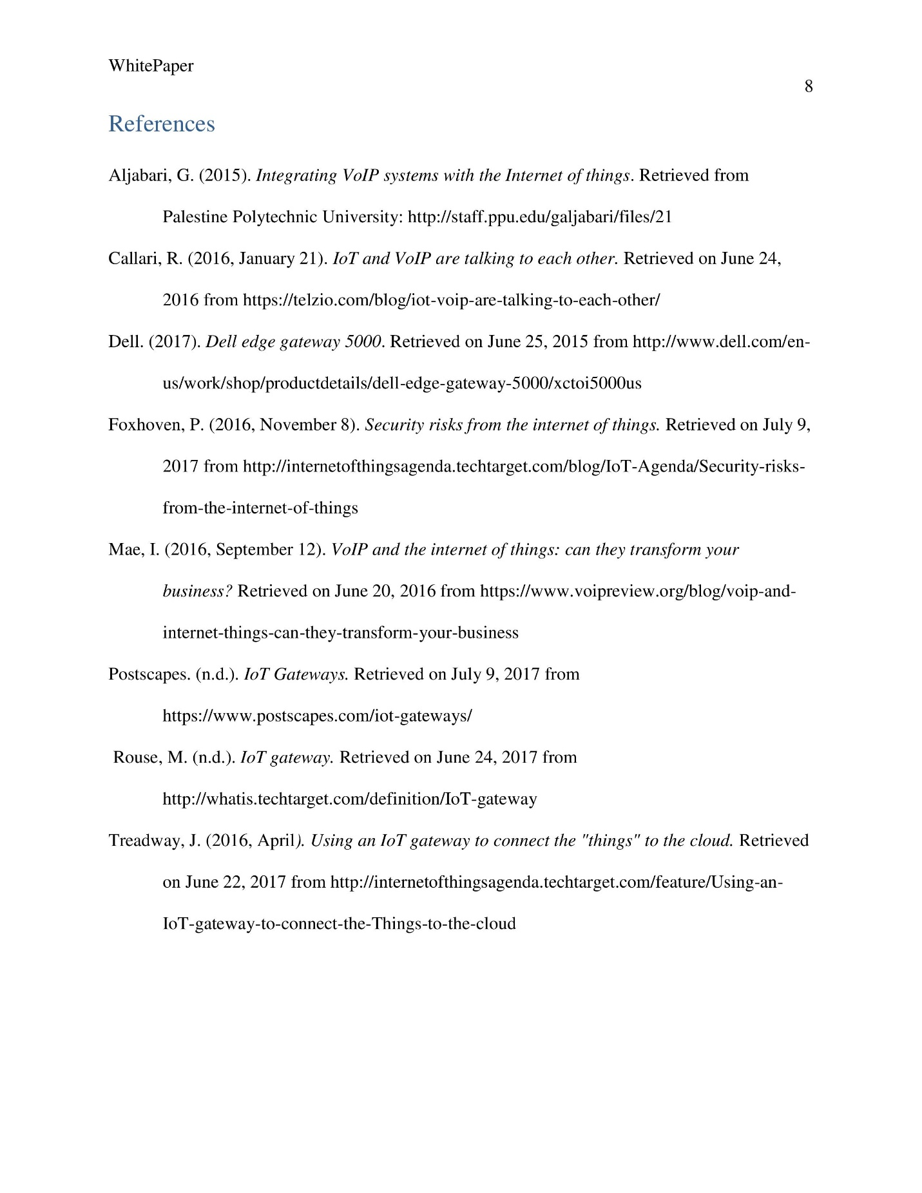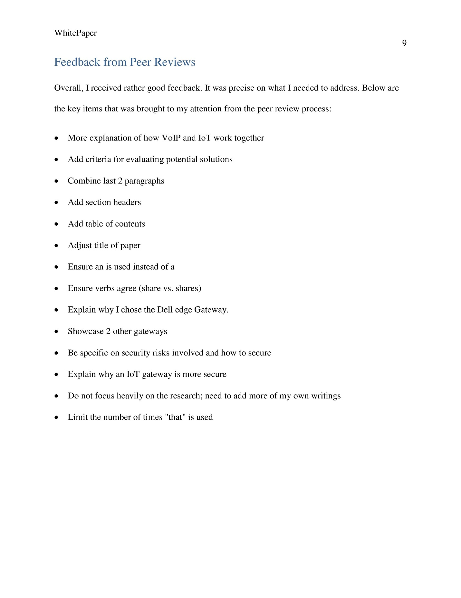

White Paper: Security Challenges in VoIP Systems

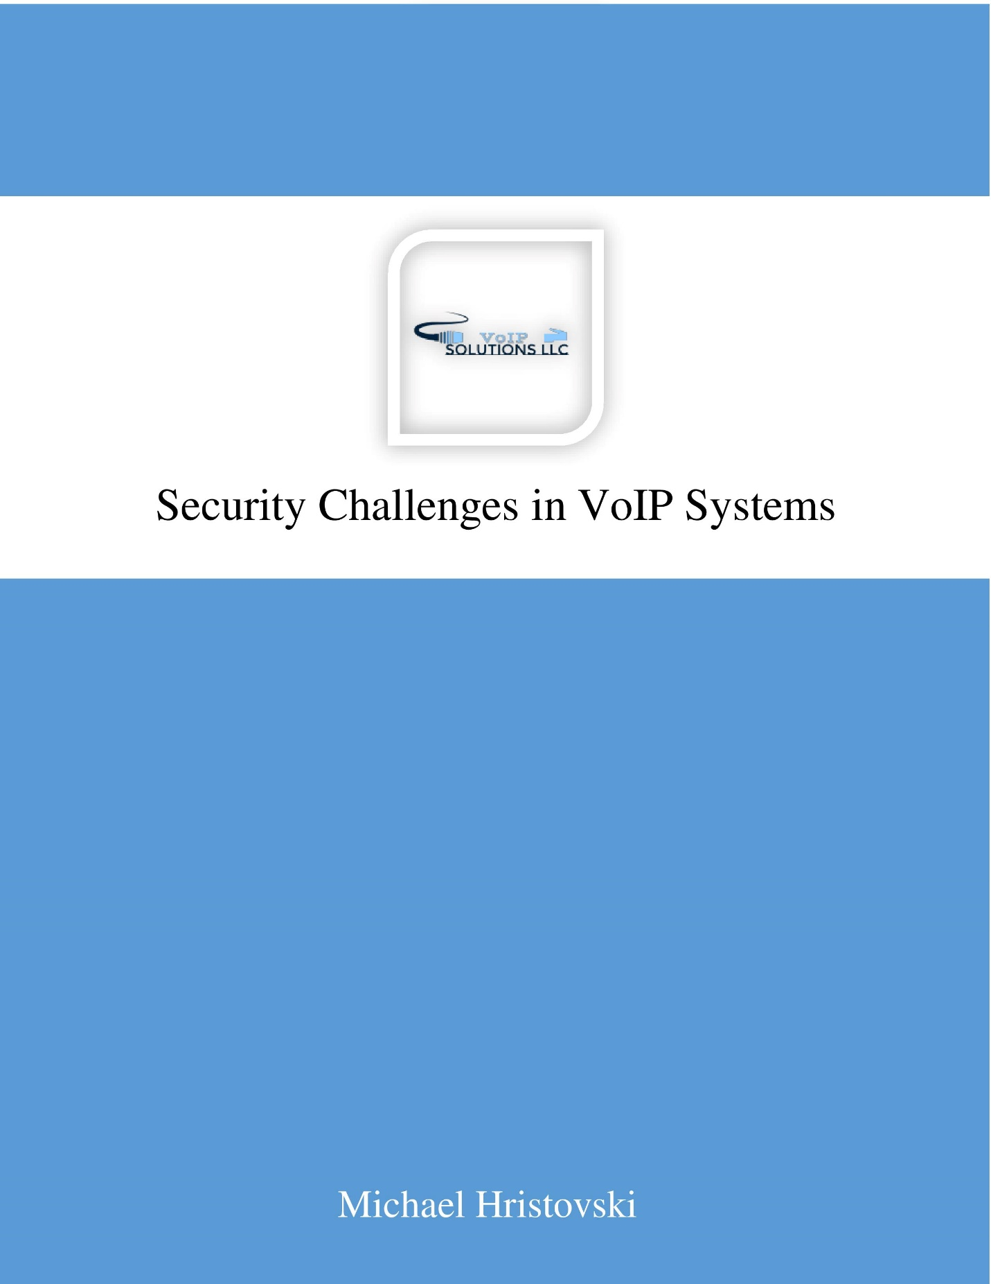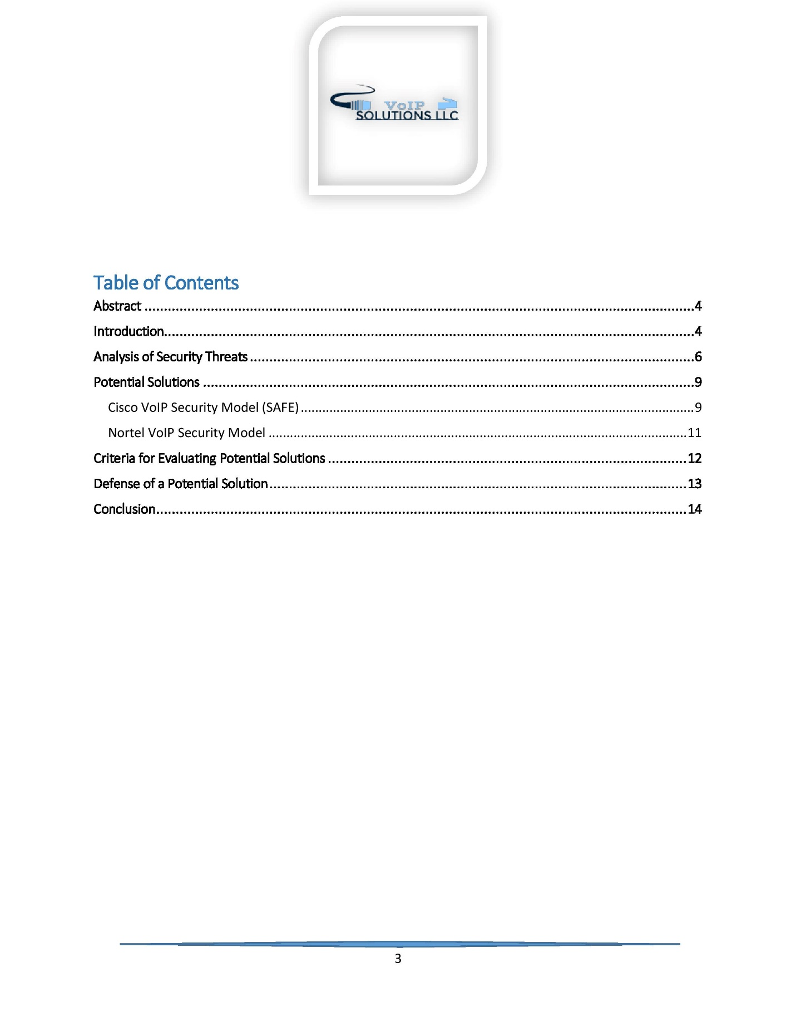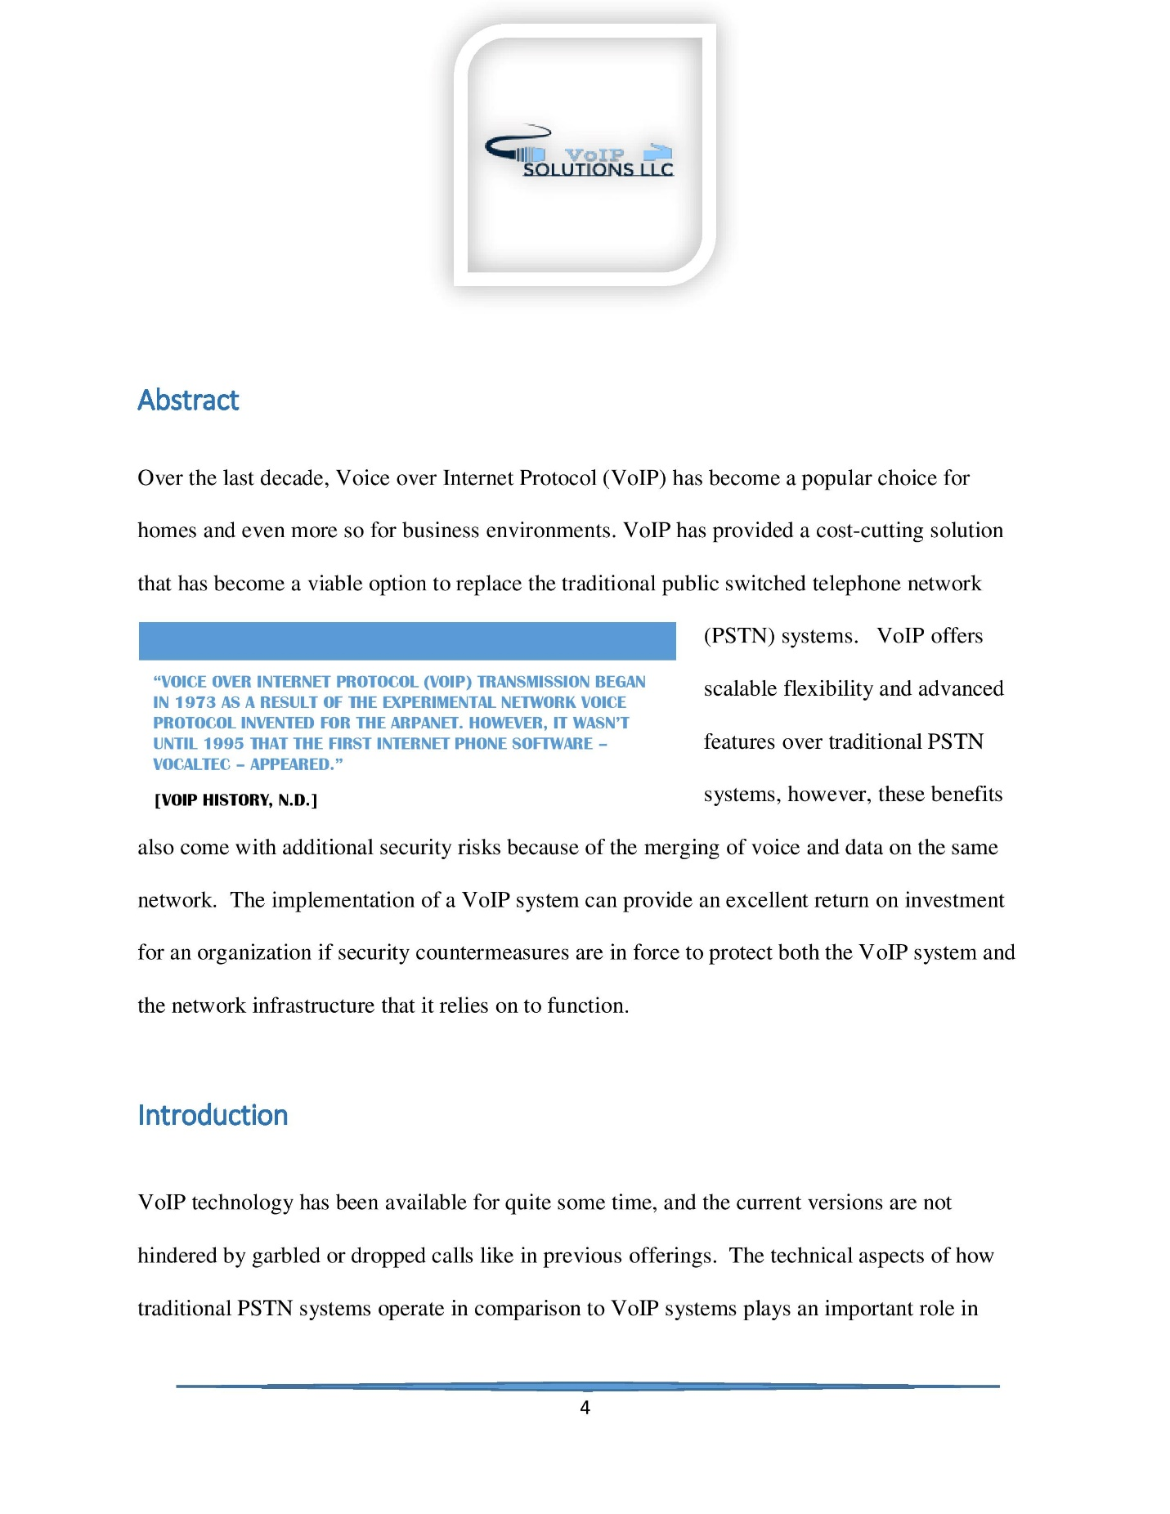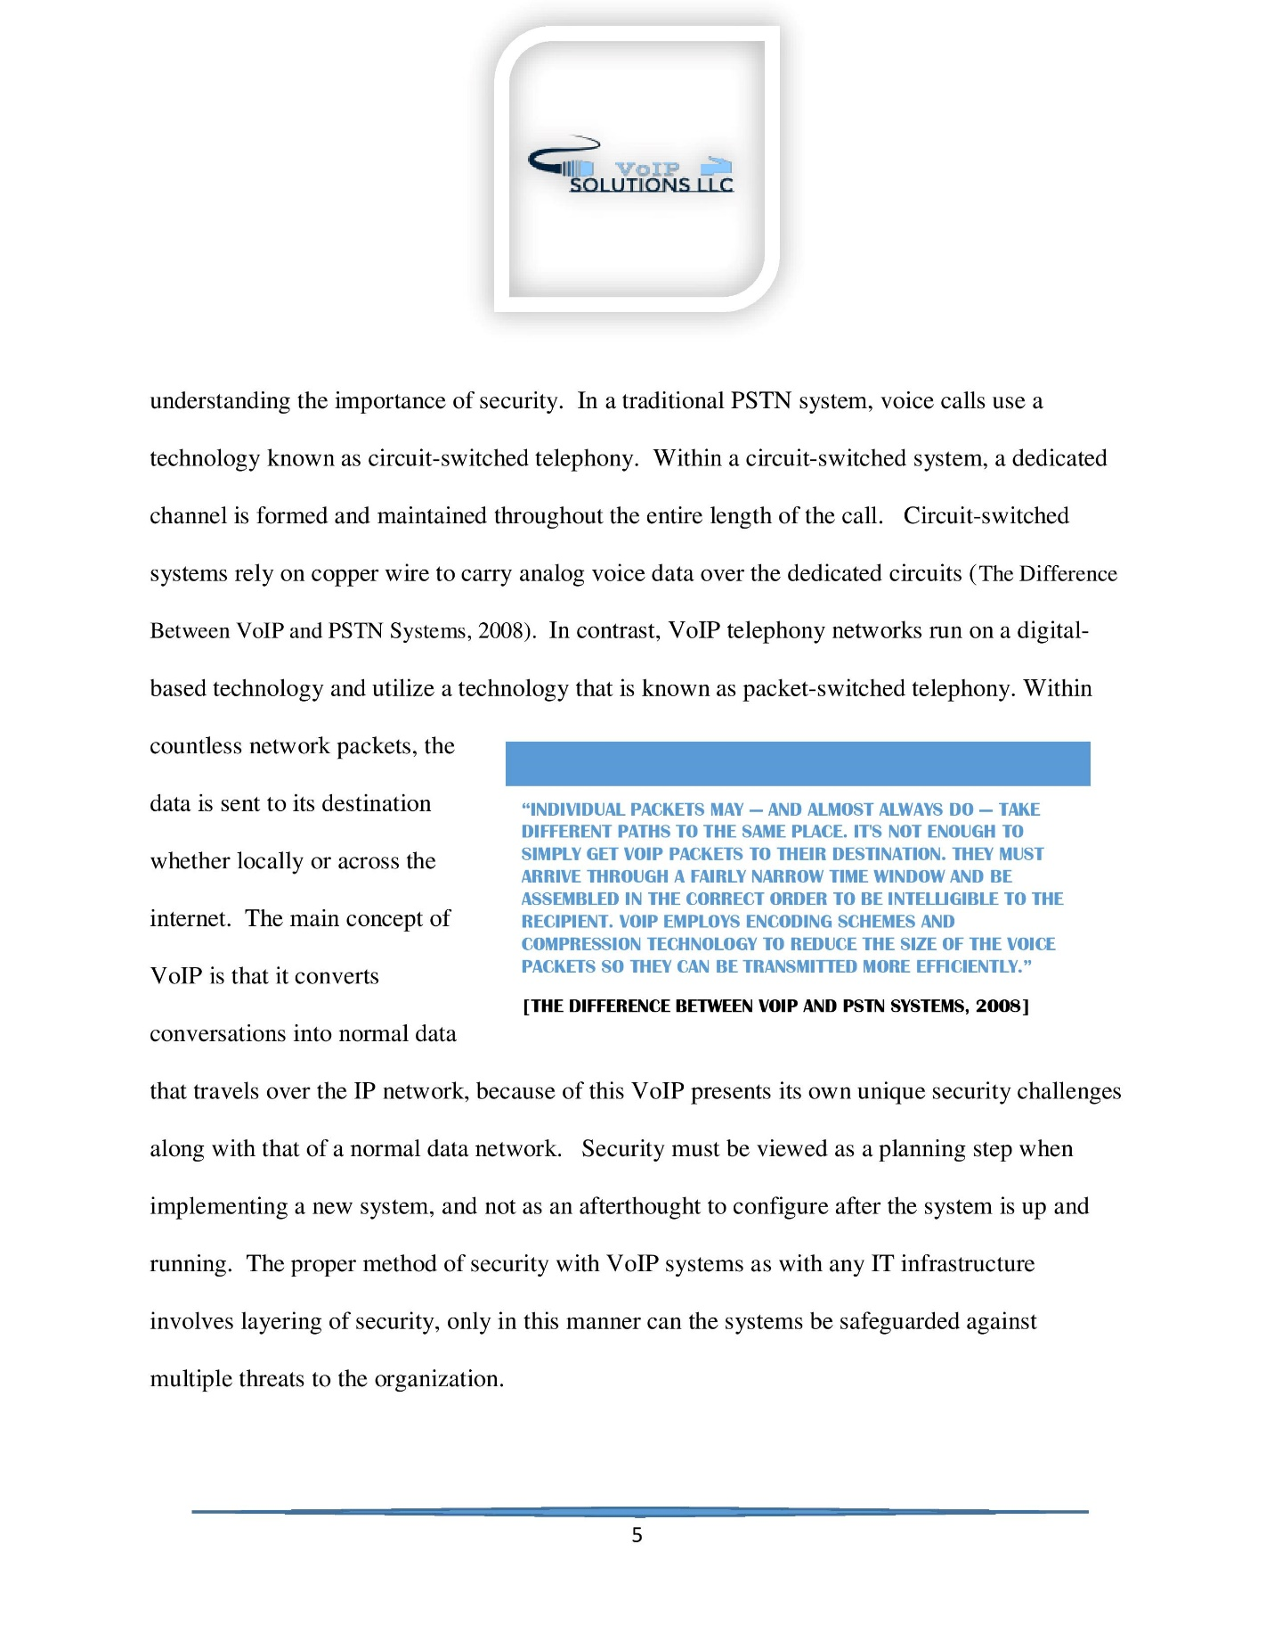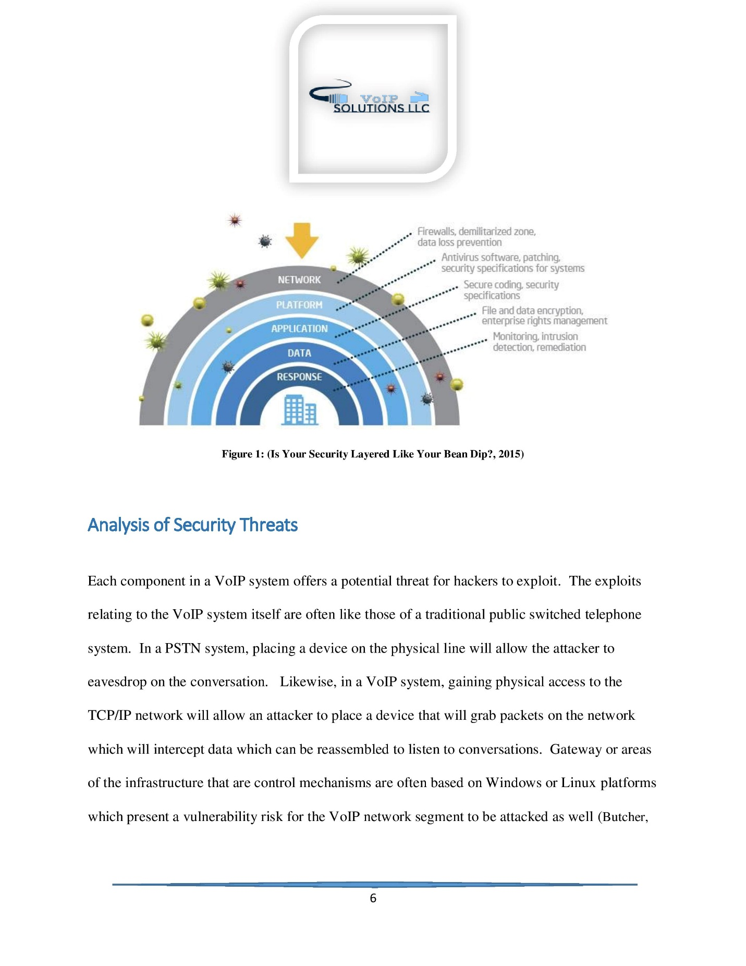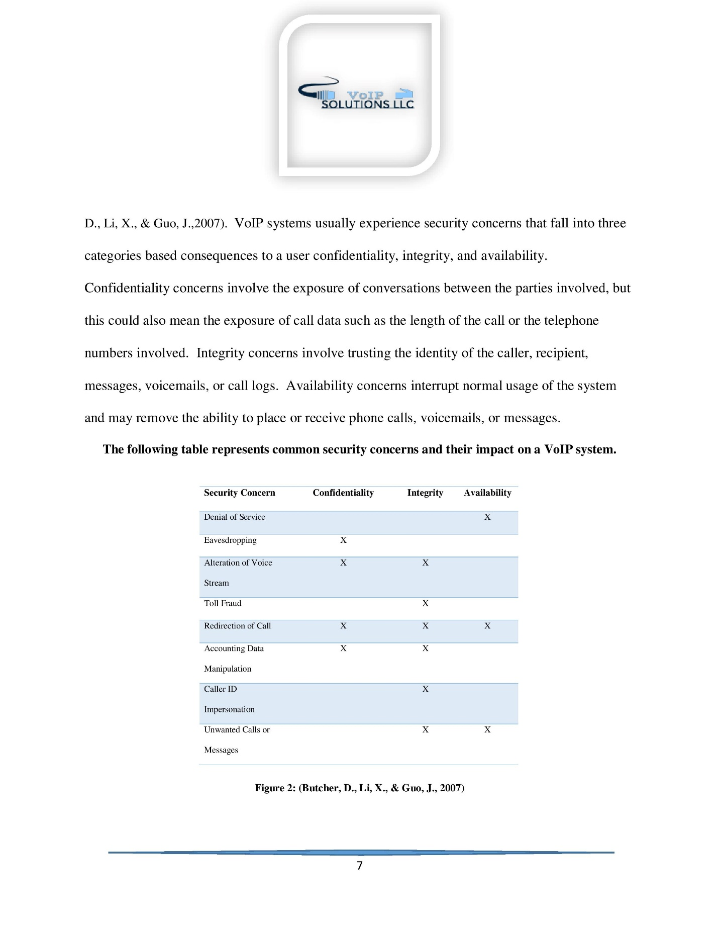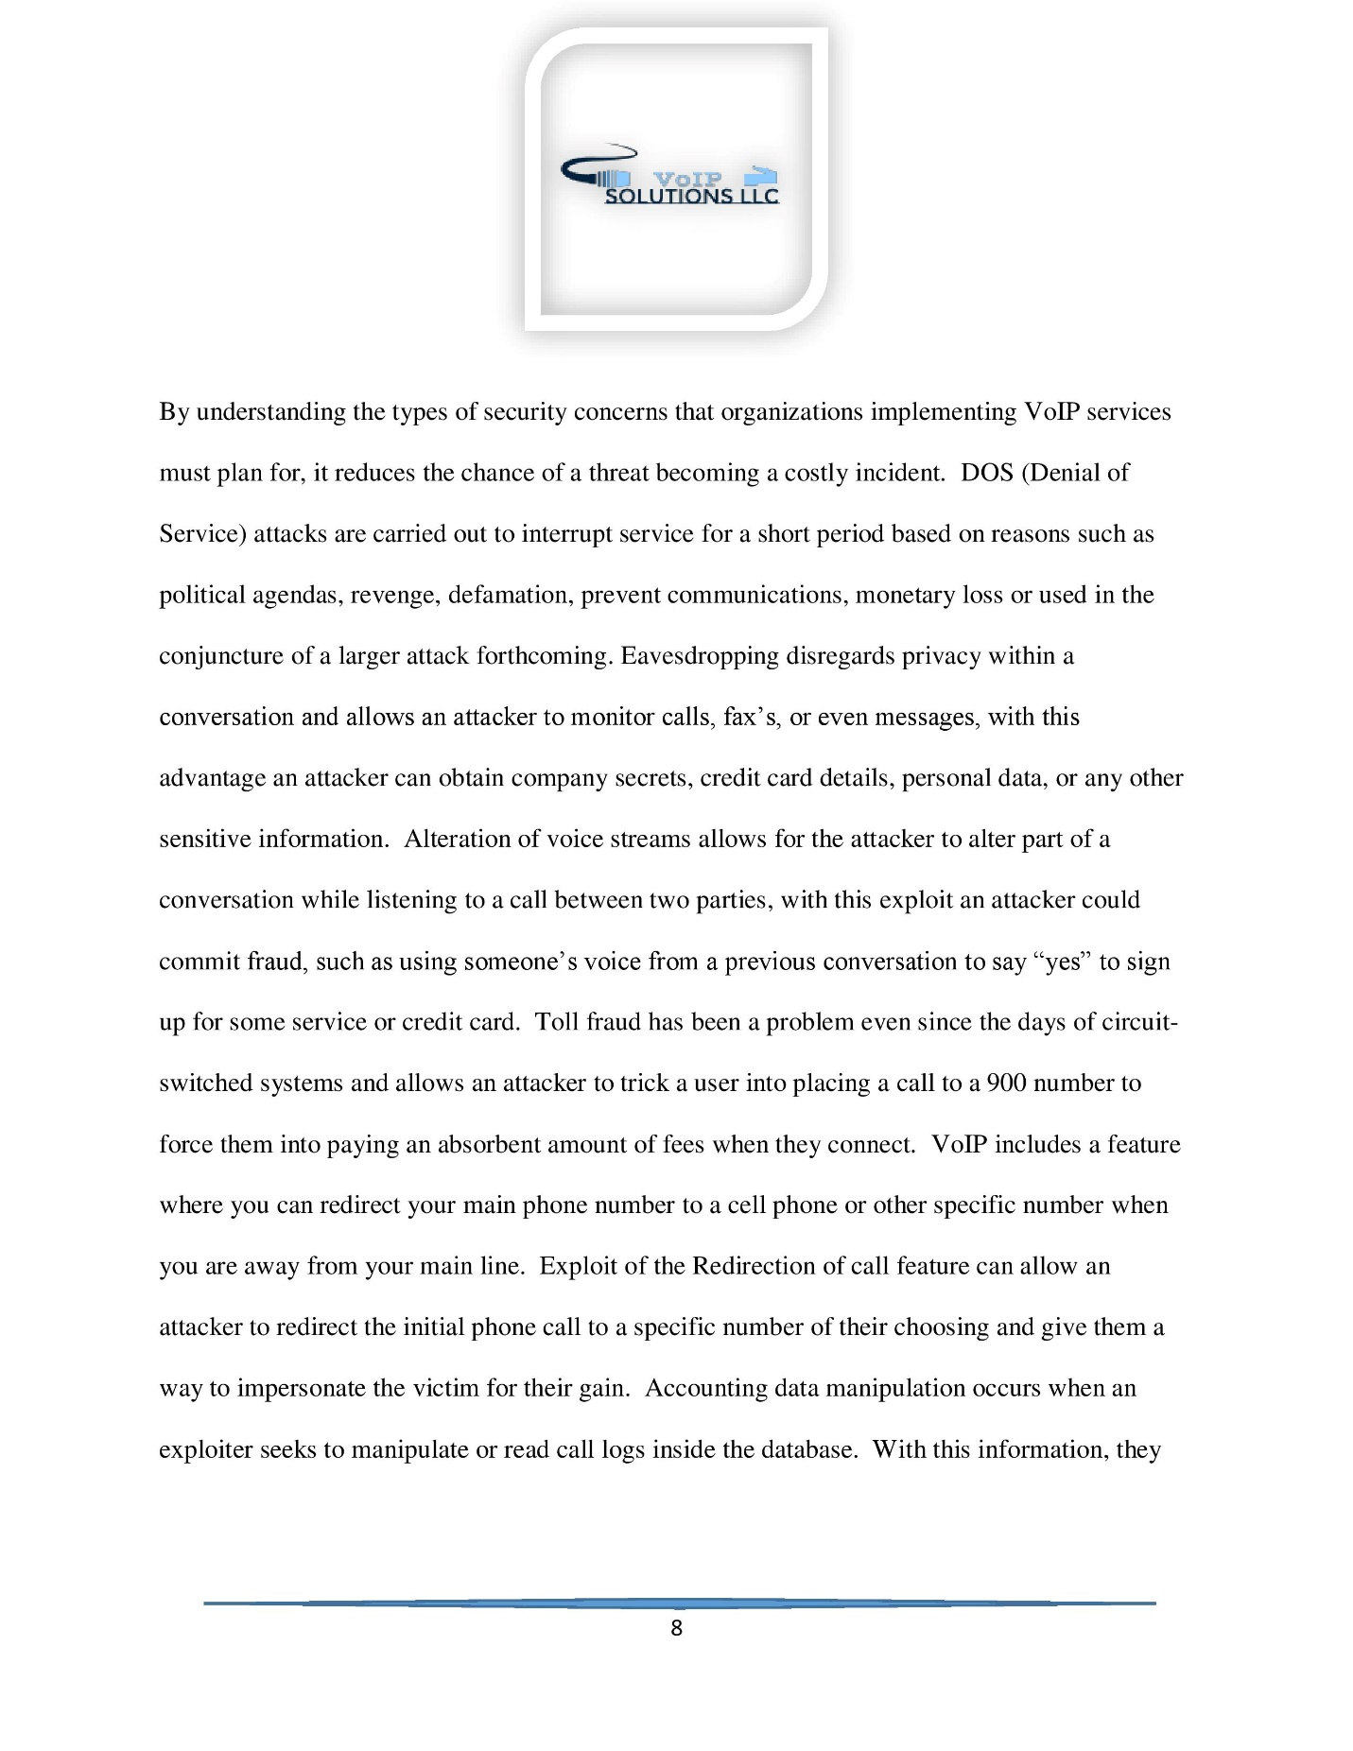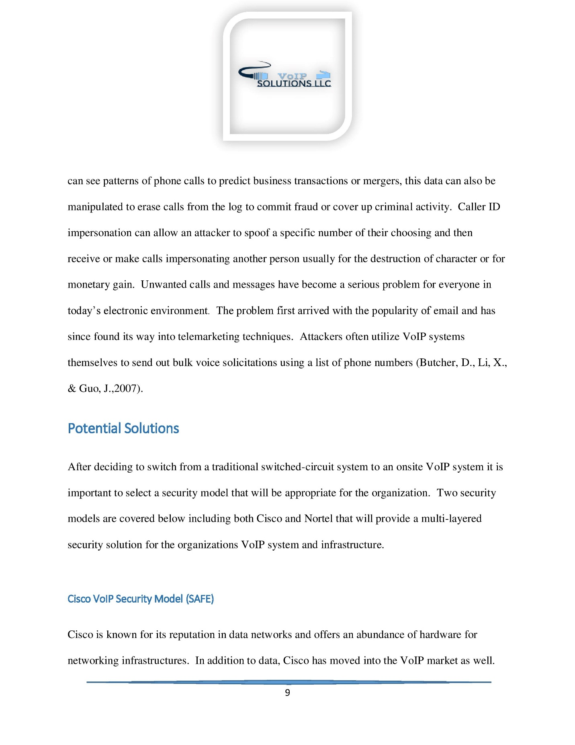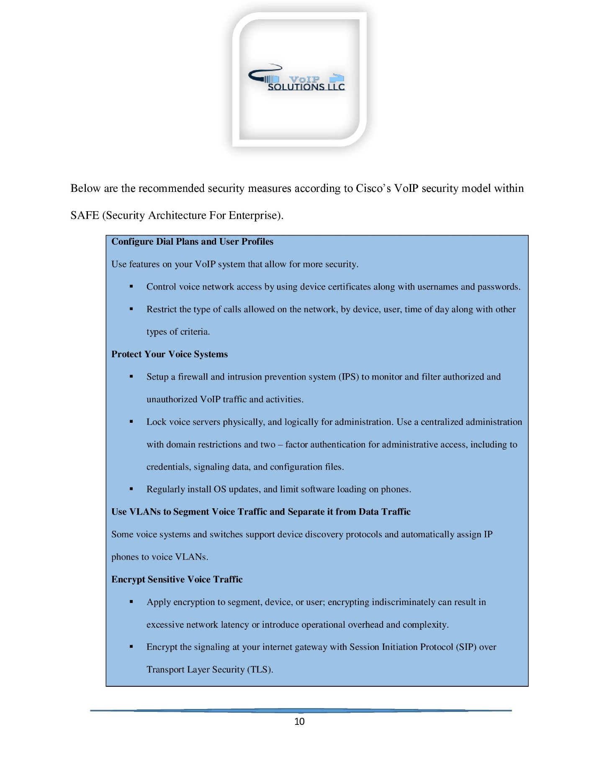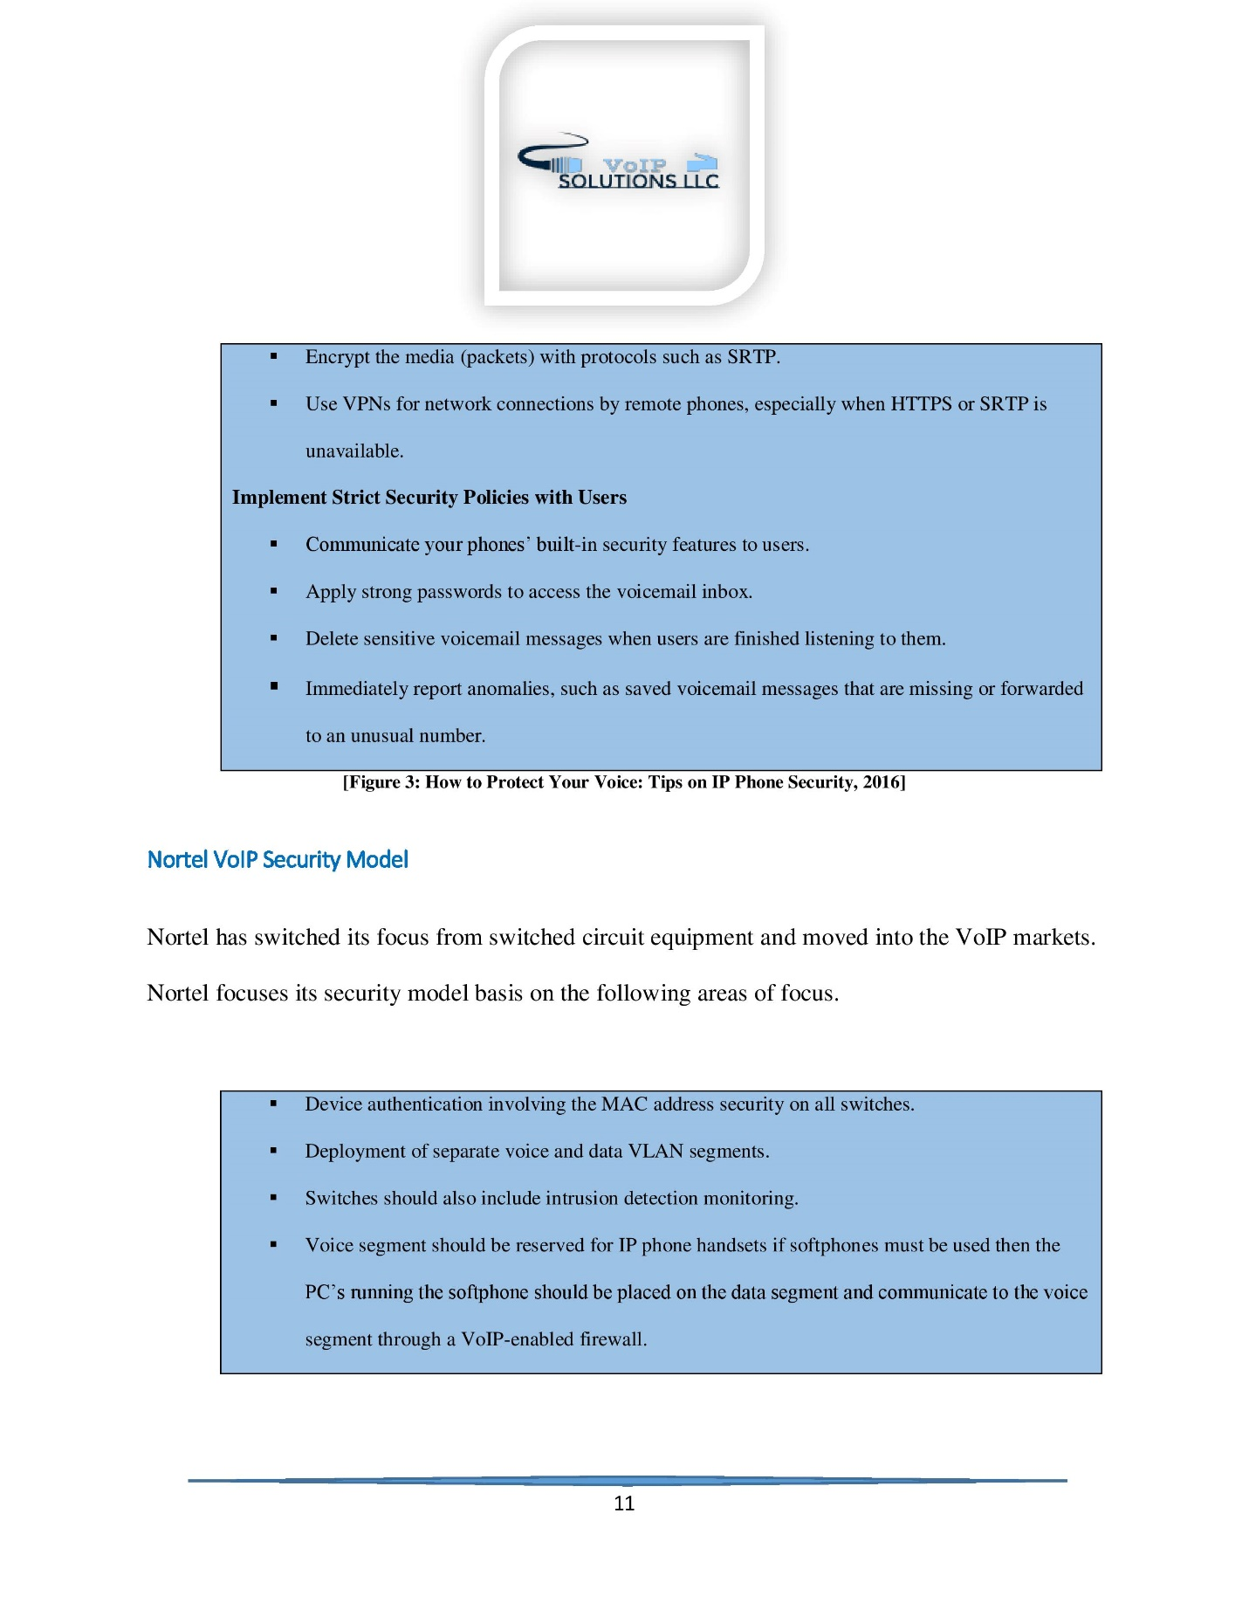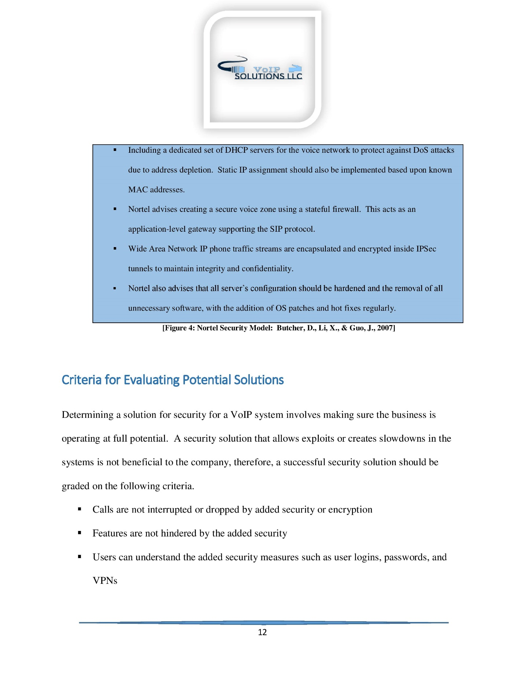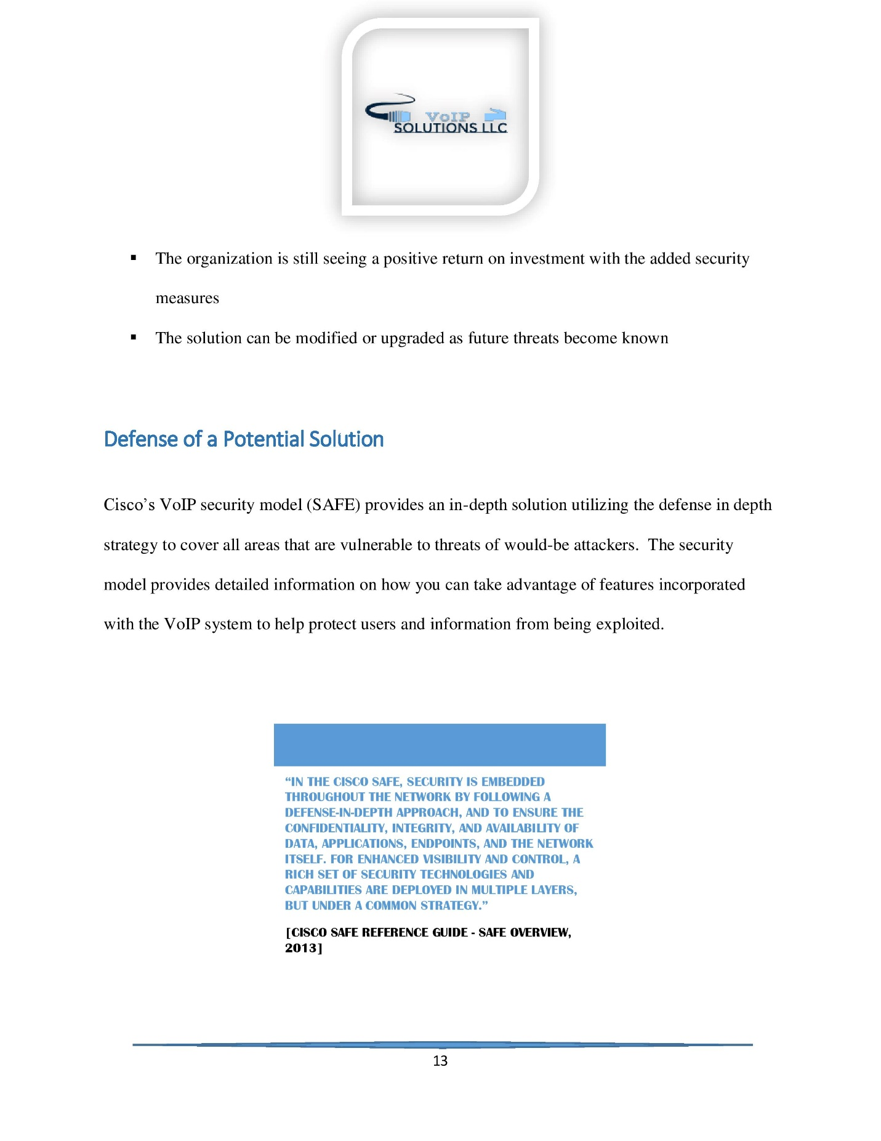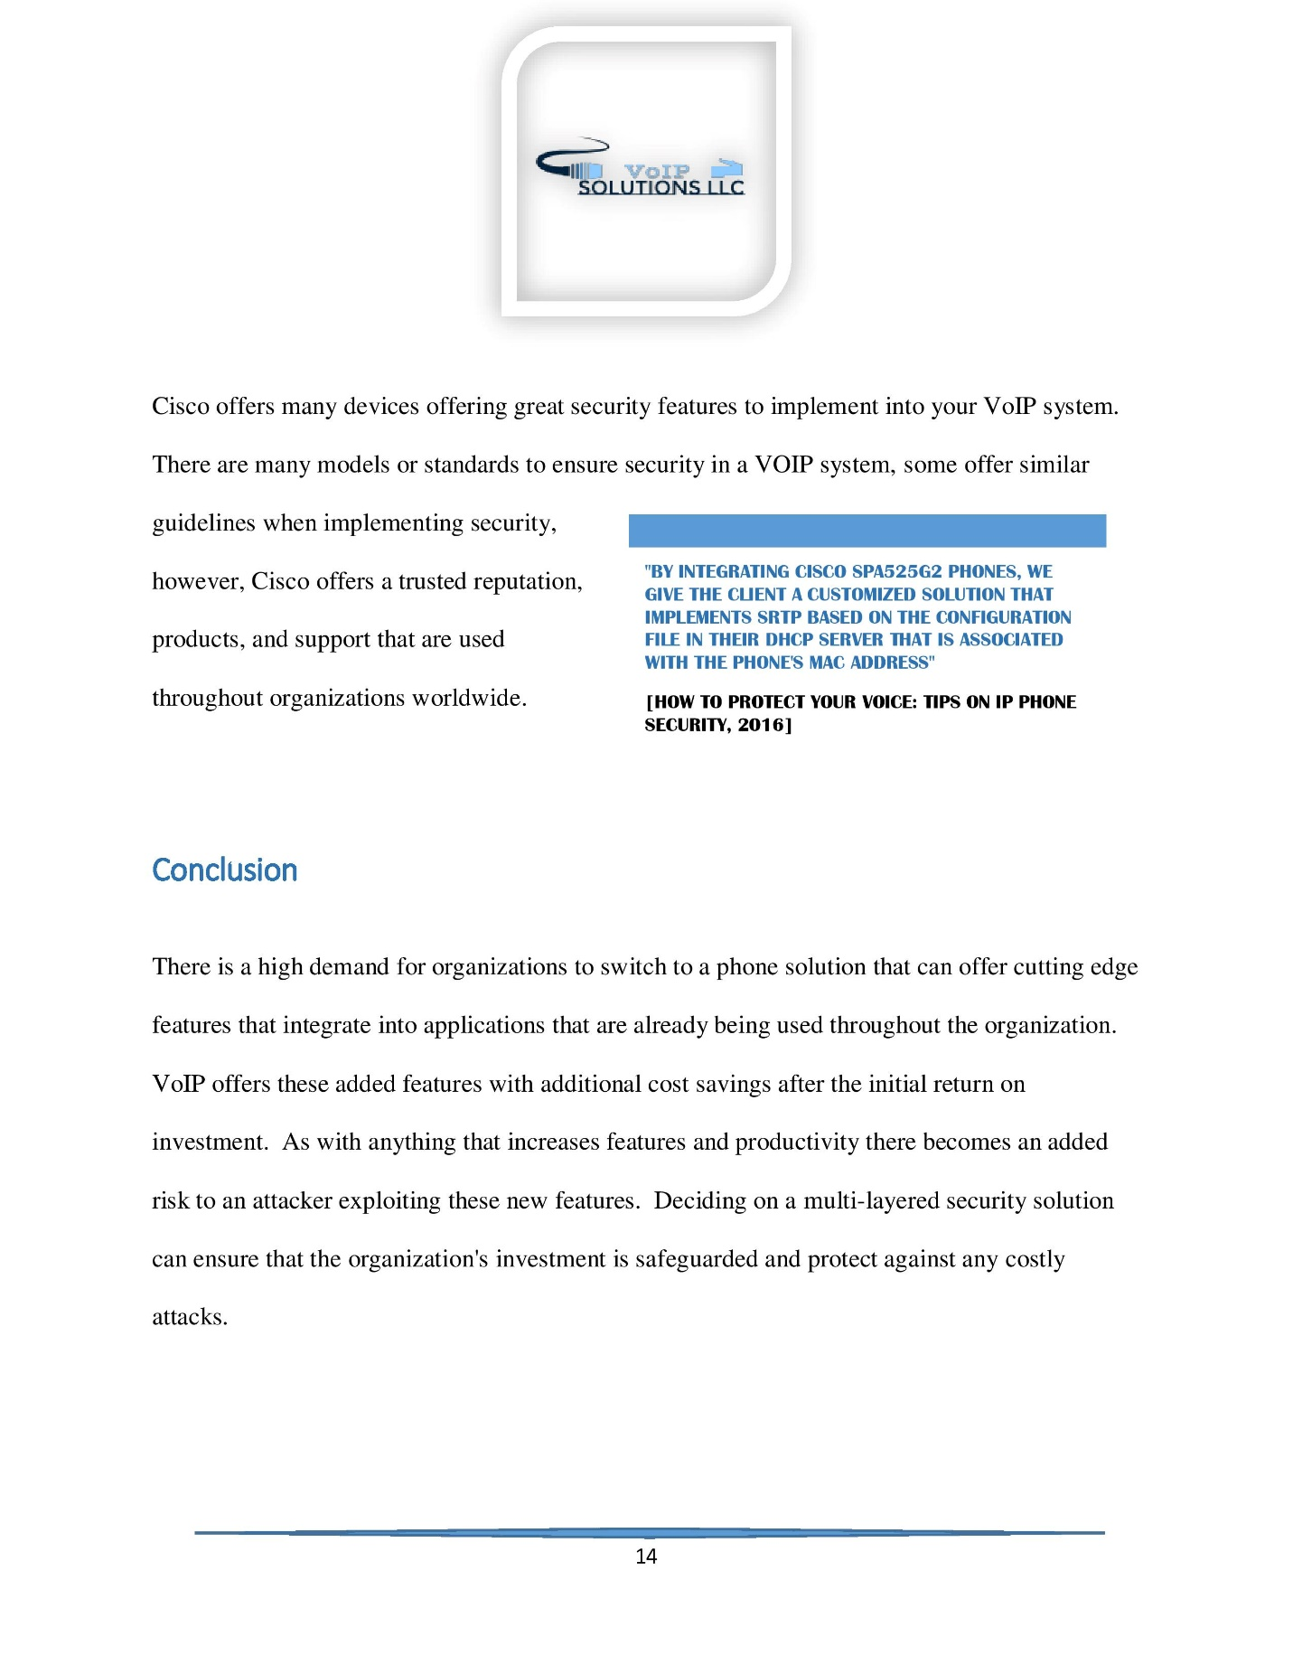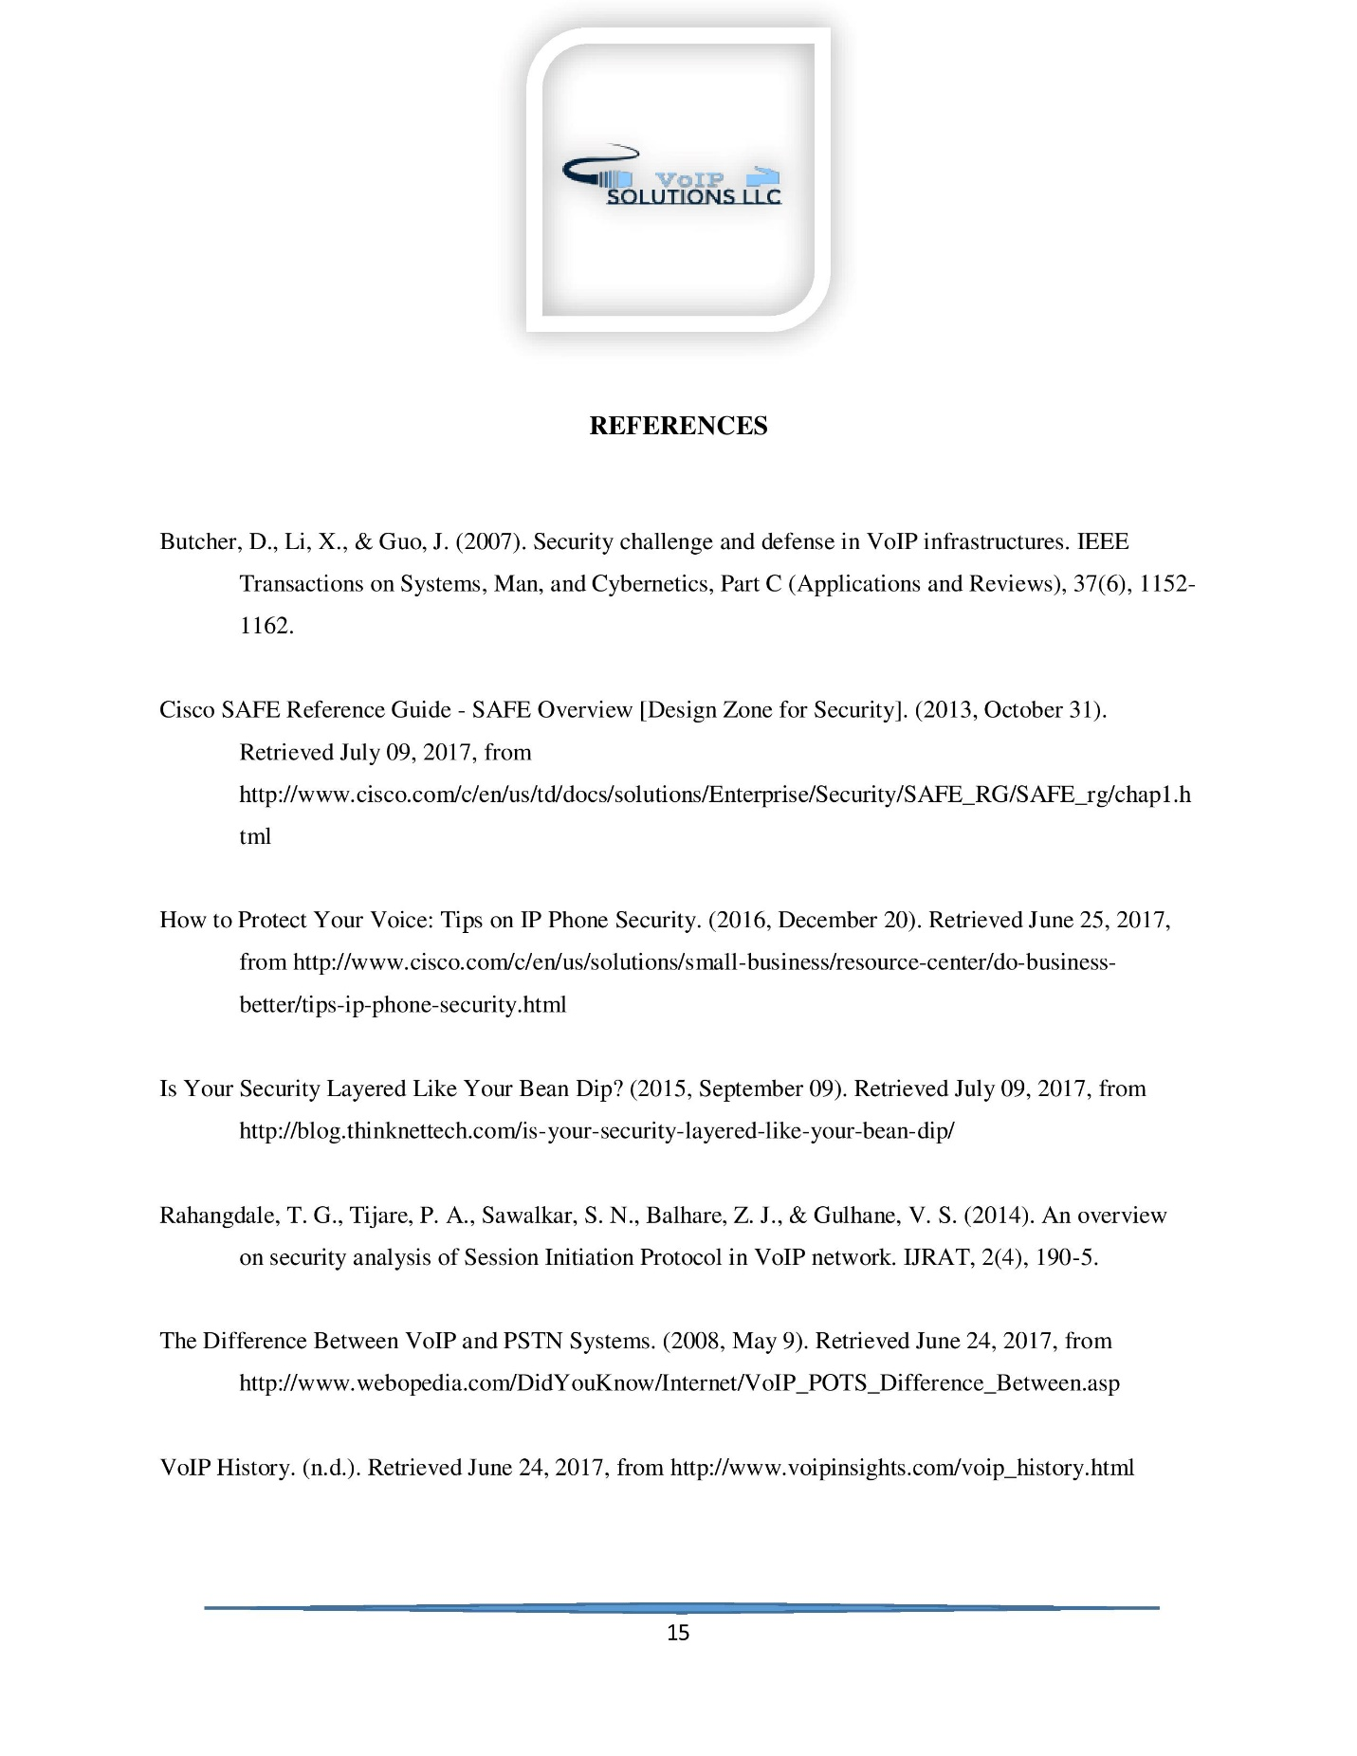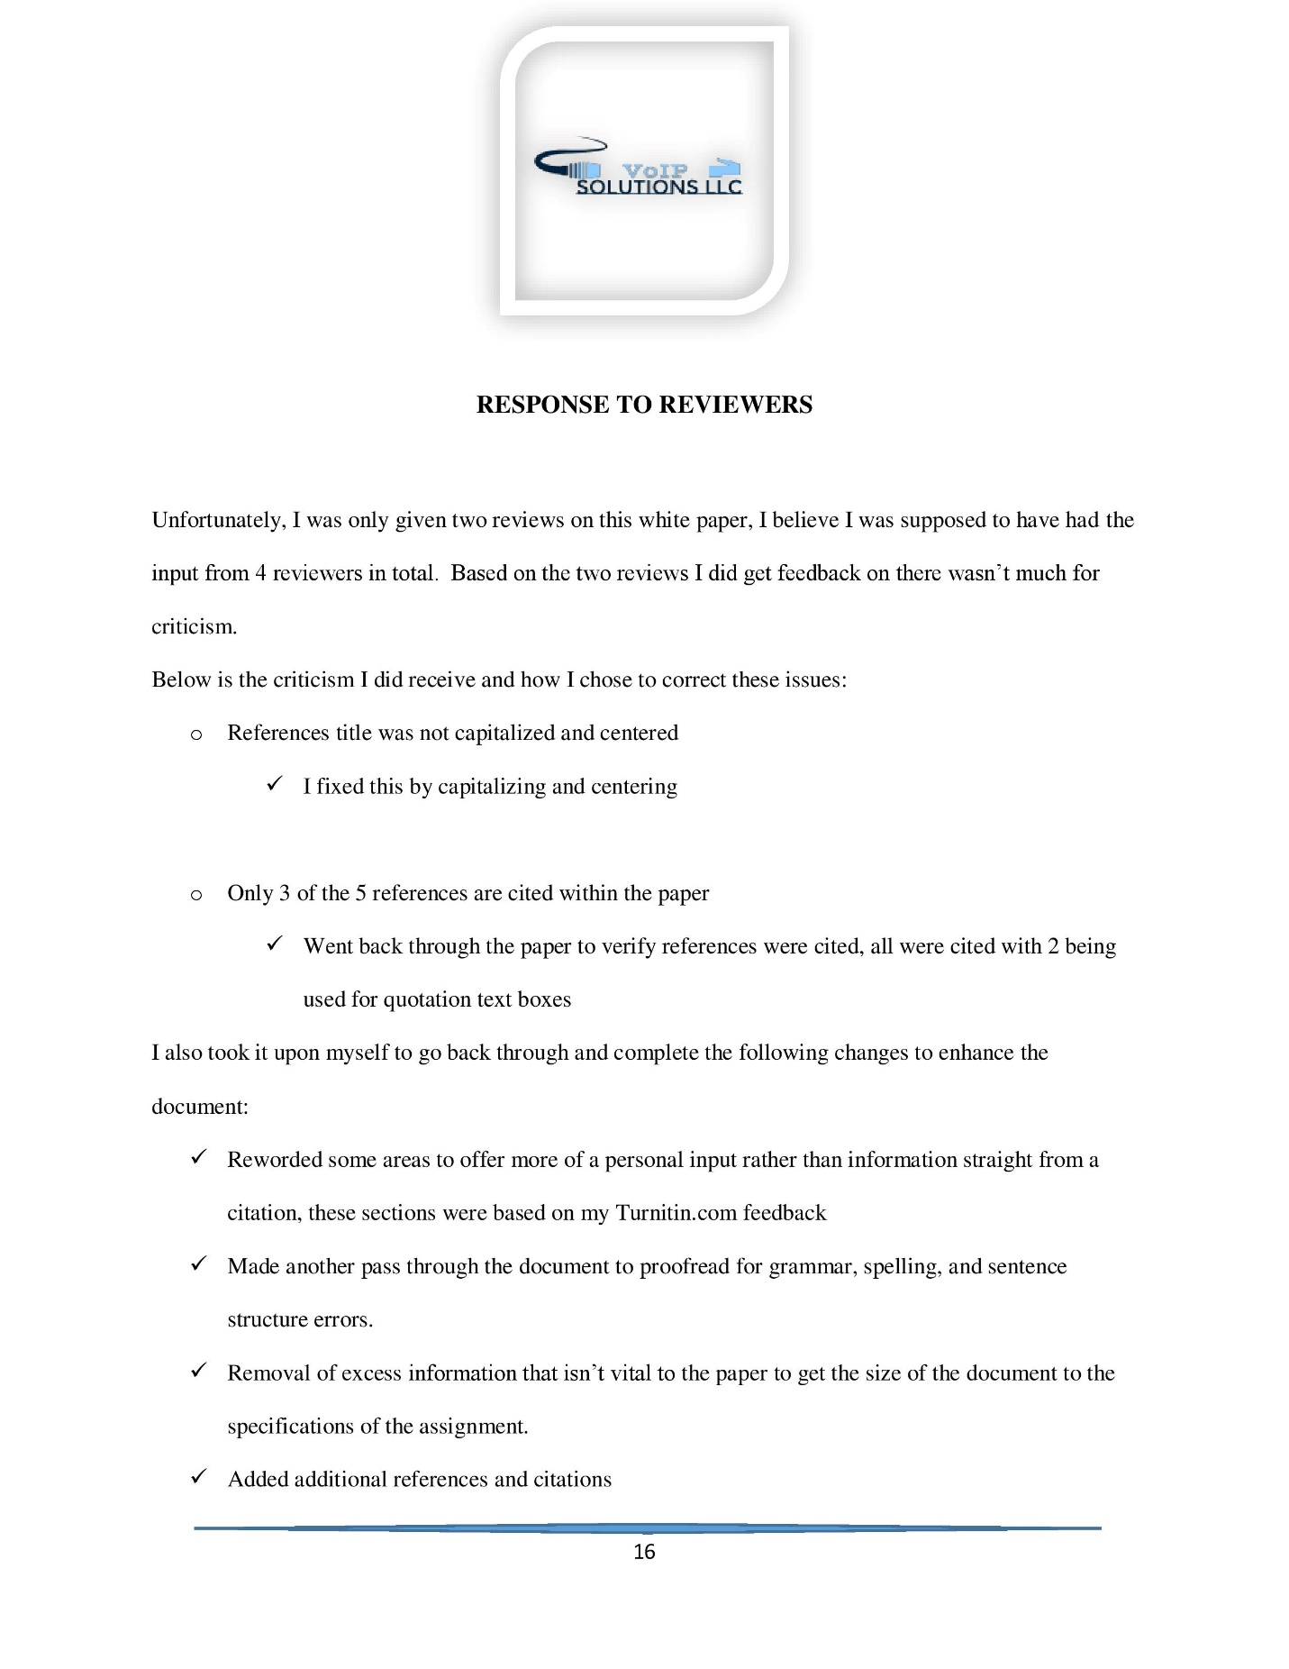

White paper: Computer Telephony Integration and QOS Implementation
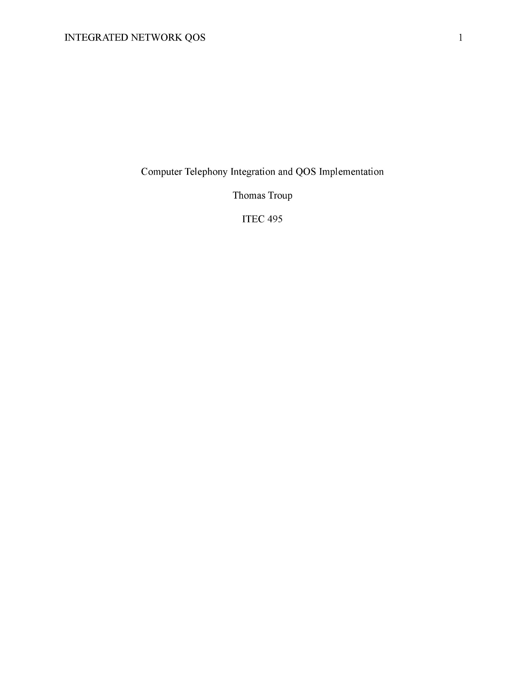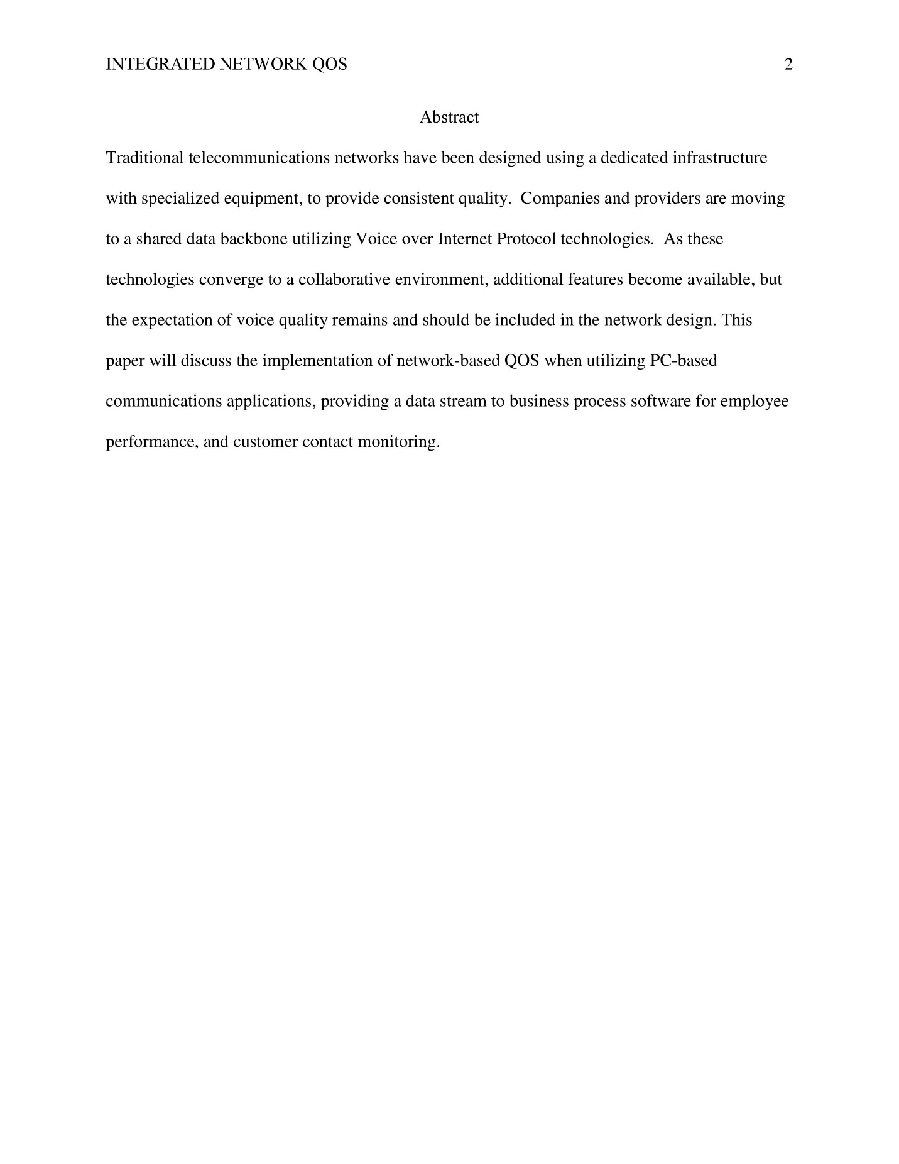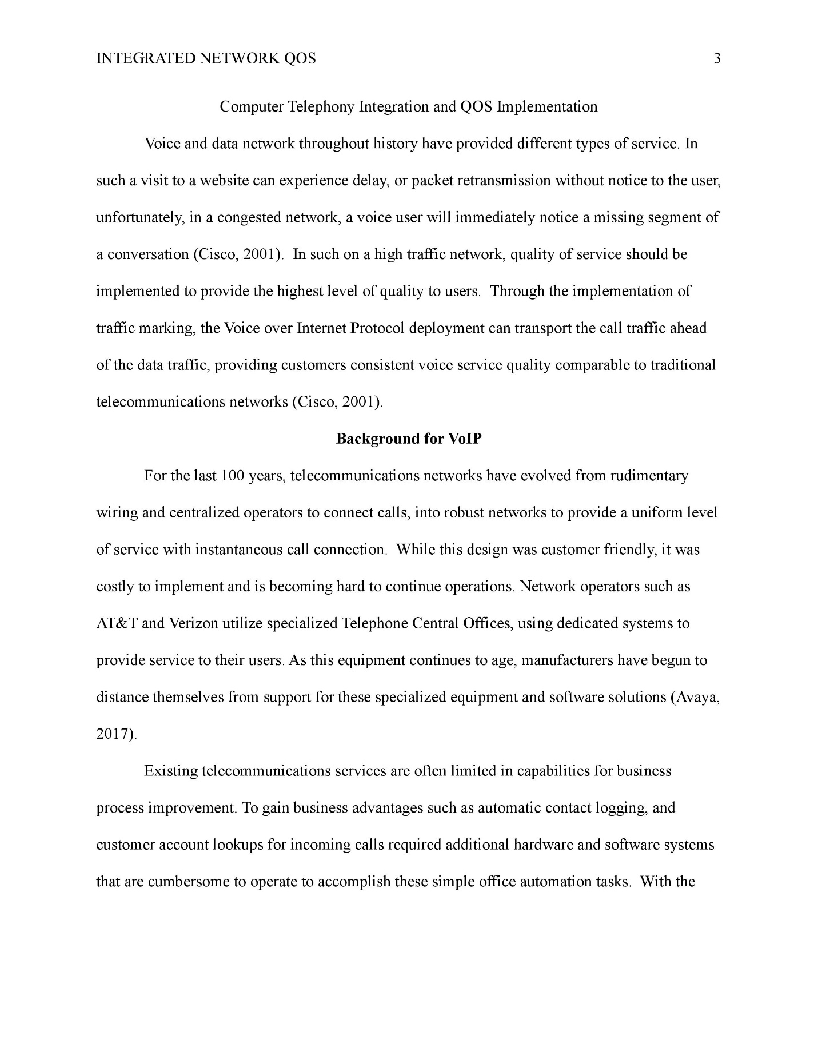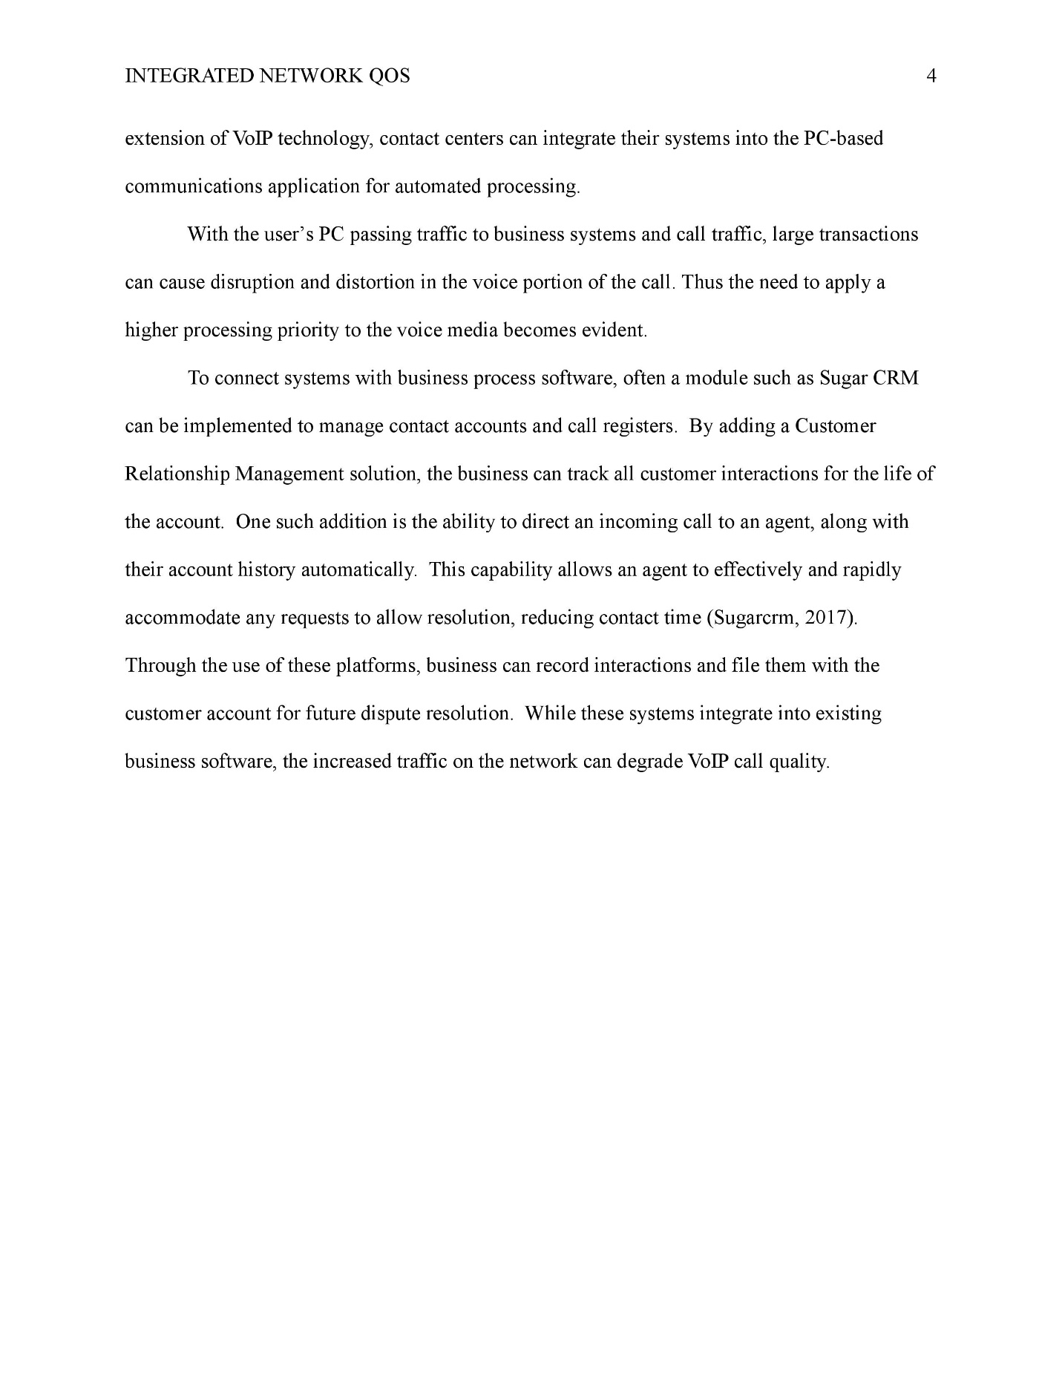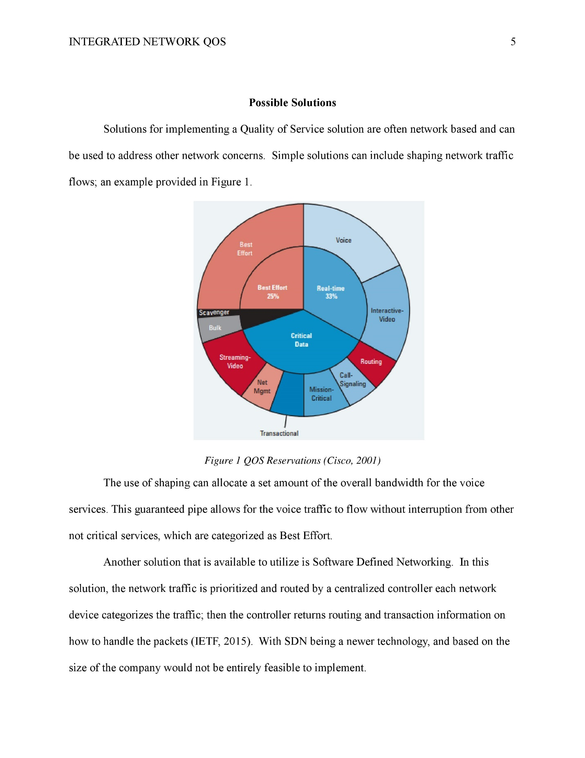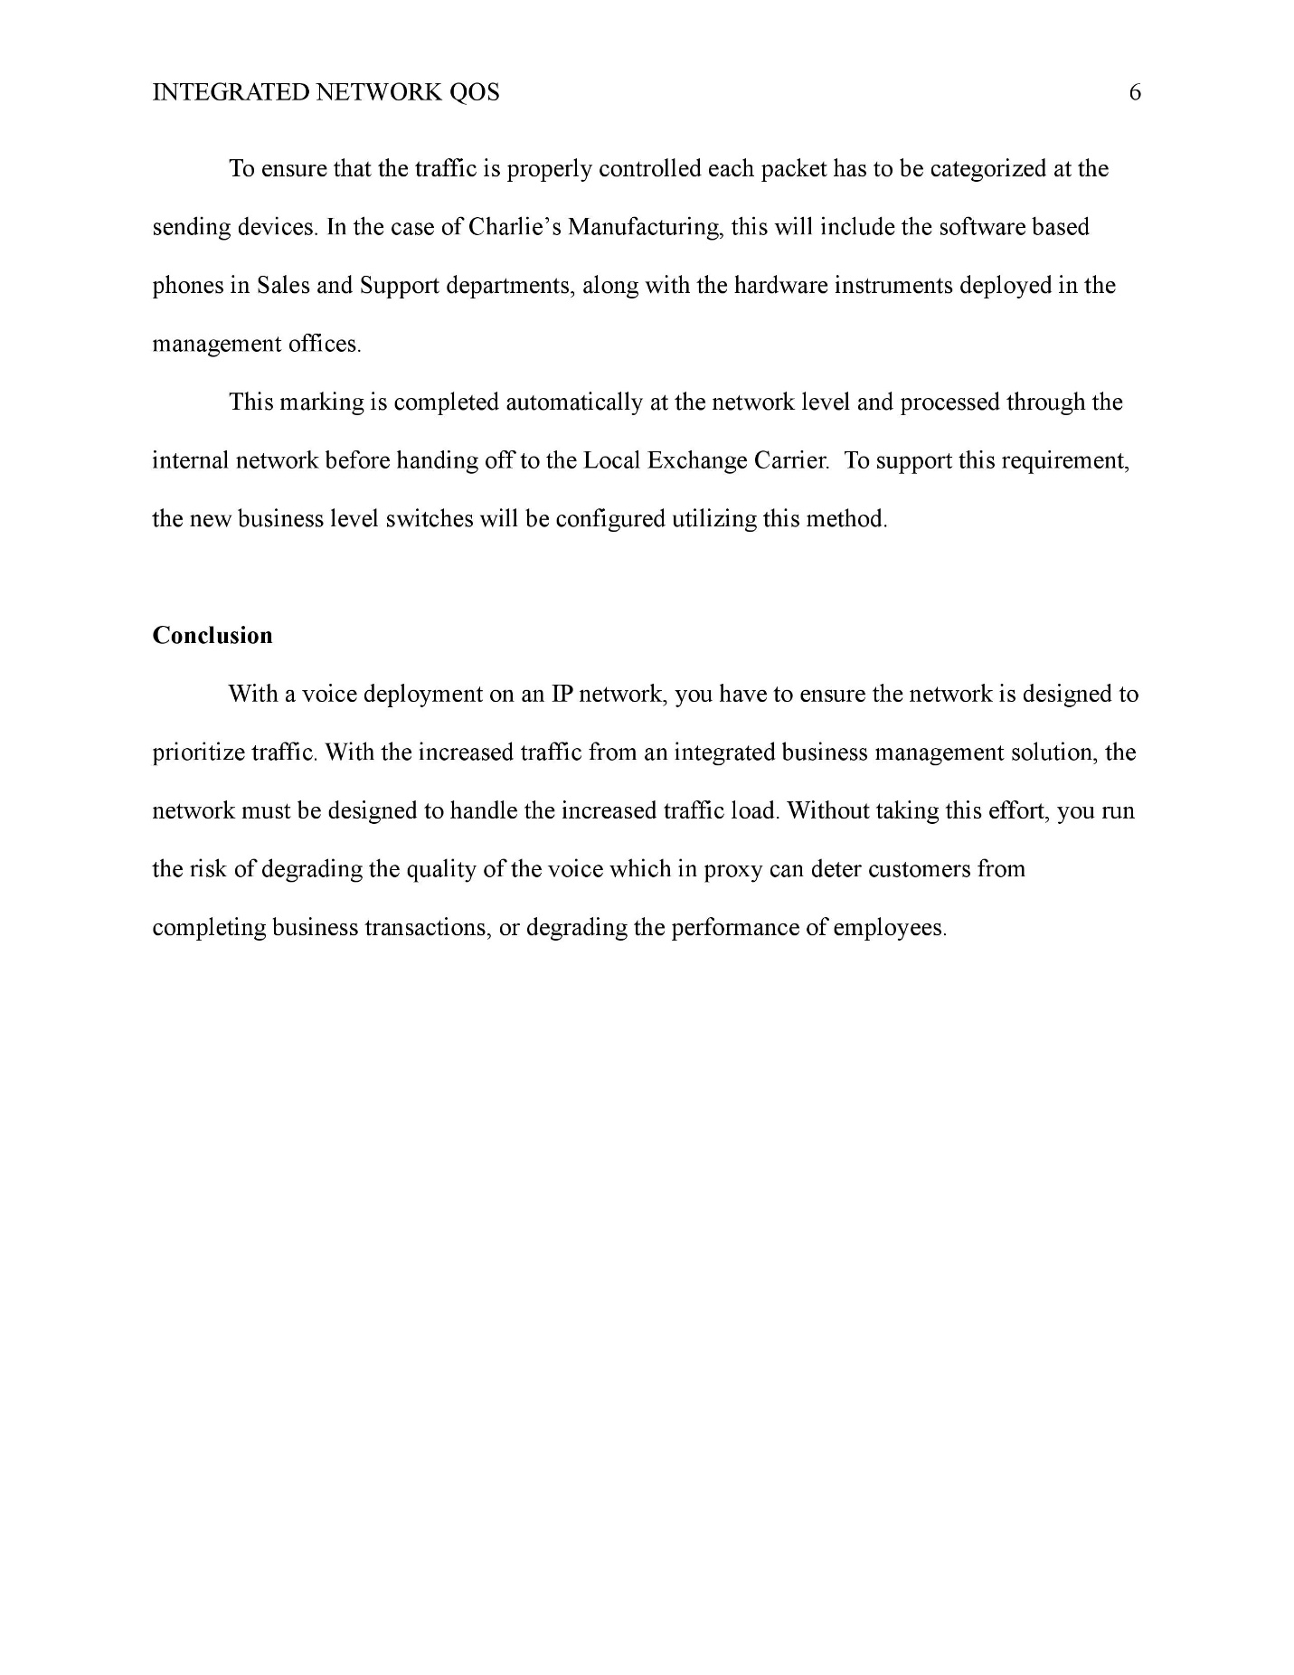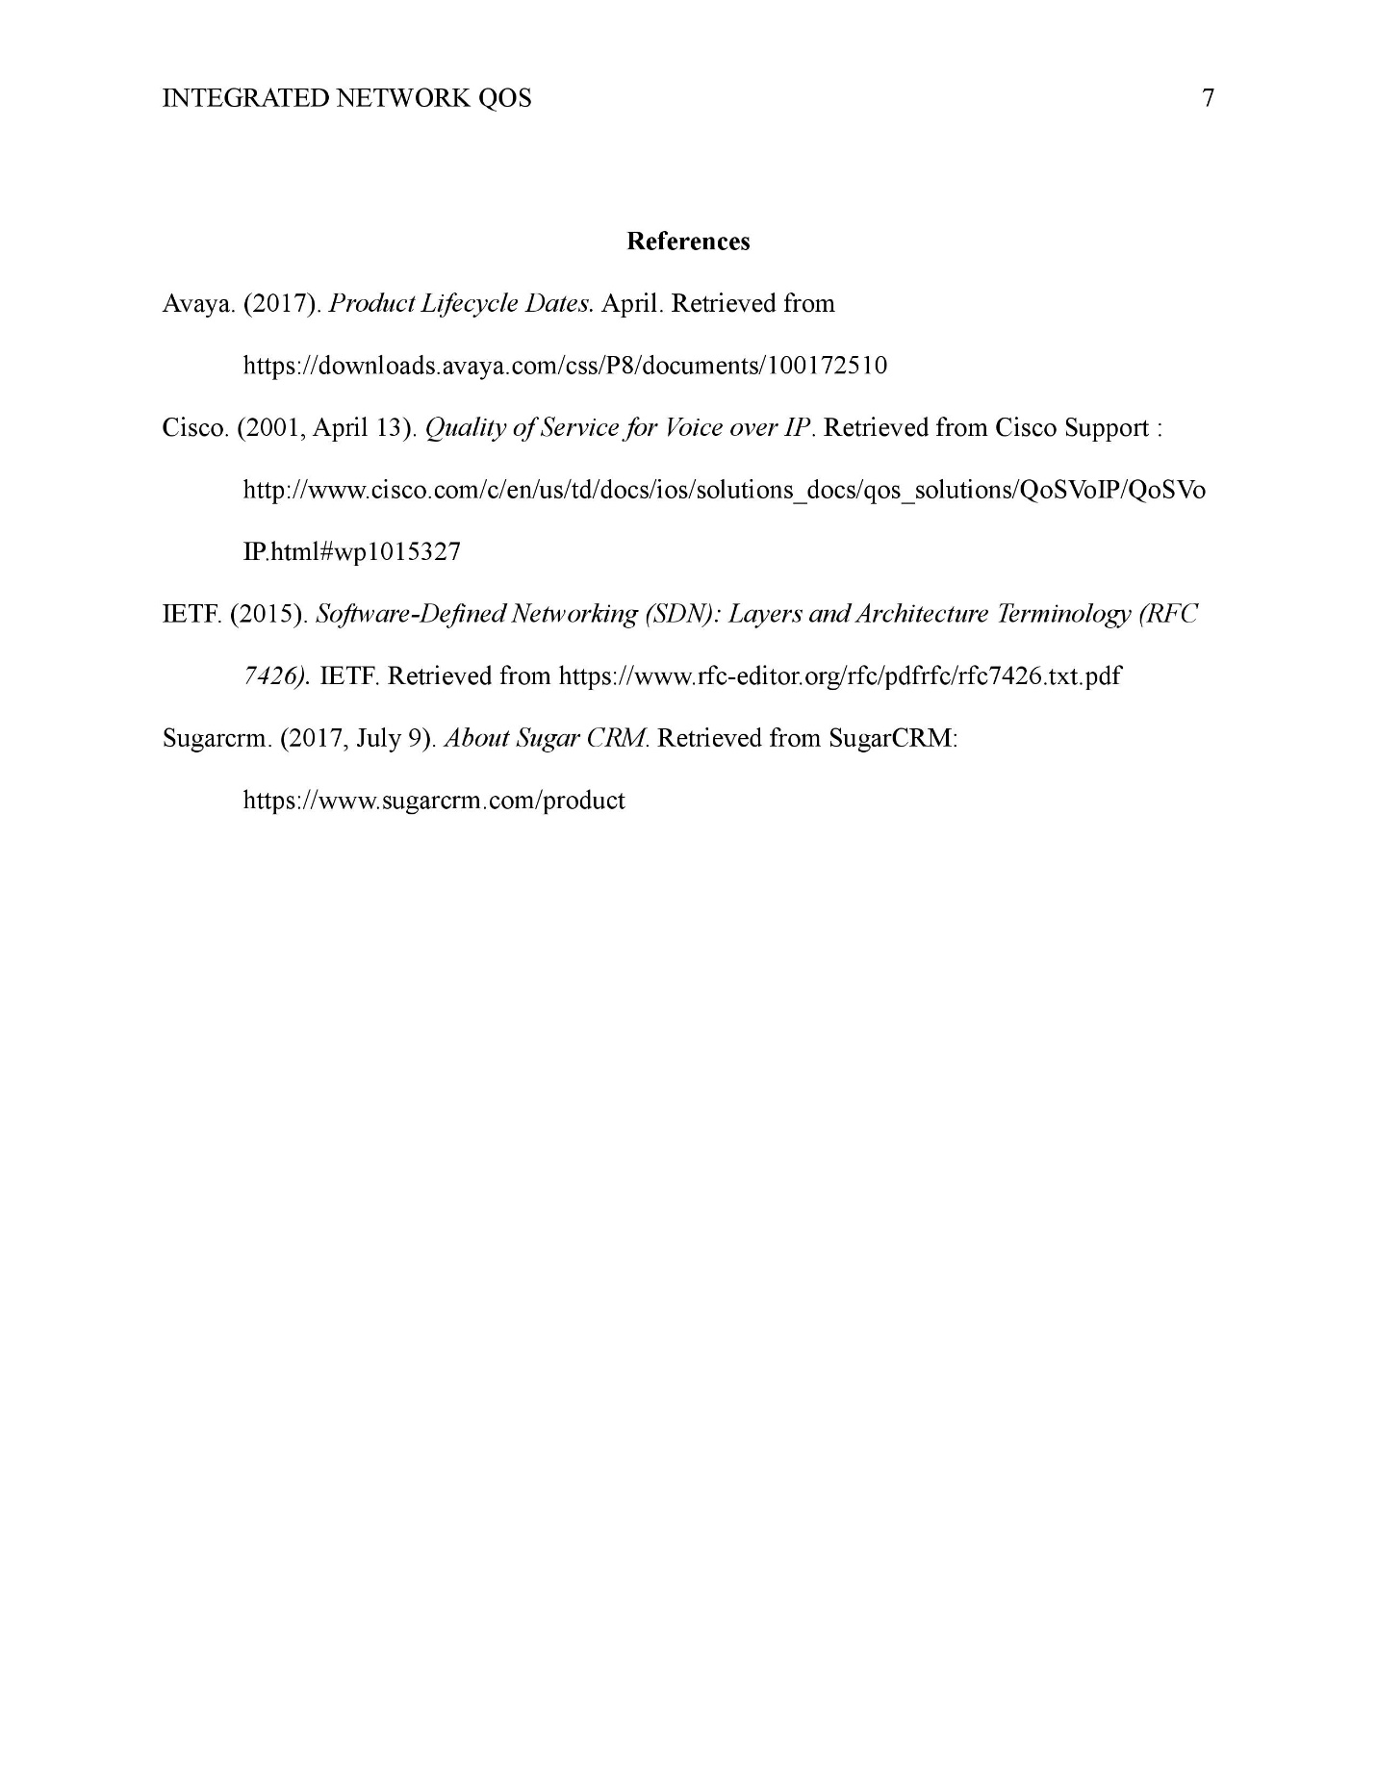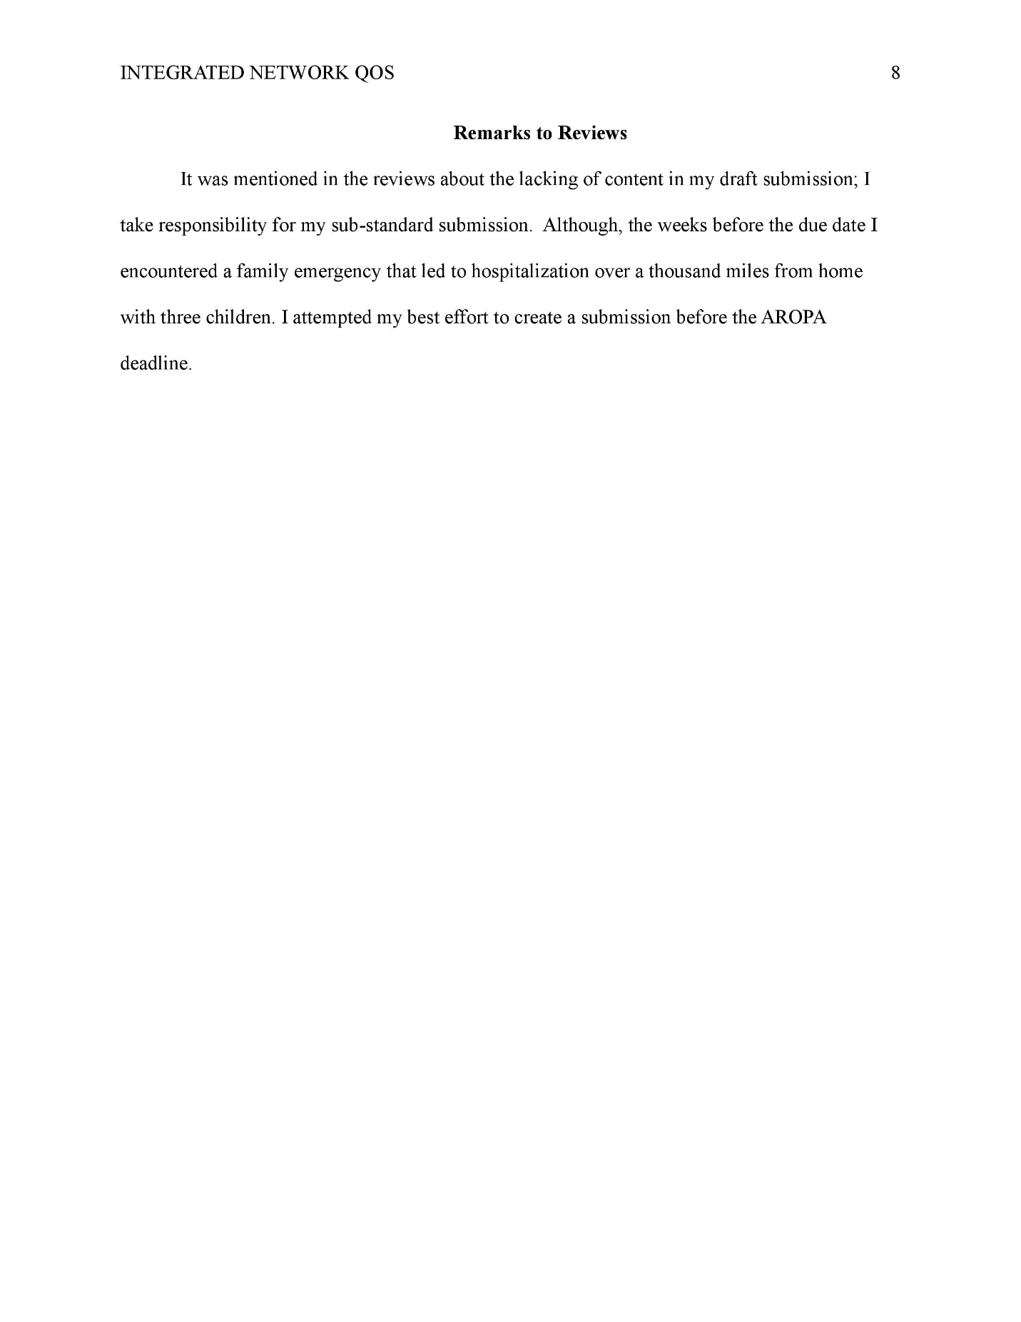

Response to Reviewers
Below is a list of points that was addressed in this revision. These topics are aggregated from all feedback received from reviewers.
- Ad an alternate solution for the critical thinking section for why we chose the VoIP system.
- Insert network diagram for network design section
- More detail for MIS section (how we talked about requirements/goals, how the course objective was met, interactions with stakeholders, why was the system needed)
- For Sys admin section, add how the backup and disaster recovery info was setup (double check this statement)
- Go into more detail about the security features e.g. what type of media encryption or what Vlan segregation does for the system
- Remove 1st person from the document
- Make things Past tense
- Run Grammarly on document (advance issues provided by reviewer
- Repetitive/overused words (most common advance issue)
- Few missing words
- Unclear antecedents
- Passive voice used (second most advance issue)
- Change "will be done" to "performed"
- (Opt.) add bookmark links to make finding sections easier or when a section is referenced
- Communications strategies section is repetitive since it is covered in the learning objections section
- Ensure the whole document is in the same tense
- Add space for the question/answer in lessons learned section so it is easier to read
- "A problem is identified, but is vague. Few alternative solutions or arguments are evaluated and evidence is sketchy. The conclusion or solution logic is difficult to follow based on the premises. Criteria for evaluating success is not mentioned. This section simply states Critical Thinking objective for the course was met, but not actual proof displayed on how the objective was met."
- Network section needs how performance was measured
- Confirm that figure 1-8 is in the artifacts folder
- Show the admin section how we set up a disaster recovery (it was mentioned in the security section)
- More documentation for admin section
- User authentication section needs discussed
- Recommends discussing phases used
- more detail in the system admin section
- Security section needs risks listed
- Network design section: use bullet points for deliverables
- "more detail one each team members skills'
- Provide admin instructions in the MIS section
- Security section: provide plan for system updates, testing the company should do and why this should do it

