Project Proposal

Wilk Web Works
Web Site Design Project
Roger Wilk

Franklin University
ITEC495-V1WW
Prof: Wayne Smith
Table of Contents

Project Proposal 3
Company Overview 3
Project Description 3
Project Goals and Objectives 4
Deliverables Summary 4
Risks & Mitigation Strategies 5
Assumptions 5
Timing 5
Project Reporting 6
Project Team 6
Annotated Bibliography 7

Project Proposal

Company Overview

Wilk Web Works is a small Web design firm founded in July 2003, and based in Livonia, Michigan. The company offers Web site design and maintenance services to a small number of clients. The primary business goal of the firm is to generate income through ads sales and affiliate programs. This goal is achieved by creating a variety of Web sites, and utilizing search engine optimization and marketing techniques to attract visitors. The company has utilized this model to generate substantial income through the first of its sites, Kookerkids.com (www.kookerkids.com) which expects to attract approximately 450,000 visitors in 2006, and has achieved annual growth rates of 45-60 percent over the past three years.

Project Description

The purpose of this project is to generate revenue by creating a Web site providing Web design tips and tutorials for beginners. The site will cover topics such as design and usability, color schemes, logo design, and navigation. Information regarding Web hosting and search engine optimization will also be presented, as will software tutorials covering Web design and graphics applications such as Macromedia's Dreamweaver and Fireworks products, as well as Adobe Photoshop.

Research will be conducted to produce a set of ideal keywords to target for the site. A variety of web-based tools will be utilized to determine the which keywords will present the most attractive income possibilities based several factors including the number of times Web users are searching for a specific keyword, and the number and dollar amount of bids placed by advertisers at ad auctions.

What's New & Novel in this Approach
This project represents the first in a series of Web sites that will allow Wilk Web Works to transition its business model from creating Web sites for small businesses, to the approach that will generate income strictly from advertising and affiliate programs. Examples of such programs include Google's AdSense program which allows Web sites to generate revenue through context-sensitive pay-per-click advertising, and Amazon's Associates program which generates income via sales commissions on Amazon products.

Project Goals and Objectives
Project Goal | Project Objectives
- To design and build a Web site (www.wilkwebworks.com) containing Web design tips and tutorials for beginners that will generate income via advertising and affiliate programs. | - Create a professional-looking web site for design 'newbies'.  - Generate income via AdSense ads and Amazon product sales.  - Offer tips in various applications and aspects of Web site design and development.

Deliverables Summary

The Web site will contain the following content:  - Home Page – Introduction to visitor, purpose of the site, etc.  - Design – A variety of tips/tutorials on site structure, colors & fonts, technical considerations, etc.  - Dreamweaver – Several tutorials on the basics of using this powerful Web site authoring tool.  - Fireworks – Tutorials to introduce beginners to some of the features of Fireworks including creating buttons, image slicing, and graphics optimization.  - Photoshop – Detailed examples on how to use some of the Web-specific features of Photoshop Elements. | Below is a draft of the Design page from the new Wilk Web Works site:  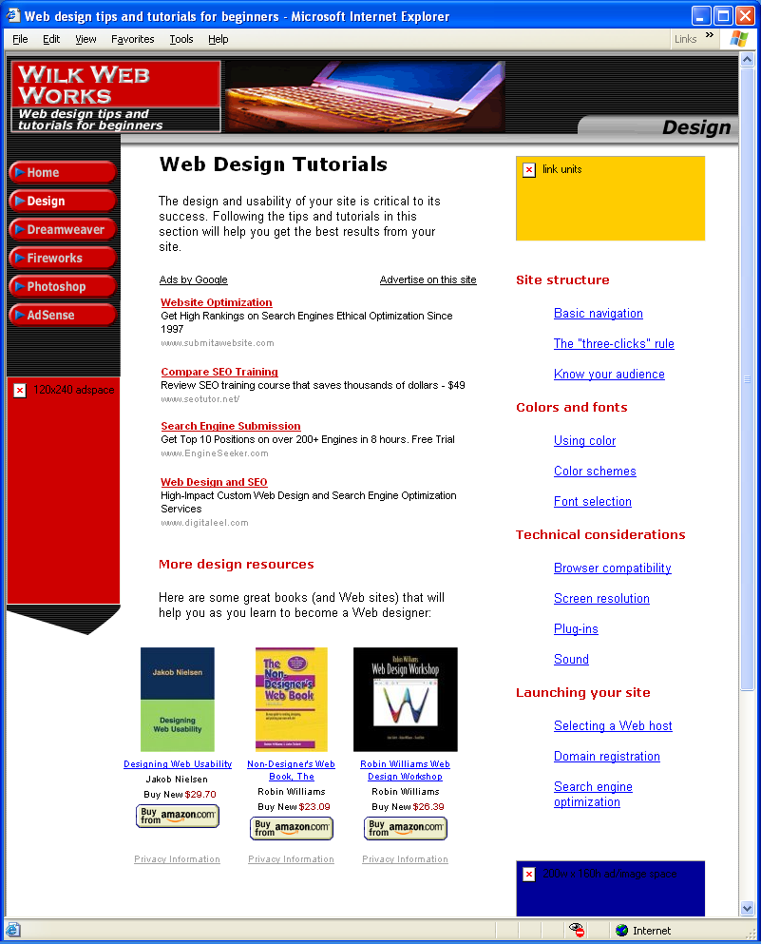

Risks & Mitigation Strategies

Critical Risk Factor | Risk  (H, M, L) | Mitigation Strategy
- Due to resource & time limitations, the scope may be too aggressive. (Original project plan had 119 tasks.) | M | Denoted several deliverables ‘2nd tier’ tasks. Removed from project plan. Some may be implemented if time permits.
- Design team lacks expertise in certain areas for which tutorials are planned. | L | Would need to acquire necessary expertise utilizing print & Web-based resources.

Assumptions

The deliverables and timings outlined in this proposal are subject to the following assumptions:
- All project resources will be available for the duration of the project.
- The existing domain www.wilkwebworks.com will be transferred to the new Web host under the existing hosting account.
- Any changes to the scope of the project may affect dates of the deliverables.

Timing

The following is a high-level summary of project milestone timings. For detailed tasks and timings, please see the project plan.

Project Phase | Start Date | End Date
Identify & Assess | 9/5/06 | 9/12/06
Analysis | 9/13/06 | 10/2/06
Design | 10/3/06 | 10/11/06
Build | 10/12/06 | 11/25/06
Implement | 11/26/06 | 11/29/06
Support | 11/30/06

Total estimated work effort for the project: 100-150 hours.

Project Reporting

Below is a list of critical reporting milestones and their due dates.

Project Phase | Due Date
Project proposal | 9/24/06
Progress report 1 | 10/22/06
Progress report 2 | 11/12/06
Project write-up | 12/10/06
Final presentation | 12/16/06

Project Team

Below is a list resources assigned to the project.

Role | Team Member | Phone | e-mail
Executive Sponsor | Wayne Smith | 614-404-4904 | smithw@franklin.edu
Business Practioner | Jacki Stevens | 313-845-5399 | Jsteve98@ford.com
Project Manager | Roger Wilk | 734-953-9619 | rwilk4@ford.com
Lead Designer | Roger Wilk | 734-953-9619 | rwilk4@ford.com

Annotated Bibliography

Aaland, Mikkel (2001). Photoshop elements solutions: The art of digital photography. San Francisco, CA: Sybex.
This comprehensive guide to Photoshop Elements provides many tips and tutorials useful to Web designers. From sharpening out-of-focus images, to creating realistic-looking composites and optimizing images for the Web, the tutorials in this book provide a wealth of information for any Web designer.

Badre, Albert N. (2002). Shaping web usability: interaction design in context. Addison-Wesley. Retrieved September 12th, 2006 from: http://www.acm.org/ubiquity/book/a_badre_1.html.
This article discusses how optimizing the user experience should be the ultimate goal of the Web designer. It covers topics such as human-computer interaction (HCI), user interface development, and usability as they apply to Web design. The article also delves into some of the challenges designers face such as the fact that the Web is less secure, is platform independent, and reaches a broader audience than would any closed system.

Comm, Joel (2006). The adsense code: What google never told you about making money with adsense. Garden City, NY: Morgan-James.
The AdSense Code provides hands-on solutions and proven strategies for increasing AdSense earnings. From the size and placement of ads, to the color schemes that make them successful, Comm provides techniques to help any Web site become more successful.

Davis, Harold (2006). Google advertising tools. Sebastopol, CA: O’Reilly Media, Inc.
This book provides specific detail on the inner-workings of Google’s AdSense and AdWords advertising programs, and also provides information on Amazon’s Associates program. The book provides URLs of many sites hosting tools that allow Web-savvy entrepreneurs, bloggers, and developers to enhance their Web earnings.

Evenson, Shelly. (2004). What is web design? Ubiquity, Volume 4, Issue 44. Retrieved September 12th, 2006 from: http://www.acm.org/ubiquity/.
This article is a review of a book of the same name written by Nico Macdonald. The article discusses many issues in the Web design industry including HTML specifications, principles of Web design, and the state of the industry.

Friedlein, Ashley (2001). Web project management: Delivering successful web sites. San Diego, CA: Academic Press.
This book provides Web project management methods to be utilized in building commercial Web sites. It presents an eight-stage approach toward successfully delivering projects on time and under budget. The book details how to define and measure project status on an ongoing basis, and provides an effective method of breaking a project into stages in order to better manage scope and deliverables.

Nielson, Jacob (2000). Designing web usability. Indianapolis, IN: New Riders Publishing.
The Web design reference covers topics ranging from content and page design, to designing for ease of navigation and designing for users with disabilities. It provides many examples of what is wrong with a Web site, and steps to take to fix it.

Overture (2006). Overture bids tool. Retrieved September 14-19, 2006 from: http://uv.bidtool.overture.com/d/USm/search/tools/bidtool/.
This is a very simple, yet very valuable tool. The visitor types in a search term, and the tool reveals the dollar amounts of (up to) the top 40 bids for ads placed in the most recent month. It can be very valuable in determining which keywords are the most lucrative to target.

Overture (2006). Overture keywords selection tool. Retrieved September 14-19, 2006 from: http://inventory.overture.com/d/searchinventory/suggestion/.
This tool allows the user to type in a search term, and returns the number of times that term was searched for in the most recent month. Used in conjunction with the Overture bids tool, it can be very valuable in determining which keywords are the most lucrative to target.

Pearrow, Mark (2000). Web site usability handbook. Rockland, MA: Charles River Media.
Pearrow provides a hands-on approach to Web usability that includes test plans to evaluate usability, as well as detailed coverage of usability techniques and terminology. The book provides practical information for both usability professionals and novice Web designers to assist in creating easy-to-use and effective Web sites.

Williams, Robin, & Tollett, John (2001). Design workshop. Berkeley, CA: Peachpit Press.
Williams and Tollett present effective and practical design principles and concepts that can be applied to any project- print or Web-based. The book provides numerous design samples to help the novice understand graphic design principles.

